**Data-Driven Approach for User-Centered Environmental Control**

by

Chen Zhong

A Thesis Presented to the

SCHOOL OF ARCHITECTURE

UNIVERSITY OF SOUTHERN CALIFORNIA

In Partial Fulfillment of the

Requirements for the Degree

MASTER OF BUILDING SCIENCE

May 2017

**COMMITTEE**

Joon-Ho Choi  
Assistant Professor  
USC School of Architecture  
joonhoch@usc.edu  
  
   
Marc Schiler  
Professor  
USC School of Architecture  
marcs@usc.edu  
  
   
Victor Regnier

Professor

USC School of Architecture and Gerontology

[regnier@usc.edu](mailto:regnier@usc.edu)

To my dear Dad and Mom, I couldn’t have done this without you.

Thank you for all of your support along the way.

# **ACKNOWLEDGEMENT**

First and foremost, I would like to express my sincere gratitude to my committee chair, Assistant Professor Joon-Ho Choi, who has provided a great support to this project. He organized the experiment and provided great idea and suggestion for the thesis and directed the research in the right direction.

I would also like to express my sincere appreciation to my committee members, Professor Marc Schiler, and Victor Regnier. They contrite a lot of time for revising the paper and add some comments. Also the great encouragement left me a deep impression. I really appreciate their valuable advice on improving the project and my writing skills.

Last but not least, I would like to express my thanks to my lovely MBS family. Without your support, I would not complete this thesis project while enjoying such wonderful and memorable time.

# **ABSTRACT**

The design and operation of heating, ventilation and air conditioning (HVAC) systems faces conflicting goals between providing acceptable thermal comfort conditions and reducing HVAC related energy consumption. Integrating individual occupants’ thermal comfort preferences into the HVAC control logic can contribute to overcoming that conflict. Yeo, M.S. developed a data-driven model for calculating the optimal start and stop moments of HVAC system in an office building (Yang et al, 2003). Moon, J.W. developed a data-driven algorithm based control model for conditioning the indoor temperature humidity and PMV (Moon et al, 2010). The artificial neural network based model used in this study demonstrated good performance in occupants’ thermal comfort and energy saving. In this research, two occupancy conditions were considered: single occupancy condition (SOC) and multi-occupancy condition (MOC). An overall thermal discomfort (OTD) index was developed to evaluate the overall thermal comfort in MOC. The human thermal comfort experiments were conducted to collect occupants’ thermal preference by surveying their thermal comfort feedback under different environment condition in an environment chamber. Twenty-one subjects participated in the experiment wherein the environmental temperature range was changed from 18ºC to 32ºC while the relative humidity varied from 40-45% over a period of 60 minutes. Data-driven model was developed based on the experiment’s thermal comfort data. A recommended temperature range was generated in accordance with the different thermal comfort requirements. Validation experiments were conducted to test the accuracy of the data-driven model for both SOC and MOC. Performance of data-driven model was analyzed on both, thermal comfort and energy saving aspects, by comparing with the predicted mean vote (PMV) model. Based on the results of the experiments, the data-driven approach demonstrated up to 45% more energy saving and 44.3% better thermal comfort performance than the industry PMV model-based control logic in single occupancy condition. In the multiple occupancy condition, the data-driven approach showed up to 42% more energy saving and 41.5% better thermal comfort performance than the PMV-based control method. The potential application of a data-driven approach to solve multiple occupancy condition was also discussed.

**CONTENT**

**[ACKNOWLEDGEMENT](#_Toc478690302)** [4](#_Toc478690302)

**[ABSTRACT](#_Toc478690303)** [5](#_Toc478690303)

**[LIST OF FIGURE](#_Toc478690304)** [9](#_Toc478690304)

**[LIST OF TABLE](#_Toc478690305)** [12](#_Toc478690305)

**[Chapter 1 Introduction](#_Toc478690306)** [14](#_Toc478690306)

[1.1. Importance of HVAC system control 14](#_Toc478690307)

[1.2. Problem of current HVAC control strategy 14](#_Toc478690308)

[1.3. Multi-occupancy condition thermal comfort 16](#_Toc478690309)

[1.4. Artificial intelligence in control systems 18](#_Toc478690310)

[1.5. Synergistic neuro-fuzzy techniques 20](#_Toc478690311)

[1.6. Goals and objectives 20](#_Toc478690312)

[1.7. Scope of this thesis 21](#_Toc478690313)

[1.8. Hypothesis statement 21](#_Toc478690314)

[1.9. Chapter Summary 21](#_Toc478690315)

**[Chapter 2 Background and Literature Review](#_Toc478690316)** [22](#_Toc478690316)

[2.1. Intelligent control techniques in HVAC systems 22](#_Toc478690317)

[2.2. Application of artificial neural network in HVAC system 24](#_Toc478690318)

[2.3. Occupancy individual factors 27](#_Toc478690319)

[2.4. Environmental factors 29](#_Toc478690320)

[2.5. Summary 30](#_Toc478690321)

**[Chapter 3 Methodology](#_Toc478690322)** [31](#_Toc478690322)

[3.1. Overview of methodology 31](#_Toc478690323)

[3.2. Experiment resources 33](#_Toc478690324)

[3.2.1. Environmental Chamber Climate Chamber 33](#_Toc478690325)

[3.2.2. Heating and cooling system 34](#_Toc478690326)

[3.2.3. Data acquisition tools 36](#_Toc478690327)

[3.3. Single occupancy condition experiment design 38](#_Toc478690328)

[3.4. Validation experiment 39](#_Toc478690330)

[3.4.1. Single occupancy condition (SOC) validation experiment 39](#_Toc478690331)

[3.4.2. Multiple occupancy condition (MOC) validation experiment 40](#_Toc478690332)

[3.5. Multiple occupancy condition evaluation method – Overall Thermal Discomfort index 42](#_Toc478690333)

[3.6. Data preprocess 44](#_Toc478690334)

[3.6.1. Data cleaning 44](#_Toc478690335)

[3.6.2 Data transformation 45](#_Toc478690336)

[3.6.3. Data reduction 47](#_Toc478690337)

[3.7. Machine learning algorithm development 47](#_Toc478690338)

[3.7.1. SOC neural network model development 48](#_Toc478690339)

[3.7.2. MOC neural network model development 49](#_Toc478690340)

[3.8. Performance validation 50](#_Toc478690341)

[3.9. Summary 51](#_Toc478690342)

**[Chapter 4 Human thermal comfort experiment data and results](#_Toc478690343)** [53](#_Toc478690343)

[4.1 Database analysis: 53](#_Toc478690344)

[4.1.1 Database information 53](#_Toc478690345)

[4.1.2 Stepwise Regression analysis 53](#_Toc478690346)

[4.2 Overall thermal comfort analysis 54](#_Toc478690347)

[4.3. Individual experiment data 55](#_Toc478690348)

[4.4 Validation experiment 56](#_Toc478690350)

[4.4.1 Individual occupancy conditions validation experiment data 56](#_Toc478690351)

[4.4.2 Multiple occupancy condition validation experiment data 58](#_Toc478690352)

[4.5 Industry recommended temperature range under environment chamber condition 60](#_Toc478690353)

**[Chapter 5 Data Analysis](#_Toc478690354)** [61](#_Toc478690354)

[5.1 Single occupancy condition Artificial Neural Network model 61](#_Toc478690355)

[5.1.1 SOC ANN model prediction 62](#_Toc478690356)

[5.1.2 SOC validation experiment results 65](#_Toc478690357)

[5.1.3 SOC ANN model improvement 68](#_Toc478690358)

[5.1.4 Single occupancy condition summary 75](#_Toc478690359)

[5.2 Multiple occupancy condition Artificial Neural Network model 75](#_Toc478690360)

[5.2.1 MOC ANN model performance 76](#_Toc478690361)

[5.2.2. MOC validation experiment results 79](#_Toc478690362)

[5.2.3 MOC ANN model improvement 81](#_Toc478690363)

[5.2.4 Multiple occupancy condition summary 83](#_Toc478690364)

[5.3 Performance comparison between the data-driven approach and industry standard 84](#_Toc478690365)

[5.3.1 Single occupancy condition 84](#_Toc478690366)

[5.3.2 Multiple occupancy condition 88](#_Toc478690367)

[5.4 Explore larger group size data-driven approach performance 91](#_Toc478690368)

[5.4.1. Six-people occupancy condition 93](#_Toc478690369)

[5.4.2. Ten-people occupancy condition 95](#_Toc478690370)

**[Chapter 6 Conclusion](#_Toc478690371)** [101](#_Toc478690371)

[6.1 Data-driven approach performance in different occupancy conditions 101](#_Toc478690372)

[6.2 Limitation of the work 103](#_Toc478690373)

[6.3 Future work 103](#_Toc478690374)

[6.4 Scope of the work 104](#_Toc478690375)

[6.5. Conclusion 105](#_Toc478690376)

**[REFERENCES](#_Toc478690377)** [107](#_Toc478690377)

# **LIST OF FIGURE**

[Figure 1.1 Multi-occupancy thermal comfort 16](file:///C:\\Users\\chen\\Desktop\\Thesis\\Thesis%20writing\\final%20version\\copyediting\\New%20folder\\Chen%20Zhong%20-%20MBS%20Thesis%20-%20Final%20version-try.docx" \l "_Toc478684024)

[Figure 1.2 Balance of Multiple occupancy condition 17](file:///C:\\Users\\chen\\Desktop\\Thesis\\Thesis%20writing\\final%20version\\copyediting\\New%20folder\\Chen%20Zhong%20-%20MBS%20Thesis%20-%20Final%20version-try.docx" \l "_Toc478684025)

[Figure 2.1 ANN based thermal control (Moon and Kim, 2010) 25](#_Toc478684026)

[Figure 2.2 comparison of the different algorithm s 30](file:///C:\\Users\\chen\\Desktop\\Thesis\\Thesis%20writing\\final%20version\\copyediting\\New%20folder\\Chen%20Zhong%20-%20MBS%20Thesis%20-%20Final%20version-try.docx" \l "_Toc478684027)

[Figure 3.1 Overall methodology diagram 31](#_Toc478684028)

[Figure 3.2 Overall workflow 32](#_Toc478684029)

[Figure 3.3 Photo of the Climate Chamber 34](file:///C:\\Users\\chen\\Desktop\\Thesis\\Thesis%20writing\\final%20version\\copyediting\\New%20folder\\Chen%20Zhong%20-%20MBS%20Thesis%20-%20Final%20version-try.docx" \l "_Toc478684030)

[Figure 3.4 AC2 with 15000 BTU 34](file:///C:\\Users\\chen\\Desktop\\Thesis\\Thesis%20writing\\final%20version\\copyediting\\New%20folder\\Chen%20Zhong%20-%20MBS%20Thesis%20-%20Final%20version-try.docx" \l "_Toc478684031)

[Figure 3.5 AC1 with 6000 BTU 34](file:///C:\\Users\\chen\\Desktop\\Thesis\\Thesis%20writing\\final%20version\\copyediting\\New%20folder\\Chen%20Zhong%20-%20MBS%20Thesis%20-%20Final%20version-try.docx" \l "_Toc478684032)

[Figure 3.6 Heater connected with supply duct 35](file:///C:\\Users\\chen\\Desktop\\Thesis\\Thesis%20writing\\final%20version\\copyediting\\New%20folder\\Chen%20Zhong%20-%20MBS%20Thesis%20-%20Final%20version-try.docx" \l "_Toc478684033)

[Figure 3.7 Supply duct 35](file:///C:\\Users\\chen\\Desktop\\Thesis\\Thesis%20writing\\final%20version\\copyediting\\New%20folder\\Chen%20Zhong%20-%20MBS%20Thesis%20-%20Final%20version-try.docx" \l "_Toc478684034)

[Figure 3.8 The diffuser positions 35](file:///C:\\Users\\chen\\Desktop\\Thesis\\Thesis%20writing\\final%20version\\copyediting\\New%20folder\\Chen%20Zhong%20-%20MBS%20Thesis%20-%20Final%20version-try.docx" \l "_Toc478684035)

[Figure 3.9 Tripod with environmental sensors 36](#_Toc478684036)

[Figure 3.10 LabVIEW control panel interface 37](#_Toc478684037)

[Figure 3.11 Experiment procedure 39](file:///C:\\Users\\chen\\Desktop\\Thesis\\Thesis%20writing\\final%20version\\copyediting\\New%20folder\\Chen%20Zhong%20-%20MBS%20Thesis%20-%20Final%20version-try.docx" \l "_Toc478684038)

[Figure 3.12 Single occupancy condition validation workflow 40](#_Toc478684039)

[Figure 3.13 Position of multiple occupants 42](#_Toc478684040)

[Figure.3.14 Normalize operator 45](file:///C:\\Users\\chen\\Desktop\\Thesis\\Thesis%20writing\\final%20version\\copyediting\\New%20folder\\Chen%20Zhong%20-%20MBS%20Thesis%20-%20Final%20version-try.docx" \l "_Toc478684041)

[Figure 3.15 Normalize parameter setting 46](#_Toc478684042)

[Figure 3.16 Nominal to Numerical operator 46](#_Toc478684043)

[Figure 3.17 Nominal to Numerical parameter setting 47](#_Toc478684044)

[Figure 3.18 Neural Net operator 48](#_Toc478684045)

[Figure 3.19 Neural Net parameter setting 49](#_Toc478684046)

[Figure 3.20 SOC neural network model structure 49](#_Toc478684047)

[Figure 3.21 MOC neural network structure 50](#_Toc478684048)

[Figure 3.22 Cross Validation operator 50](file:///C:\\Users\\chen\\Desktop\\Thesis\\Thesis%20writing\\final%20version\\copyediting\\New%20folder\\Chen%20Zhong%20-%20MBS%20Thesis%20-%20Final%20version-try.docx" \l "_Toc478684049)

[Figure 3.23 Cross Validation parameter setting 51](#_Toc478684050)

[Figure 3.24 Cross Validation setting in Rapidminer 51](#_Toc478684051)

[Figure 3.25 Overall process of Neural Network in Rapidminer 52](#_Toc478684052)

[Figure 4.1 Stepwise regression result in Minitab 54](#_Toc478684053)

[Figure 4.2 Overall Thermal discomfort versus Environmental temperature 54](#_Toc478684054)

[Figure 4.3 Subject A’s thermal comfort experiment data 55](file:///C:\\Users\\chen\\Desktop\\Thesis\\Thesis%20writing\\final%20version\\copyediting\\New%20folder\\Chen%20Zhong%20-%20MBS%20Thesis%20-%20Final%20version-try.docx" \l "_Toc478684055)

[Figure 4.4 Subject B’s thermal comfort experiment data 55](file:///C:\\Users\\chen\\Desktop\\Thesis\\Thesis%20writing\\final%20version\\copyediting\\New%20folder\\Chen%20Zhong%20-%20MBS%20Thesis%20-%20Final%20version-try.docx" \l "_Toc478684056)

[Figure 4.5 Subject C’s thermal comfort experiment data 56](file:///C:\\Users\\chen\\Desktop\\Thesis\\Thesis%20writing\\final%20version\\copyediting\\New%20folder\\Chen%20Zhong%20-%20MBS%20Thesis%20-%20Final%20version-try.docx" \l "_Toc478684057)

[Figure 4.6 Subject D’s 1st validation experiment data 56](file:///C:\\Users\\chen\\Desktop\\Thesis\\Thesis%20writing\\final%20version\\copyediting\\New%20folder\\Chen%20Zhong%20-%20MBS%20Thesis%20-%20Final%20version-try.docx" \l "_Toc478684058)

[Figure 4.7 Subject D’s 2nd validation experiment data 56](file:///C:\\Users\\chen\\Desktop\\Thesis\\Thesis%20writing\\final%20version\\copyediting\\New%20folder\\Chen%20Zhong%20-%20MBS%20Thesis%20-%20Final%20version-try.docx" \l "_Toc478684059)

[Figure 4.8 Subject D’s 3rd validation experiment data 57](file:///C:\\Users\\chen\\Desktop\\Thesis\\Thesis%20writing\\final%20version\\copyediting\\New%20folder\\Chen%20Zhong%20-%20MBS%20Thesis%20-%20Final%20version-try.docx" \l "_Toc478684060)

[Figure 4.9 Subject D’s 4th validation experiment data 57](file:///C:\\Users\\chen\\Desktop\\Thesis\\Thesis%20writing\\final%20version\\copyediting\\New%20folder\\Chen%20Zhong%20-%20MBS%20Thesis%20-%20Final%20version-try.docx" \l "_Toc478684061)

[Figure 4.10 Subject D’s 4 times validation experiments’ data comparison 58](#_Toc478684062)

[Figure 4.11 Group A's 1st validation experiment 58](file:///C:\\Users\\chen\\Desktop\\Thesis\\Thesis%20writing\\final%20version\\copyediting\\New%20folder\\Chen%20Zhong%20-%20MBS%20Thesis%20-%20Final%20version-try.docx" \l "_Toc478684063)

[Figure 4.12 Group A's 2](file:///C:\\Users\\chen\\Desktop\\Thesis\\Thesis%20writing\\final%20version\\copyediting\\New%20folder\\Chen%20Zhong%20-%20MBS%20Thesis%20-%20Final%20version-try.docx" \l "_Toc478684064)[nd](file:///C:\\Users\\chen\\Desktop\\Thesis\\Thesis%20writing\\final%20version\\copyediting\\New%20folder\\Chen%20Zhong%20-%20MBS%20Thesis%20-%20Final%20version-try.docx" \l "_Toc478684064) [validation experiment 59](file:///C:\\Users\\chen\\Desktop\\Thesis\\Thesis%20writing\\final%20version\\copyediting\\New%20folder\\Chen%20Zhong%20-%20MBS%20Thesis%20-%20Final%20version-try.docx" \l "_Toc478684064)

[Figure 4.13 Group A's 3](file:///C:\\Users\\chen\\Desktop\\Thesis\\Thesis%20writing\\final%20version\\copyediting\\New%20folder\\Chen%20Zhong%20-%20MBS%20Thesis%20-%20Final%20version-try.docx" \l "_Toc478684065)[rd](file:///C:\\Users\\chen\\Desktop\\Thesis\\Thesis%20writing\\final%20version\\copyediting\\New%20folder\\Chen%20Zhong%20-%20MBS%20Thesis%20-%20Final%20version-try.docx" \l "_Toc478684065) [validation experiment 59](file:///C:\\Users\\chen\\Desktop\\Thesis\\Thesis%20writing\\final%20version\\copyediting\\New%20folder\\Chen%20Zhong%20-%20MBS%20Thesis%20-%20Final%20version-try.docx" \l "_Toc478684065)

[Figure 4.14 Group A's 4](file:///C:\\Users\\chen\\Desktop\\Thesis\\Thesis%20writing\\final%20version\\copyediting\\New%20folder\\Chen%20Zhong%20-%20MBS%20Thesis%20-%20Final%20version-try.docx" \l "_Toc478684066)[th](file:///C:\\Users\\chen\\Desktop\\Thesis\\Thesis%20writing\\final%20version\\copyediting\\New%20folder\\Chen%20Zhong%20-%20MBS%20Thesis%20-%20Final%20version-try.docx" \l "_Toc478684066) [validation experiment 59](file:///C:\\Users\\chen\\Desktop\\Thesis\\Thesis%20writing\\final%20version\\copyediting\\New%20folder\\Chen%20Zhong%20-%20MBS%20Thesis%20-%20Final%20version-try.docx" \l "_Toc478684066)

[Figure 4.15 Group A’s 4 times validation experiment data comparison 60](file:///C:\\Users\\chen\\Desktop\\Thesis\\Thesis%20writing\\final%20version\\copyediting\\New%20folder\\Chen%20Zhong%20-%20MBS%20Thesis%20-%20Final%20version-try.docx" \l "_Toc478684067)

[Figure 4.16 CBE Thermal Comfort Tool 60](file:///C:\\Users\\chen\\Desktop\\Thesis\\Thesis%20writing\\final%20version\\copyediting\\New%20folder\\Chen%20Zhong%20-%20MBS%20Thesis%20-%20Final%20version-try.docx" \l "_Toc478684068)

[Figure 5.1 Single occupancy condition ANN model architecture 61](file:///C:\\Users\\chen\\Desktop\\Thesis\\Thesis%20writing\\final%20version\\copyediting\\New%20folder\\Chen%20Zhong%20-%20MBS%20Thesis%20-%20Final%20version-try.docx" \l "_Toc478684069)

[Figure 5.2 Subject E’s thermal comfort preference prediction 63](file:///C:\\Users\\chen\\Desktop\\Thesis\\Thesis%20writing\\final%20version\\copyediting\\New%20folder\\Chen%20Zhong%20-%20MBS%20Thesis%20-%20Final%20version-try.docx" \l "_Toc478684070)

[Figure 5.3 Subject A’s thermal comfort preference prediction 64](file:///C:\\Users\\chen\\Desktop\\Thesis\\Thesis%20writing\\final%20version\\copyediting\\New%20folder\\Chen%20Zhong%20-%20MBS%20Thesis%20-%20Final%20version-try.docx" \l "_Toc478684071)

[Figure 5.4 Subject B’s thermal comfort preference prediction 65](file:///C:\\Users\\chen\\Desktop\\Thesis\\Thesis%20writing\\final%20version\\copyediting\\New%20folder\\Chen%20Zhong%20-%20MBS%20Thesis%20-%20Final%20version-try.docx" \l "_Toc478684072)

[Figure 5.5 Subject A’s validation experiment results 66](#_Toc478684073)

[Figure 5.6 Validation experiment results and ANN model prediction 67](file:///C:\\Users\\chen\\Desktop\\Thesis\\Thesis%20writing\\final%20version\\copyediting\\New%20folder\\Chen%20Zhong%20-%20MBS%20Thesis%20-%20Final%20version-try.docx" \l "_Toc478684074)

[Figure 5.7 Proposed new ANN model prediction 68](file:///C:\\Users\\chen\\Desktop\\Thesis\\Thesis%20writing\\final%20version\\copyediting\\New%20folder\\Chen%20Zhong%20-%20MBS%20Thesis%20-%20Final%20version-try.docx" \l "_Toc478684075)

[Figure 5.8 Comparison between ANN model prediction and validation experiment 69](file:///C:\\Users\\chen\\Desktop\\Thesis\\Thesis%20writing\\final%20version\\copyediting\\New%20folder\\Chen%20Zhong%20-%20MBS%20Thesis%20-%20Final%20version-try.docx" \l "_Toc478684076)

[Figure 5.9 Tendency of ANN accuracy 71](file:///C:\\Users\\chen\\Desktop\\Thesis\\Thesis%20writing\\final%20version\\copyediting\\New%20folder\\Chen%20Zhong%20-%20MBS%20Thesis%20-%20Final%20version-try.docx" \l "_Toc478684077)

[Figure 5.10 Previous SOC-ANN architecture 72](file:///C:\\Users\\chen\\Desktop\\Thesis\\Thesis%20writing\\final%20version\\copyediting\\New%20folder\\Chen%20Zhong%20-%20MBS%20Thesis%20-%20Final%20version-try.docx" \l "_Toc478684078)

[Figure 5.11 New SOC-ANN architecture 72](file:///C:\\Users\\chen\\Desktop\\Thesis\\Thesis%20writing\\final%20version\\copyediting\\New%20folder\\Chen%20Zhong%20-%20MBS%20Thesis%20-%20Final%20version-try.docx" \l "_Toc478684079)

[Figure 5.12 Prediction of new ANN model 73](file:///C:\\Users\\chen\\Desktop\\Thesis\\Thesis%20writing\\final%20version\\copyediting\\New%20folder\\Chen%20Zhong%20-%20MBS%20Thesis%20-%20Final%20version-try.docx" \l "_Toc478684080)

[Figure 5.13 Comparison between validation data and new ANN model prediction 73](file:///C:\\Users\\chen\\Desktop\\Thesis\\Thesis%20writing\\final%20version\\copyediting\\New%20folder\\Chen%20Zhong%20-%20MBS%20Thesis%20-%20Final%20version-try.docx" \l "_Toc478684081)

[Figure 5.14 MOC-ANN model architecture 76](#_Toc478684082)

[Figure 5.15 Group A MOC-ANN model prediction 77](file:///C:\\Users\\chen\\Desktop\\Thesis\\Thesis%20writing\\final%20version\\copyediting\\New%20folder\\Chen%20Zhong%20-%20MBS%20Thesis%20-%20Final%20version-try.docx" \l "_Toc478684083)

[Figure 5.16 Group B MOC-ANN model prediction 77](file:///C:\\Users\\chen\\Desktop\\Thesis\\Thesis%20writing\\final%20version\\copyediting\\New%20folder\\Chen%20Zhong%20-%20MBS%20Thesis%20-%20Final%20version-try.docx" \l "_Toc478684084)

[Figure 5.17 Group C MOC-ANN model prediction 78](file:///C:\\Users\\chen\\Desktop\\Thesis\\Thesis%20writing\\final%20version\\copyediting\\New%20folder\\Chen%20Zhong%20-%20MBS%20Thesis%20-%20Final%20version-try.docx" \l "_Toc478684085)

[Figure 5.18 Group A Validation Experiment result 79](file:///C:\\Users\\chen\\Desktop\\Thesis\\Thesis%20writing\\final%20version\\copyediting\\New%20folder\\Chen%20Zhong%20-%20MBS%20Thesis%20-%20Final%20version-try.docx" \l "_Toc478684086)

[Figure 5.19 Comparison between prediction and validation experiment result 80](file:///C:\\Users\\chen\\Desktop\\Thesis\\Thesis%20writing\\final%20version\\copyediting\\New%20folder\\Chen%20Zhong%20-%20MBS%20Thesis%20-%20Final%20version-try.docx" \l "_Toc478684087)

[Figure 5.20 MOC-ANN model accuracy with different training data size 81](file:///C:\\Users\\chen\\Desktop\\Thesis\\Thesis%20writing\\final%20version\\copyediting\\New%20folder\\Chen%20Zhong%20-%20MBS%20Thesis%20-%20Final%20version-try.docx" \l "_Toc478684088)

[Figure 5.21 New ANN Model prediction 82](file:///C:\\Users\\chen\\Desktop\\Thesis\\Thesis%20writing\\final%20version\\copyediting\\New%20folder\\Chen%20Zhong%20-%20MBS%20Thesis%20-%20Final%20version-try.docx" \l "_Toc478684089)

[Figure 5.22 Comparison of validation experiment data and new MOC-ANN model prediction 83](file:///C:\\Users\\chen\\Desktop\\Thesis\\Thesis%20writing\\final%20version\\copyediting\\New%20folder\\Chen%20Zhong%20-%20MBS%20Thesis%20-%20Final%20version-try.docx" \l "_Toc478684090)

[Figure 5.23 Comparison of ASHRAE Standard (PMV based) and ANN prediction 85](file:///C:\\Users\\chen\\Desktop\\Thesis\\Thesis%20writing\\final%20version\\copyediting\\New%20folder\\Chen%20Zhong%20-%20MBS%20Thesis%20-%20Final%20version-try.docx" \l "_Toc478684091)

[Figure 5.24 Comparison of ASHRAE Standard (PMV based) and ANN in multiple occupancy condition 89](file:///C:\\Users\\chen\\Desktop\\Thesis\\Thesis%20writing\\final%20version\\copyediting\\New%20folder\\Chen%20Zhong%20-%20MBS%20Thesis%20-%20Final%20version-try.docx" \l "_Toc478684092)

[Figure 5.25 Integrating individual validation data into group validation data 92](file:///C:\\Users\\chen\\Desktop\\Thesis\\Thesis%20writing\\final%20version\\copyediting\\New%20folder\\Chen%20Zhong%20-%20MBS%20Thesis%20-%20Final%20version-try.docx" \l "_Toc478684093)

[Figure 5.26 Integrating individual thermal preference data into group thermal preference data 92](file:///C:\\Users\\chen\\Desktop\\Thesis\\Thesis%20writing\\final%20version\\copyediting\\New%20folder\\Chen%20Zhong%20-%20MBS%20Thesis%20-%20Final%20version-try.docx" \l "_Toc478684094)

[Figure 5.27 Temperature range of PMV model and ANN model 93](file:///C:\\Users\\chen\\Desktop\\Thesis\\Thesis%20writing\\final%20version\\copyediting\\New%20folder\\Chen%20Zhong%20-%20MBS%20Thesis%20-%20Final%20version-try.docx" \l "_Toc478684095)

[Figure 5.28 Overall thermal discomfort condition of group (10) A 95](file:///C:\\Users\\chen\\Desktop\\Thesis\\Thesis%20writing\\final%20version\\copyediting\\New%20folder\\Chen%20Zhong%20-%20MBS%20Thesis%20-%20Final%20version-try.docx" \l "_Toc478684096)

[Figure 5.29 MOC-ANN model prediction of acceptability of different environment temperature 96](file:///C:\\Users\\chen\\Desktop\\Thesis\\Thesis%20writing\\final%20version\\copyediting\\New%20folder\\Chen%20Zhong%20-%20MBS%20Thesis%20-%20Final%20version-try.docx" \l "_Toc478684097)

[Figure 5.30 Recommended temperature range of the MOC-ANN model and the PMV model 97](file:///C:\\Users\\chen\\Desktop\\Thesis\\Thesis%20writing\\final%20version\\copyediting\\New%20folder\\Chen%20Zhong%20-%20MBS%20Thesis%20-%20Final%20version-try.docx" \l "_Toc478684098)

[Figure 5.31 MOC-ANN model prediction of energy saving level 97](file:///C:\\Users\\chen\\Desktop\\Thesis\\Thesis%20writing\\final%20version\\copyediting\\New%20folder\\Chen%20Zhong%20-%20MBS%20Thesis%20-%20Final%20version-try.docx" \l "_Toc478684099)

[Figure 6.1 Occupancy condition category in this research 101](file:///C:\\Users\\chen\\Desktop\\Thesis\\Thesis%20writing\\final%20version\\copyediting\\New%20folder\\Chen%20Zhong%20-%20MBS%20Thesis%20-%20Final%20version-try.docx" \l "_Toc478684100)

[Figure 6.2 Apple watch 105](file:///C:\\Users\\chen\\Desktop\\Thesis\\Thesis%20writing\\final%20version\\copyediting\\New%20folder\\Chen%20Zhong%20-%20MBS%20Thesis%20-%20Final%20version-try.docx" \l "_Toc478684101)

[Figure 6.3 NEST Thermal stat 105](file:///C:\\Users\\chen\\Desktop\\Thesis\\Thesis%20writing\\final%20version\\copyediting\\New%20folder\\Chen%20Zhong%20-%20MBS%20Thesis%20-%20Final%20version-try.docx" \l "_Toc478684102)

[Figure 6.4 Workflow of combining smart device 105](file:///C:\\Users\\chen\\Desktop\\Thesis\\Thesis%20writing\\final%20version\\copyediting\\New%20folder\\Chen%20Zhong%20-%20MBS%20Thesis%20-%20Final%20version-try.docx" \l "_Toc478684103)

# **LIST OF TABLE**

[Table 1.1 PMV thermal comfort scale 15](#_Toc478685566)

[Table 2.1 Summary of the previous ANN model application 27](#_Toc478685567)

[Table 3.1. The 7-point scale survey 38](#_Toc478685568)

[Table 3.2. Thermal Discomfort Condition 38](#_Toc478685569)

[Table.3.3 Group 1 subjects’ information 41](#_Toc478685570)

[Table.3.4 Group 2 subjects’ information 41](#_Toc478685571)

[Table.3.5 Group 3 subjects’ information 41](#_Toc478685572)

[Table.3.6 Overall Thermal Discomfort (OTD) Evaluation 43](#_Toc478685573)

[Table 4.1 Database overview 53](#_Toc478685574)

[Table 4.2. Database information 53](#_Toc478685575)

[Table 5.1 Accuracy comparison among different ANNs’ architecture 62](#_Toc478685576)

[Table.5.2 Subject E’s temperature range of different thermal comfort conditions 63](#_Toc478685577)

[Table.5.3 Subject A’s temperature range of different thermal comfort conditions 64](#_Toc478685578)

[Table.5.4 Subject B’s temperature range of different thermal comfort condition 65](#_Toc478685580)

[Table.5.5 Subject A’s validation experiment temperature range results 66](#_Toc478685581)

[Table.5.6 Temperature range between validation experiment results and ANN model prediction 67](#_Toc478685582)

[Table.5.7 ANN model 10-cross validation results 68](#_Toc478685583)

[Table.5.8 Temperature range of proposed new ANN model prediction 69](#_Toc478685584)

[Table.5.9 Temperature range of ANN model and validation experiment 70](#_Toc478685585)

[Table.5.10. New ANN model’s 10-cross validation results 70](#_Toc478685586)

[Table 5.11 ANN prediction accuracy of different training data size 70](#_Toc478685587)

[Table.5.12 ANN accuracy of different training size 71](#_Toc478685588)

[Table.5.13 New ANN model output options 71](#_Toc478685589)

[Table.5.14 Temperature range of ANN model and validation experiment 74](#_Toc478685590)

[Table.5.15 10-cross validation result of new ANN model 74](#_Toc478685591)

[Table.5.16 New ANN model accuracy of different training data size 75](#_Toc478685592)

[Table.5.17 MOC-ANN model accuracy of different architecture 76](#_Toc478685593)

[Table.5.18 MOC-ANN model accuracy of different training data size 80](#_Toc478685594)

[Table.5.19 Results of MOC ANN model prediction accuracy 81](#_Toc478685595)

[Table.5.20 New ANN output options 82](#_Toc478685596)

[Table.5.21 Results of 10-cross validation 83](#_Toc478685597)

[Table.5.22 Temperature range of PMV model and ANN model 85](#_Toc478685598)

[Table.5.23. 5 Subject-wise results of PMV model and ANN model 87](#_Toc478685599)

[Table.5.24 Temperature range of PMV model, ANN model, and validation experiment 89](#_Toc478685600)

[Table.5.25. 3 Group results of PMV model and ANN model 90](#_Toc478685601)

[Table.5.26 Temperature range of PMV model, ANN model and validation experiment data, \*6people size 94](#_Toc478685602)

[Table.5.27 5 Six-people groups’ results of PMV model and ANN model performance, \*6people size 94](#_Toc478685603)

[Table.5.28 Temperature range of Thermal Comfort Level condition, \*10 people size 98](#_Toc478685604)

[Table.5.29. 5 Ten-people group results of PMV model and ANN model performance in Thermal Comfort Level 98](#_Toc478685605)

[Table.5.30 Temperature range of Energy Saving Level condition, \*10-people size 99](#_Toc478685606)

[Table.5.31 Five \*10-people size group results of PMV model and ANN model performance in Energy Saving Level, 100](#_Toc478685607)

# **Chapter 1 Introduction**

* 1. Importance of HVAC system control

Heating, ventilation and air conditioning (HVAC) systems have been playing an important role in providing occupants a comfortable thermal environment, and are the largest energy consumers in buildings (Vahid et al, 2014). Among building systems, the HVAC system’s energy consuming growth is particularly significant, which accounts for 50% of the building’s energy use and 20% of the total energy consumption of the USA (Yamada, 1999). One of the most cost-effective methods to save energy is increasing the energy efficiency of the building operations (Atilla, 1995). Improperly configured building systems waste approximately 20% of a building’s energy usage, which is about 8% of the total energy usage in the United States.(Brambley, 2005) Therefore, the topic of saving on energy consumption of the building operation attracts great attention from both, companies and scientists.(Kolokotsa et al, 2000)

However, energy saving should not sacrifice a user’s welfare (Nicol and Humphreys, 2002). Supplying occupants with thermal comfort is the fundamental task of the HVAC system. It is necessary to adopt advanced control strategies on HVAC systems, combined with the building design’s new innovations. The main objective is providing comfortable thermal environments for the occupants, and minimizing energy consumption at the same time (Hernández, 1994).

* 1. Problem of current HVAC control strategy

Nowadays, most building management systems (BMS) are designed based on industry standards, such as the ASHRAE (American Society of Heating, Refrigerating, and Air-Conditioning Engineers) standard. In order to ensure and assess the occupants’ satisfaction of the environmental conditions, ASHRAE standards use the predicted mean vote (PMV) as the thermal comfort index. Mechanical engineers decide the design setpoint temperature based on the recommended value from PMV-based industry standard. The design of the setpoint temperature has a significant influence on the building system’s energy consumption as well as the occupants’ thermal comfort. According to Tyler’s simulation study (Hoyt et al, 2015), among seven climate zones, a 1ºC setpoint temperature expansion can contribute to 10-15% energy saving in an HVAC system. Environment temperature is an important factor of thermal comfort.(Fanger, 1972) However, there are a set of assumptions made in the PMV model, which is used to quantify the average thermal comfort of building occupants. These assumptions require that occupants stay in a thermal zone, which is controlled by a typical centrally HVAC system, and that the system operate, based on predefined set points. Besides, the comfort preferences should be the same (e.g. all occupants must prefer 23.7ºC) among individual indoor space or group of neighboring spaces with similar thermal loads. The parameters considered in the PMV model are: metabolic rate, clothing insulation, air temperature, mean radiant temperature, air speed, and relative humidity. There are many factors that could potentially contribute to the thermal comfort preference of every individual, which are not considered by the PMV model, such as individual differences (Lenzuni et al, 2009), biological sex differences,(Wyon et al, 2009) regional differences, (Yu et al, 2009) and medical environments.(Khodakarami et al, 2012) These non-linear feature variables cannot use the PMV model to evaluate, and make the prediction of the human thermal comfort condition different with the actual condition.

Recent studies have shown that the correlations between standard-defined comfort range and occupant-reported comfort range are weak and context-dependent.(Barlow and Fiala, 2007), (Corgnati, 2007), (Wagner et al, 2007) The thermal comfort, sometimes, does not occur at the thermal neutrality point which is defined by industry standards.(Van, 2008) For example, predicted mean vote (PMV) has thermal scale (Table 1.1) from Cold (-3) to Hot (+3). Sometimes, when people feel slight cold or slightly warm, they are still comfortable.

Table 1.1 PMV thermal comfort scale

|  |  |
| --- | --- |
| *Sensation* | *Value* |
| *Cold* | -3 |
| *Cool* | -2 |
| *Slightly Cool* | -1 |
| *Neutral* | 0 |
| *Slightly Warm* | 1 |
| *Warm* | 2 |
| *Hot* | 3 |

Constantly, the predicted ranges are found to be smaller and narrower than the occupants’ actual comfort ranges, implying a potential energy conservation by making more flexible and adaptive control of system set points (Hwang, 2009), (Nicol and Humphreys, 2009). Moreover, occupants could report varying comfort preferences even under similar indoor environmental conditions, since many environmental and occupants’ variables are too difficult to predict. Common methods for assessing indoor environmental quality and thermal comfort are field studies, which generally involve a one time or periodical survey about their comfort and summarize their experience over different seasons. Participants are asked multiple times to report their current level of comfort over a period of time (Buratti and Ricciardi, 2009). Usually, the occupant survey method is limited by time and participant population because of the challenges with continuous and large-scale acquisition of human contributed data (References, 2008). Compared to traditional industry code standard, field studies demonstrate higher accuracy in the prediction of ambient comfort because they make less assumption and predict on the basis of actual feedback from the occupants. This means they will take almost all the contextual influence factors such as climate, building characteristic, and culture into consideration. However, the field studies have some drawbacks, like they cannot reflect the real-time or context dependent occupants’ thermal comfort.

## Multi-occupancy condition thermal comfort

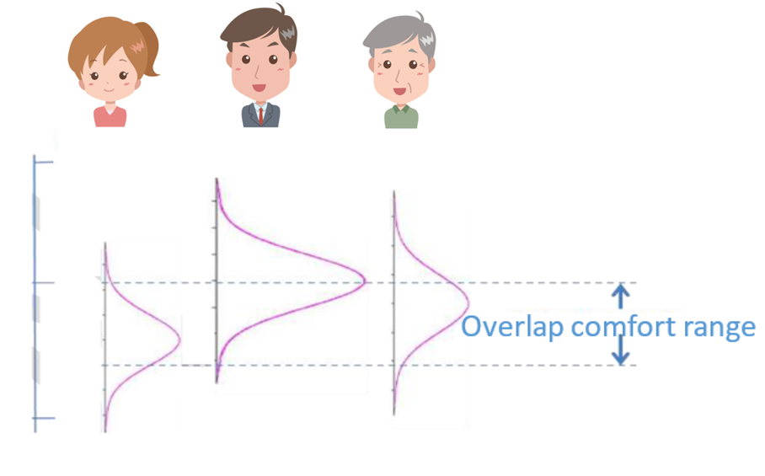The multi-occupancy condition (MOC) is the physical state that several occupants share in one thermal zone. Occupants have different thermal preferences and thermal stress tolerance, which makes it difficult to balance the control of the typical central HVAC system to cater to different occupants’ thermal requirement. However, multi-occupancy condition is dominant, especially in an office building. Simply finding a consensus cannot solve the problem, since the different individuals’ thermal comfort range might not overlap.

Figure 1

Figure 1.1 Multi-occupancy thermal comfort

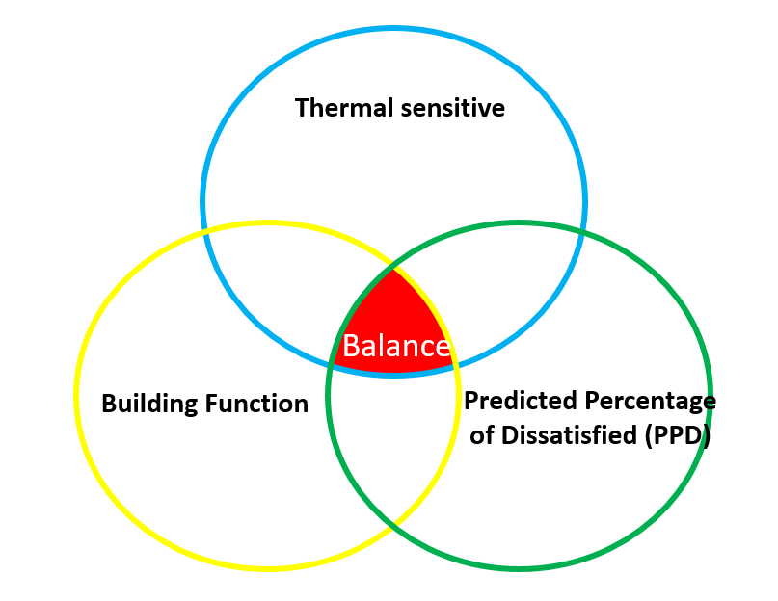There are three typical factors (Fig.1.2) that need to be considered when designers and researchers want to look into solving the multiple occupants’ thermal conflict.

Figure 1.2 Balance of Multiple occupancy condition

Thermal sensitivity represents the occupants’ thermal tolerance. Some occupants are more sensitive to temperature, which has a narrow comfortable temperature range. On the other hand, some occupants have a high thermal tolerance. They might feel thermally comfortable in a wider range of temperature variation as compared to thermally sensitive people. It is important to consider those thermal-sensitive people, since they are always and easily ignored. The typical thermal sensitive group is comprised of women and children. PMV indicates that a constant temperature range is not applicable to those people, and is the main complaint from occupants.

Building function is another important factor that should be considered. Different building functions have different priorities on either energy saving or thermal comfort side. For example, in a typical office building, facility managers might prefer energy saving rather than high level thermal comfort, as long as they can maintain an acceptable thermal comfort level to the building occupants. In a hospital, thermal comfort assumes more importance, since patients need to be under a higher level of thermal comfort conditions. Different building functions offer challenges to designers and researchers when they are investigating optimal temperature under multiple occupancy condition.

Predicted Percentage of Dissatisfied (PPD) indicates the percentage of people who are dissatisfied about the thermal environment. It is a popular and important factor that has been used in current control logic. Sometimes, there is absolutely no balance point for multiple occupancy condition. Under this condition, a small number of occupants’ thermal comfort needs to be sacrificed to ensure most people’s thermal comfort requirement. This sacrificing strategy has been widely used in the current mechanical system design.

* 1. Artificial intelligence in control systems

Started in 1990s, artificial intelligence (AI) has been applied to the control of the building systems. Both conventional and bioclimatic buildings adopted artificial intelligence (AI) techniques to improve system control. The development of evolutionary algorithms has helped optimize the intelligent controllers, which can contribute to the control of the intelligent buildings’ subsystems (Lopez et al, 2004). The synergy of the neural networks technology and evolutionary algorithms optimize the control of the system to overcome the non-linear features of PMV calculations, time delay, and system uncertainty (Dounis and Manolakis, 2001), (Calvino et al, 2004), (Singh et al, 2006), (Kolokotsa, 2001). Including fuzzy adaptive control, minimum-power comfort control (Federspiel and Asada, 1994), and optimal comfort control (Arthur and Gerald, 1998), some advanced control algorithms have been incorporated in smart control. Some hydronic heating systems have adopted a back-propagation algorithm based direct neural network controller to optimize the system control, and its control system performance is better than the performance of the conventional control system (Kanarachos and Geramanis, 1998).

In Japan, neural network has been extensively used since the 1990s, including robot control, recognizing printed characters, commercial products and industrial systems (Asakawa and Takagi, 1994). In an HVAC system, two neural networks have been applied in an air conditioner control, based on users' preferences. One of the neural networks was used to estimate the PMV index by using sensor input. However, the optimal control is not always reliable for a given user. The other neural network was used to correct the output of the first neural network, which can be trained by users.

With the rapid development of the artificial intelligence technologies, researchers made an effort to develop an intelligent system for the HVAC system, considering both energy conservation and users' thermal comfort conditions(Huang and Nelson, 1994) for large buildings such as hotels, office buildings, airport and other commercial buildings that need the robust HVAC control system to control the building's microclimate environmental conditions while they aimed to minimize the energy consumptions (Shepherd and Batty, 2003). A lot of research has been done concerning applications of fuzzy and neural control for Heating Ventilation and Air Conditioning (HVAC) system (Tobi and Hanafusa, 1991). The results cited are superior as compared with the conventional control systems (Liang and Du, 2005), (Ling et al, 1991).

The application of traditional control methods in buildings has faced an obstacle. The mathematical model of the operation in a building system is difficult to develop because of the strict requirement of the model and non-linear variables. In the intelligent systems, model-free controllers solve the problem, since it does not require a mathematical model of the operation system. It is a potential solution of the automatic control systems. Incorporating higher-level parameters (Dounis et al, 1992), including non-linear variables into the intelligent controllers, can potentially optimize the control system with both energy conservation and occupants’ thermal comfort conditions. In the intelligent system, occupants start to participate in the control of the system to pursue the desired comfort conditions.

Genetic Algorithms were proposed to be used in the optimization of the fuzzy control logic. The good performance of genetic algorithms in solving the multi-optimization problems make it a promising option to use in optimizing the neural network performance, such as the weight of the node, and the number of the hidden layers. The combination of the genetic algorithm and neural network has been researched more widely in recent years. Moreover, the genetic algorithm also demonstrates a better performance to optimize the control system in finding the optimal point considering the energy cost, system operation efficiency, thermal comfort, demand response and some other related factors.

## Synergistic neuro-fuzzy techniques

With the wide use of neural network techniques in fuzzy technology, Neuro-fuzzy systems were developed from the 1990s. Hybrid systems – such as Adaptive Neuro-Fuzzy Inference System (ANFIS)(Jang et al, 1996) – have been used to make the advanced control of the lighting system in building, considering the natural lighting with the prediction made by the model.(Kurian et al, 2005) Integrating users’ physical data, thermal comfort feedback, non-linear modeling of buildings, the climate parameters, and indoor environmental data into intelligent system can contribute to optimize the energy saving and guarantee the satisfaction of occupants’ thermal comfort.(Morel et al, 2000) A neural controller, combined with the neural network prediction capabilities, can be adopted in the hydronic heating system and solar buildings.(Argiriou et al, 2004) Adaptive Neural Network (ANN) was developed by Kanarachos and Geramanis (Kanarachos and Geramanis, 1998), who have used it to control the single zone with hydronic heating systems. The inputs of the controller are the parameters related to the heating plant, and the output of the controller is the indoor set point temperature. However, in this controller, there is no weather data or indoor environmental data considered. Yamada et al. have developed an air-conditioning control algorithm with the use of neural networks, fuzzy logic, and predictive control (Yamada et al, 1999). The number of occupants and the weather-related parameters can be predicted by this system. These predictions become the input, and are used to estimate building performance with the considering of both energy conservation and maintaining the high comfort level indoor conditioning.

## Goals and objectives

The discussion so far has been about the importance of the smart HVAC control system and the problems faced the current HVAC system, especially the thermal requirement of the multiple occupants’ condition. The current industry standard and PMV model cannot meet the occupants’ thermal requirement. The goal, therefore, is to develop a control algorithm that can improve the thermal comfort condition while reducing the energy consumption. The proposed algorithm can help generate the optimal environmental temperature considering the multiple occupants’ thermal preference in one HVAC zone on both aspects; namely, energy saving and thermal comfort.

## Scope of this thesis

The B11 climate chamber in the Watt Hall of the University of Southern California was used as the site to conduct the human subject experiment. Twenty-one subjects attended the single-occupancy experiment, and five of them attended the validation experiment. Nine subjects were divided into three groups and attended the multi-occupancy experiment. Both SOC and MOC validation experiment were conducted and the same experiment process was repeated four times. Single-occupancy experiment subjects’ physical data and environment data are used to develop and training the artificial intelligence model. Single occupancy condition validation experiment and multi-occupancy validation experiment data were used to test the performance of the proposed control algorithm. Thereafter, the results of the proposed control algorithm were compared with the conventional industry standard, such as ASHRAE-55. The experiment lasted 65 mins for both: single-occupancy experiment and multi-occupancy experiment. Both SOC and MOC validation experiment procedures are the same as the SOC experiment. Due to the limitation of time and available resources, only young people in a range of 18 to 25 were recruited as volunteers.

## Hypothesis statement

The data driven approaches for human-based environmental control can potentially improve the HVAC system performance in both energy saving and thermal comfort aspects.

## Chapter Summary

The need of a new control logic, and how it can be useful to multi-occupancy human comfort and energy saving, was explained. Artificial intelligence technologies adopted in HVAC control was discussed in detail. The goals, objectives and the scope of work were defined. Chapter 2 focuses on the background research and literature review. Chapter 3 describes the experiment procedure, analysis method, machine learning model development, and Overall Thermal Discomfort (OTD) index in detail.

# **Chapter 2 Previous Work: Background and Literature Review**

## 2.1. Intelligent control techniques in HVAC systems

In order to address the challenge of energy saving and multiple occupants’ thermal comfort, personalized and user-based control approaches have been proposed by some researchers (Erickson and Cerpa, 2012), (Feldmeier and Paradiso, 2010). Data-driven approaches can be used in existing buildings with the conventional HVAC control system (Jazizadeh et al, 2014), (Jazizadeh et al, 2012). These approaches are geared toward occupant comfort driven control logic, considering individual users’ differences. By modeling the individuals’ comfort levels separately, the estimation of occupants’ thermal comfort can be predicted and drive the control of the building’s system. Erickson and Cerpa (Erickson and Cerpa, 2012), have developed a user-based control approach to control the temperature of the rooms. This control methods showed better performance on energy conservation, with 10.1% energy savings, when compared to the existing building control systems and thermal comfort levels, with all occupants expressing satisfaction. Murakami et al. have proposed an approach to generate temperature set points by collecting 50 occupants’ voting in an office room (Murakami et al, 2007). The HVAC system can dynamically adjust the set points based on occupants’ voting. The results showed 20% higher energy performance than the conventional constant set point of 26◦C. Researchers have found that there will be a 10% energy saving by extending 1ºC setpoint temperature of HVAC during summer and winter (Hoyt et al, 2015). Therefore, extending the temperature setpoint range, without sacrificing the occupants thermal comfort level, has a great potential for energy saving. Feld Meier and Paradiso have measured the occupants’ varied body parameters in order to study the occupants’ thermal comfort preference (Feldmeier and Paradiso, 2010). The PI (proportional-integral) controller was used to control the HVAC system’s set points. The window locations in their test bed buildings, can be adjusted by the controller, based on personalized comfort preferences. The experiment results show 24% more energy savings than the conventional standard HVAC control system. The goal of this research is to provide the most comfortable condition to occupants, and then saving the energy by selecting the optimized temperature. However, previous study (Nicol and Humphreys, 2002) has shown that the human comfort environmental conditions’ range is similar to the PMV comfort zone (i.e., between −0.5 and 0.5 on the PMV index). When the occupants’ acceptable set point temperature range is determined, the set points can be determined by other criteria, such as system efficiency and machine operation efficiency. There are three centrally interrelated functions including heating, ventilation, and air conditioning, which contribute to providing thermal comfort and indoor air quality, and minimize the operation and maintenance cost of the HVAC system.

The application of intelligent controllers in an HVAC system has been widely studied in recent years. There are many researchers who have directly applied intelligent controllers to HVAC systems for intelligent control (Liang and Du, 2007), (Alcal’a et al, 2003), while others used artificial intelligence – fuzzy logic methods to optimize the performance of current PID controllers (Li et al, 2005) (Mohan and Patel, 2002). In the latter case, intelligent-fuzzy techniques are also adopted to auto-turning the PID controllers to overcome the difficulty of manual adjustment of the PID gains.

Liang and Du have designed an intelligent control system, combining the occupants’ feedback learning and minimum energy consumption control strategies in an HVAC system (Liang and Du, 2007). In their work, the minimum energy consumption strategy included a balance control between the input power of HVAC mechanical equipment and the system operation energy cost (Liang and Du, 2007). This control system is based on the Predicted Mean Vote (PMV) model, as proposed by Fanger. Six factors that influence peoples’ thermal comfort, including air temperature, radiant temperature, air velocity, relative humidity, occupants' activity level, and clothing insulation (Fanger, 1972) were considered. The occupants’ learning strategy was designed to learning the user’s thermal comfort preference, by collecting the specific users’ thermal comfort feedback (Liang and Du, 2007). Fountain et al. designed an intelligent control strategy that can be adopted to short-term occupancy condition in hotels (Fountain et al, 1994). The thermal comfort control also adopted a comfort zone with the integration of occupants learning strategy (Fountain et al, 1994). The control system tracks the user’s thermal sensation, such as the PMV thermal comfort index (from Cold (-3) to Hot (+3)), rather than modeling the thermal comfort temperature range. The intelligent control method application procedure was more convenient than the conventional control system, in terms of occupants’ thermal comfort control. In order to overcome the nonlinear variables of the PMV model, an artificial neural network (ANN) controller was designed. The further optimization of the energy consumption of operation can be achieved by integrating the variable air volume method.

## 2.2. Application of artificial neural network in HVAC system

Several studies have been carried out on the improvement of the thermal quality with people’s increasing requirements of thermal comfort. Many industry standards and codes suggest the thermal comfort conditions range that have been widely applied in building system design (ASHRAE 55, 2004). Based on previous research, the HVAC control system can maintain the thermal condition by selecting the proper system application (Moon and Kim, 2010). However, there are still some defects in the conventional control system, such as the lack of consideration of multi-occupancy condition.

Recently, artificial intelligence (AI) technology has been studied extensively in the application of optimization on indoor thermal environment control of buildings. Various researches (Moon and Kim, 2010) have been conducted on applying the AIs to control the system, based on the data acquired from perceiving the surrounding environments. The successful application of AI to intelligent machine learning helps optimize the systems and control algorithm concerning working performance and satisfaction of the design purpose (Moon and Kim, 2010). Following is an example application of the ANN based control model developed by Dr. Moon in 2016.

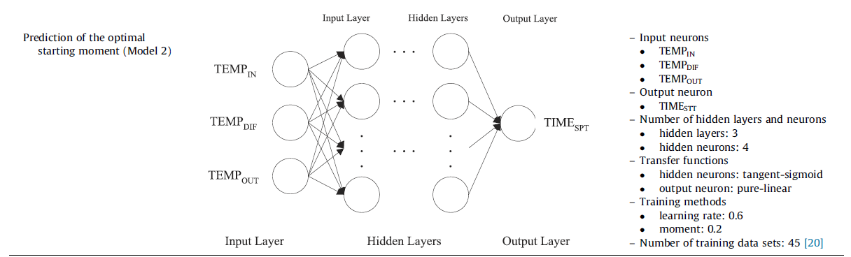

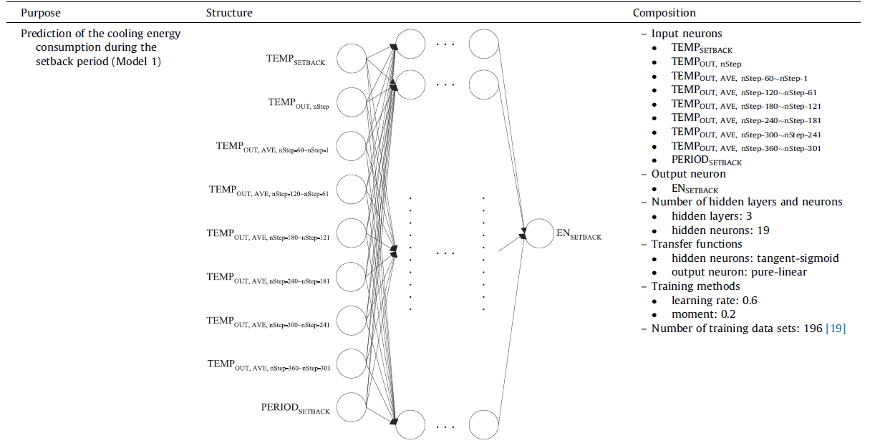

Figure 2.1 ANN based thermal control (Moon and Kim, 2010)

In his study, a control algorithm was used to optimize the thermal comfort as well as the energy conservation of buildings in the cooling season. Two artificial neural network (ANN) based models were adopted in the control algorithm. One ANN model was used to make the prediction of the energy consumption during the unoccupied time of different setback temperature and the other was used to predict the time required for advanced cooling operation (Moon and Kim, 2010). The ANN model based control algorithm has a better performance on 18.03% energy saving than the conventional HVAC system (Moon and Kim, 2010). However, this research still has some limitations. The first one is the thermal comfort model. Dr. Moon’s control algorithm still relies on the PMV model to evaluate the thermal comfort; however the PMV model has several limitations as mentioned in the previous paragraph. Secondly, the proposed control algorithm does not provide the solution to the multi-occupancy condition thermal comfort. The PMV model can be used to estimate a single occupant’s thermal condition rather than for multiple occupants. Thus, the user-based data driven control algorithm needs to be proposed to solve these problems.

The artificial neural network (ANN) is one of the most popular machine learning technologies that has been widely applied in the industry. It is a computational model that mimics the biological processes of decision making by the human nervous system (McCulloch and Pitts, 1943). The ANN model can consider the non-linear variables systems or unclear dynamical variables in the systems. Operators don’t need to understand the principle of these variables and logic, the model will track the patterns of the data and make appropriate predictions, based on it (Moon and Kim, 2010). The ANN model has two major processes in the application: (1) self-training by a back-propagation process; (2) calculating output by a feed-forward process with a set of input neurons, hidden neurons, transfer functions, and weightiness of each connection between neurons. The predictive and adaptive function of the control system can be achieved based on these two processes.

The ANN-based control models have been adopted extensively in the building of the thermal control system. Table 2.1, summarizing the recent research about ANN-based model, has been applied in the building HVAC control system. By avoiding overcooling and overheating, ANN-based strategy demonstrates good performance in thermal control in buildings. Moreover, ANN-based strategy can also help improve the energy efficiency of the buildings through optimal heating and cooling supply. Therefore, there is no need to keep the HVAC system running all day long. Adjusting the operation time as per an occupant’s schedule can improve the system’s energy performance. Secondly, occupants may not care about the energy consumption in the buildings. A guest in a hotel doesn’t need to pay the electricity bills. Sometimes, they adjust the set point temperature of the HVAC system to an extreme mode, which is more than necessary. Generally, occupants do not understand the setback time and the temperature application of the HVAC system. Occupants cannot determine the optimal moment to turn on and turn off the HVAC system, since it requires some professional knowledge.

Table 2.1 Summary of the previous ANN model application

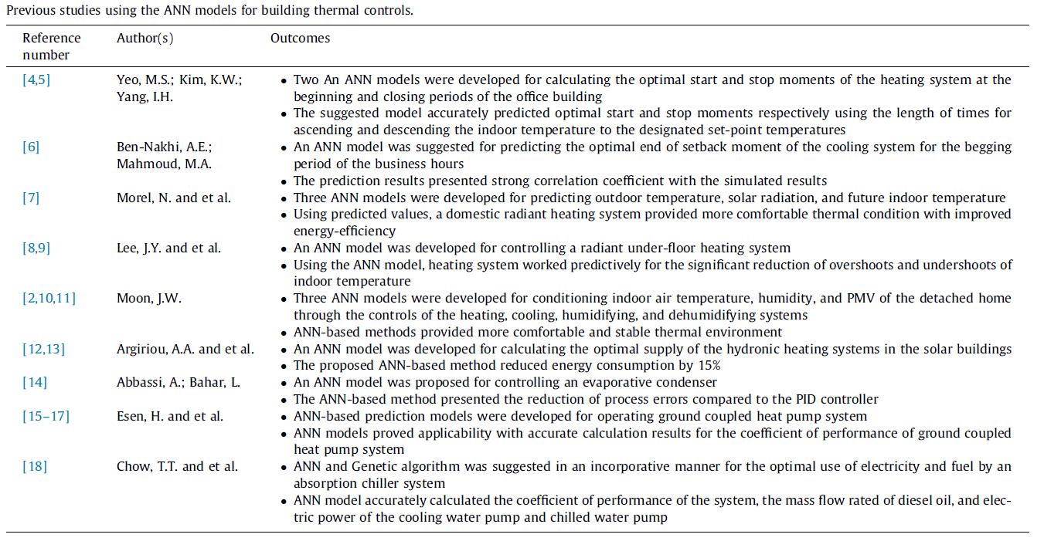

Thus, it is necessary for the building manager to employ active management for the optimal operation of the HVAC system in the building. For example, the optimal setback temperature and time should be determined and applied to the control system to improve the energy performance of the building (Yang et al, 2003). Additionally, the optimal moment to switch on the HVAC to the normal set-point temperature is necessary to make the contribution of advanced control system, which will provide a more comfortable thermal condition when the guest returns the room (Yang et al, 2003).

## 2.3. Occupancy individual factors

* Gender – Occupants’ thermal comfort preferences varies due to the difference between the genders. Several studies have shown that males are more sensitive about elevated temperature than females, which means rising temperature might cause more discomfort to males than females. Generally, males have a higher requirement of thermal comfort than females, and they reported thermal discomfort more frequently than females. Wyon, D.P., conducted a research that tested males and females in the same clothing index condition doing productivity tests while using a dual vote to collect their thermal comfort and thermal sensation levels during the changing temperature in the climate chamber (Wyon et al, 2009). Joon-Ho Choi’s study revealed that females prefer higher temperature than males in the same environmental condition (Choi et al, 2010). However, males tend to be more sensitive about the relative humidity condition than females (Karjalainen, 2007) (Lan et al, 2007).
* Age – There are many studies on the relationship between people’s age and their thermal comfort requirement. Some literature shows that the thermal sensitivity declines with increasing age. There are also some researchers who provide some evidence to prove the gradual reduction in the thermoregulation after the age of sixty (Lenzuni and Del, 2009). Joon-Ho Choi’s study revealed that people who are over the age of 40 have higher thermal satisfaction than people who are under 40(Choi et al, 2010). In this study, the age of the subjects will be recorded and related to their thermal comfort profile.
* Heart rate – Heart rate is an important parameter to reflect an occupant’s metabolic rate and body condition. Metabolic rate is a significant factor of the human thermal comfort. Joon- Ho Choi’s research investigated the relationship between the human heart rate and thermal comfort, and explored the possibility of using heart rate as a factor for the human thermal sensation model (Choi et al, 2012). Therefore, in this research, heart rate has been considered. In this study, the subjects’ heart rate was monitored and recorded by using a heart rate sensor. The heart rate data were transferred to the LabVIEW program, and were used to develop the ANN model.
* Metabolic rate – Metabolic rate can reflect the people’s activity level, which is an important factor that can influence human thermal comfort. Occupants may have different metabolic rates due to different activity levels and environmental conditions (Toftum, 2005). In this study, the subjects are required to sit next to a table, and can only perform basic computer-related tasks. The estimated metabolic rate of the subjects was 1.0 met.
* Clothing insulation index – The clothing insulation varies, based on the different clothing worn by the people. The different values of clothing insulation may influence the heat transfer, including heat gain and heat loos between the human body and the environment. High clothing insulation can contribute to keeping warm and might lead to overheating of the system, while low clothing insulation can help a person in keeping cool and might even lead to overcooling. The clothing insulation depends on the layers of the clothes and the materials of the clothes (Havenith, 1999). In this experiment, subjects are suggested to wear spring or fall season clothes, and their clothing insulation index were recorded into their thermal comfort profile.

## 2.4. Environmental factors

* Air speed – In heating, ventilation and air conditioning (HVAC), air speed or air velocity is the parameter to describe the environmental air movement condition, regardless of direction. Based on the ANSI/ASHRAE standard-55, air speed is the rate of air movement at the position of an exposed body. High-velocity air might make people uncomfortable. Air speed is an important factor that influences human thermal comfort. In a human thermal comfort experiment, air speed must be carefully controlled according to the research requirement.
* Mean radiant temperature – The mean radiant temperature (MRT) shows the radiant heat gain from surfaces, and it has relationship among the materials’ absorptivity and emissivity. The mean radiant temperature can influence people’s thermal comfort since it is an important method of the heat gain. In this experiment, the indoor MRT were recorded by the MRT sensor, and the data were transferred into the LabVIEW program dynamically.
* Indoor environmental air temperature – The air temperature is the mean temperature of the occupants’ surrounding air. Based on the ASHRAE 55 standard, the level of the air temperature considers the ankle level, waist level, and head level, depending on the subjects’ seating or standing conditions.(ASHRAE 55, 2004) The temporal average air temperature is recorded at three-minute intervals’ air temperature on more than 18 spaced points. The measurement of the air temperature is conducted using a dry-bulb thermometer. In this experiment, the air temperature was measured at 4 height levels: 0.1m, 0.6m, 1.1m, and 1.6m, from the floor.
* Indoor environmental relative humidity – Relative humidity (RH) is used to describe the water vapor content in the air. A high relative humidity might hinder people’s skins’ sweat evaporation, which will cause a heat loss decrease of the human body. On the other hand, low relative humidity might cause discomfort, including a desiccation effect on the mucous membrane and skin. In this experiment, the relative humidity was maintained between 60% - 70%, which is the recommended comfort value suggested by the ASHRAE standard. The values of the RH were transported to the LabVIEW program and were recorded into the subjects’ personal thermal profiles.

## 2.5. Summary

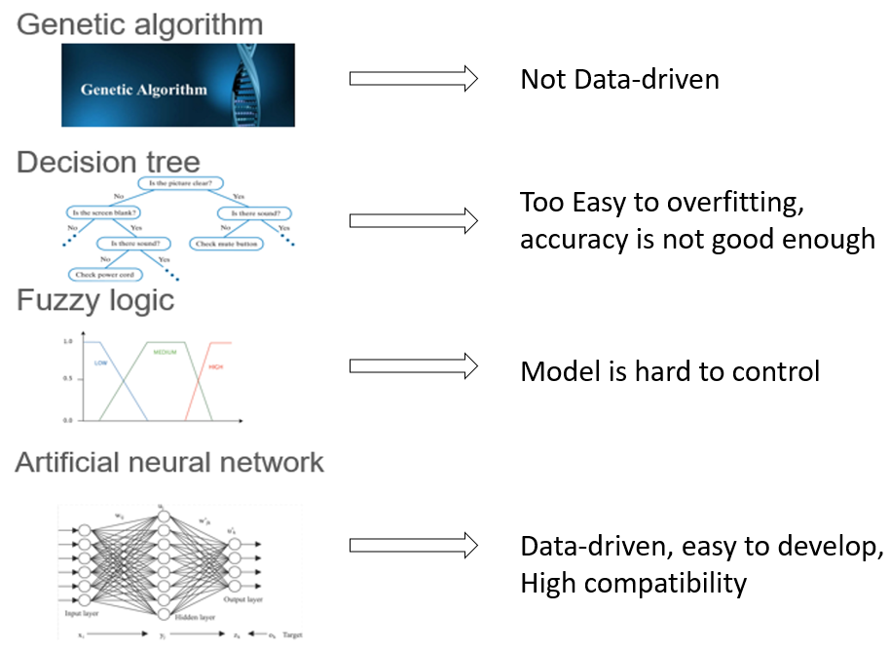This chapter summarizes the different algorithms that have been adopted into the HVAC system controls. The comparisons of these algorithms and an analysis of limitations of previous research have been done in this chapter.

Figure 2.2 comparison of the different algorithm s

After comparing the genetic algorithm, decision tree, fuzzy logic control, and artificial neural network in this research, the artificial neural network model was selected based on the data feature of the experiment and the control objective. The occupant-based control algorithm should have the capability to update dynamically according to the user’s physical data and environmental data. Also, the non-linear features variables that might influence thermal comfort should be considered in the control algorithm. Fuzzy concept algorithm, such as ANN is a good option, since it does not require a mathematic model and has capability to consider non-linear variables. The artificial neural network can meet all the requirements of the thermal comfort calculation. Thus, the ANN algorithm was selected to develop the control algorithm.

# **Chapter 3 Methodology**

## 3.1. Overview of methodology

In this research, two types of occupancy condition experiments were conducted in the climate chamber, B11, in the basement of Watt Hall. In total, 21 subjects participated in the single occupancy condition (SOC) experiment. Subjects’ thermal comfort preference was collected by measuring their thermal comfort feedback under different thermal conditions in the climate chamber. The overall methodology is experiment – machine learning – validation (Fig.3.1).

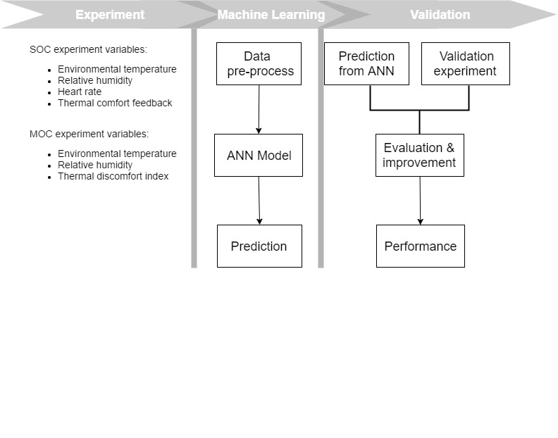

Figure 3.1 Overall methodology diagram

In the single occupancy condition, the data from the SOC experiment results were used to develop the machine learning model. The 21 subjects’ experiment results were used to train the responding occupants’ artificial neural network (ANN) model. Each subject had a neural network model trained by their experiment data. Of the 21 subjects who attended the SOC experiment, 5 occupants were randomly selected to attend a validation experiment. The validation experiment repeated the SOC experiment process four times. Based on the results of the validation experiment, the occupants’ artificial neural network was modified. A comparison between the industry standard and the ANN prediction was made on both, thermal comfort and energy saving aspects.

As for the multiple occupancy condition, nine subjects were divided into three three-people size group. . An overall thermal discomfort index was developed to evaluate the overall multiple occupants’ thermal comfort condition. A multiple occupancy condition (MOC) artificial neural network model was trained by the group size thermal preference. Three three-people group subjects attended the validation experiment. The MOC artificial neural network model was improved by results of the validation experiment. Performance of ANN model was generated by making a comparison between the industry standard (ASHRAE-55) and the ANN model prediction results.

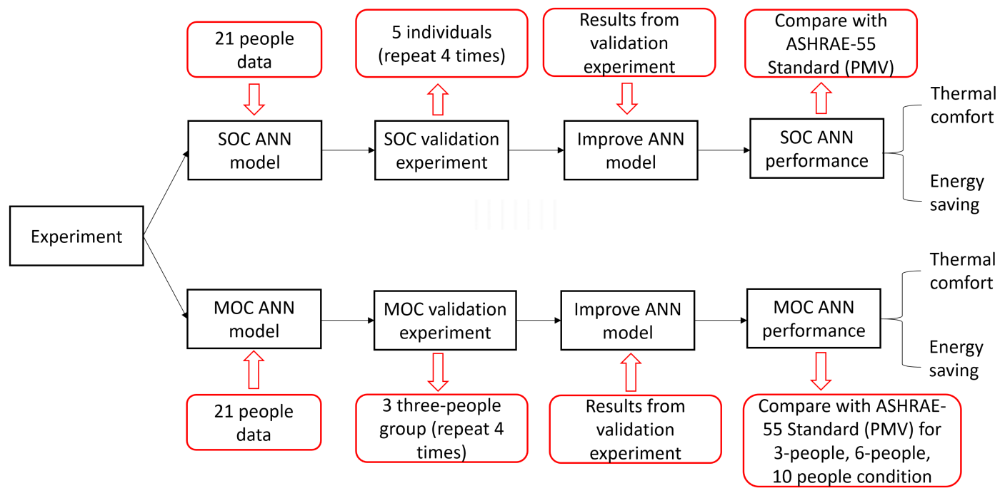

Figure 3.2 Overall workflow

In the climate chamber, the environmental factors that might influence human thermal comfort were strictly controlled using professional experiment equipment. Air-speed was controlled to within 0.2m/s, Mean Radian Temperature (MRT) equal environmental temperature and the CO2 density was within the range of 700 to 900ppm. Occupant factors were also controlled by the requirement of their clothes condition as well as activities. All subjects were required to maintain 1 clo clothing insulation condition, and 1.0 met metabolic rate with common office work activities. The main environmental factors are environmental temperature (from 18ºC to 32ºC) and environmental relative humidity (from 40% to 50%).

## 3.2. Experiment resources

The thermal control system program in the Environmental Chamber was developed by the author on LabVIEW, including 2 air-conditioning units, and 4 heater units. Subjects’ heart rate and environmental conditions were collected by LabVIEW with SensorDAQ. Subjects’ individual information, such as body mass index (BMI), age, and clothing insulation index were collected from the subjects’ profiles. Based on the subjects’ experiment data, an artificial neural network model can be trained to indicate the occupants’ thermal preference.

This study was conducted on a within-subject design and the participants were assigned to the experimental setting in random order. Both, the experimental setting and the environment condition including air temperature and relative humidity, are the independent variables of this study. Dependent variables are divided into subjective and objective measures. Subjective measures include the participants’ thermal comfort condition under different environmental conditions. Objective measures consist of the environmental temperature, environmental relative humidity, and the occupant’s heart rate.

### 3.2.1. Environmental Chamber

The human subjects’ experiments were conducted in the Environmental Chamber, located in the basement of Watt Hall at the University of Southern California. The chamber is cuboid, with a length of 4.5 meters, width of 2.9 meters, and height of 2.4 meters. The Environmental Chamber is a concrete-enclosed room. The wall was covered with high thermal insulation foam board. Air-conditioning facilities were placed at the corner of the climate chamber and were separated by high insulation board. The exhaust air of the AC unit was released out from the climate chamber. The office table was placed in the middle of the room for subjects doing computer-based work. The researcher also worked at the table to operate the chamber’s air-conditioning system as well as to monitor the experiment. A photograph of the Environmental Chamber is shown in Fig.3.3

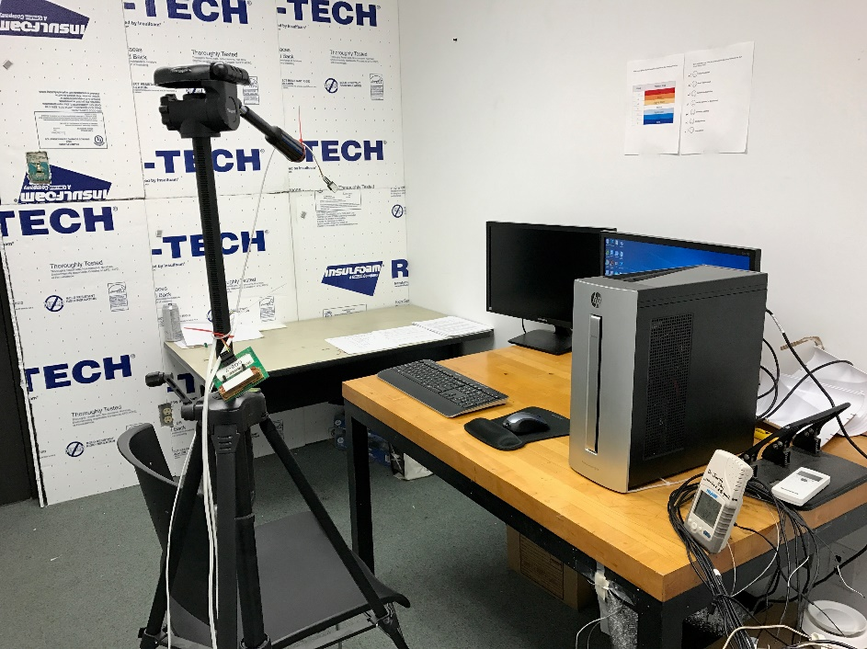

Figure 3.3 Photo of the Climate Chamber

### 3.2.2. Heating and cooling system

The temperature of the Environmental Chamber is regulated by 2 air-conditioning units (shown in Fig.3.4 and Fig. 3.5) having capacity of 6000 BTU and 15000 BTU and four portable heaters (shown in Fig.3.6) having capacity of 1200 Watts each.

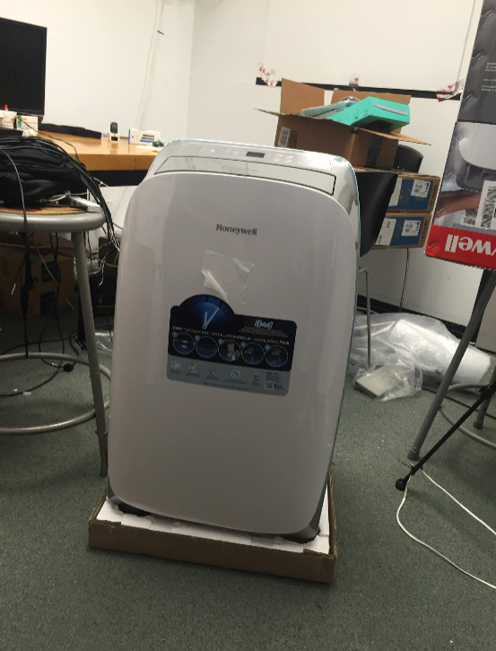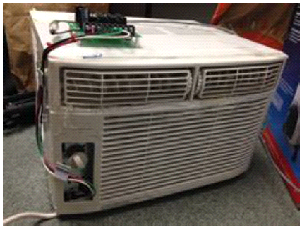

Figure 3.5 AC2 with 15000 BTU

Figure 3.4 AC1 with 6000 BTU

Air-conditioning units and portable heaters were installed at the corner of the room and were separated by the high thermal insulation board (shown in Fig.3.7). The AC units and heaters were connected with four flexible ducts, and supplied conditioned air to the diffuser box located on the 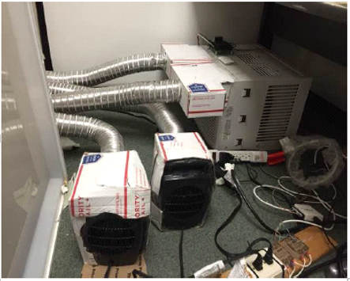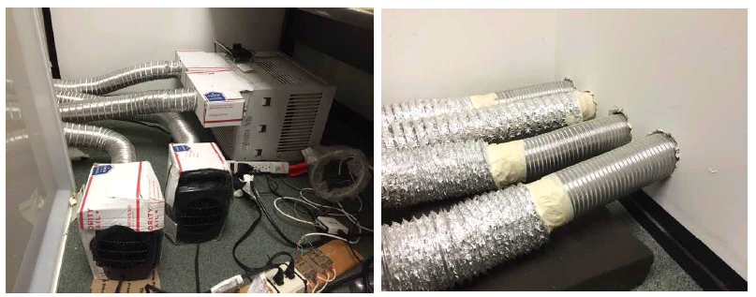two sides of the subjects’ working desk.

Figure 3.6 Heater connected with supply duct

Figure 3.7 Supply duct

Two flexible ducts supplied cooling air and heating air into the diffuser box to ensure the air movement within the climate chamber stayed uniform. The location of air diffusers is displayed in Fig. 3.8.

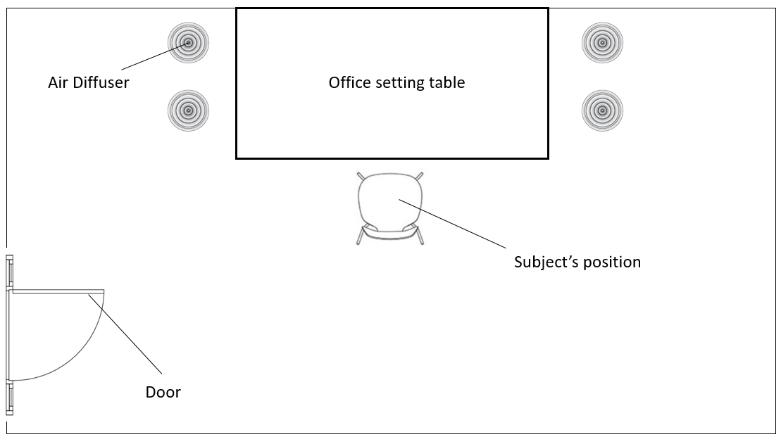

Figure 3.8 The diffuser positions

The AC1 with 6000 BTU was hacked and connected to a wire board, which can be controlled by the LabVIEW program along with the fan speed and compressor power. The AC2 with 15000 BTU was controlled manually for cooling the room to the initial experiment temperature (18ºC). Portable heaters were plugged into a socket. The socket was connected with a data acquisition which can be controlled by the LabVIEW program.

### 3.2.3. Data acquisition tools

#### 3.2.3.1. Objective data acquisition

All the environmental sensors, including four air temperature sensors, one mean radiant temperature sensor, one CO2 sensor, and one relative humidity sensor were installed on a tripod (shown in Fig.3.9). Air temperature sensors were placed at different heights: 0.1m, 0.6m, 1.1m, and 1.6m, from the floor, as per the suggestion of ASHRAE-55. The MRT sensor was placed at a height of 0.6m from the floor, considering the sitting activity level, as suggested by ASHRAE-55. The tripod device was used to measure the environment temperature and relative humidity.

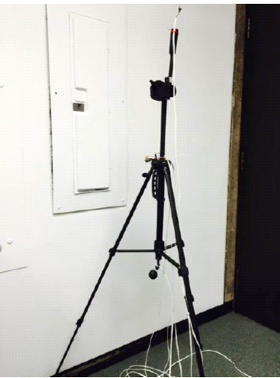

Figure 3.9 Tripod with environmental sensors

LabVIEW 2016 was used to operate the air-conditioning system and collect the subject’s real-time data. The interval of the data collection is 10 seconds, and the value of the senor, including heart rate and environmental conditions, were displayed on the LabVIEW’s front panel interface. (shown in Fig.3.10).

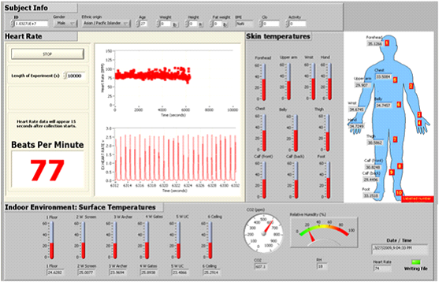

Figure 3.10 LabVIEW control panel interface

#### 3.2.3.2. Subjective data acquisition

**Human subject recruitment**

Volunteers were recruited in the University of Southern California using email, in-house publications, and student referrals. Volunteers received a $10/hour Amazon gift card as compensation for their experiment time. The age range of the volunteers was from 18 to 25, which is the common age among undergraduate students and graduate students. All the occupants individual information including gender, race, age, BMI were listed in the Chapter 4.1.

**Questionnaire of thermal sensation and thermal comfort**

The typical thermal comfort questionnaire (Table 3.1) is on a 7-point scale (ASHRAE-55), but the target of this research is to find the acceptable condition boundary and the uncomfortable condition. Therefore, it is not necessary to distinguish between Very Comfortable, Comfortable, Slightly Comfortable, and Neutral. Instead of a 7-point scale survey, a Thermal Discomfort Condition survey (Table 3.1) was used, to collect the subjects’ thermal comfort and thermal sensation condition in the experiment. The survey included 4 different thermal discomfort conditions, which are Comfortable, Slightly uncomfortable, Uncomfortable, Very uncomfortable, and their corresponding values. The Thermal Discomfort Condition survey combined the Very Comfortable, Comfortable, Slightly Comfortable, and Neutral Condition.

Table 3.1. The 7-point scale survey

|  |  |
| --- | --- |
| *Value* | *Thermal comfort condition* |
| *-3* | Very uncomfortable |
| *-2* | Uncomfortable |
| *-1* | Slightly uncomfortable |
| *0* | Neutral |
| *1* | Slightly comfortable |
| *2* | Comfortable |
| *3* | Very comfortable |

Table 3.2. Thermal Discomfort Condition

|  |  |
| --- | --- |
| *Value* | *Thermal discomfort condition* |
| *0* | Comfortable |
| *1* | Slightly uncomfortable |
| *2* | Uncomfortable |
| *3* | Very uncomfortable |

**Experimental conditions of the climate chamber**

In order to keep the stability of experimental conditions, subjects underwent a tutorial 20 mins before the experiment. Food and heavy activities are not allowed during the experiment. Subjects were asked to do some productivity tests during the experiment, and they also took the thermal discomfort condition survey every 5 mins. The experiment lasted for one hour, total 12 times thermal comfort survey were collected.

## 3.3. Single occupancy condition experiment design

There were 21 subjects included in the human subject experiment. The University of Southern California Institutional Review Board (IRB) approved the experimental method and process. Prior to the experiment, the laboratory staff assisted the subjects to wear the skin sensor, heart rate sensor, smart band and set up the system. The temperature of the climate chamber was conditioned to 18ºC with a uniform air supply. At the same time, the subjects’ basic information were recorded on the recording paper, which included the subjects’ cloth condition, body mass index, age, gender, etc.

After setting up the system, the experiment began. The heater was turned on and heated air was uniformly supplied by four diffusers. Every 5 mins, the staff conducted a survey on the subjects concerning their thermal comfort condition. During the entire experiment, the heart rate sensors were worn by the subjects on their body.

The subjects’ physical data was collected and displayed on the LabVIEW platform. After 60 minutes, the data as exported as an Excel file from the LabVIEW. The data from each subject was saved to be used for future data analysis. The experiment procedure diagram is shown below:

## 3.4. Validation experiment

Figure 3.11 Experiment procedure

The subjects of the validation experiment were randomly selected from among 21 subjects who participated in the SOC experiment. The validation experiment was done in order to test the performance of the artificial neural network. Based on the comparison, the actual validation experiment results with subject’s corresponding ANN model prediction results – the ANN model – was modified and improved. The validation experiment was categorized into two types of occupancy condition. One was a single occupancy condition, and the other, a multiple occupancy condition.

### 3.4.1. Single occupancy condition (SOC) validation experiment

There were 5 subjects that participated in the single occupancy condition validation experiment. Each subject attended the validation experiment to get the result of their thermal preference. Thereafter, a comparison was made of their validation experiment results with the ANN model prediction results which is based on their SOC experiment. A new ANN model was thus generated, by considering the results from the ANN model prediction and the validation experiment results. Figure 3.12 shows the workflow of the SOC validation experiment. In this research, the validation experiment was repeated 4 times. Each validation experiment was the same experiment process with SOC experiment.

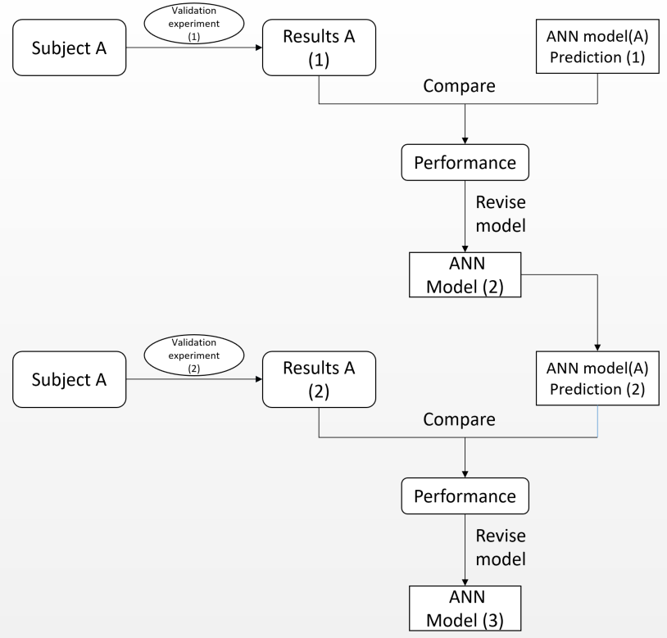

Figure 3.12 Single occupancy condition validation workflow

### 3.4.2. Multiple occupancy condition (MOC) validation experiment

In the multi-occupancy validation experiment, a three-people group was selected from 21 subjects based on their BMI, gender, and race. The principle for selection of volunteers was to cover as wide a range as possible to include different BMI, gender and race conditions. Totally, there were three groups; each group was comprised of three people (Table 3.2, Table 3.3, and Table 3.4). Similar to the SOC validation experiment, the MOC validation experiment was repeated four times. Occupants were asked to stay in the environment chamber together, and the temperature of the room was changed from 18ºC to 32ºC. Similar to the single experiment, their feedback of the thermal comfort and thermal sensation were collected during the experiment. The positions of occupants are given in the table (Fig.3.13). All three occupants’ data were transported onto the LabVIEW platform.

Table.3.2 Group 1 subjects’ information

|  |  |  |  |
| --- | --- | --- | --- |
| Group 1 | BMI | Gender | Race |
| Subject A | 18.0 | Male | African |
| Subject B | 22.1 | Female | Asian |
| Subject C | 25.6 | Male | Caucasian |

Table.3.3 Group 2 subjects’ information

|  |  |  |  |
| --- | --- | --- | --- |
| Group 2 | BMI | Gender | Race |
| Subject D | 19.1 | Male | Asian |
| Subject E | 23.4 | Male | Asian |
| Subject F | 21.7 | Female | African |

Table.3.4 Group 3 subjects’ information

|  |  |  |  |
| --- | --- | --- | --- |
| Group 3 | BMI | Gender | Race |
| Subject G | 18.7 | Female | Caucasian |
| Subject H | 22.1 | Male | Asian |
| Subject I | 24.7 | Male | Asian |

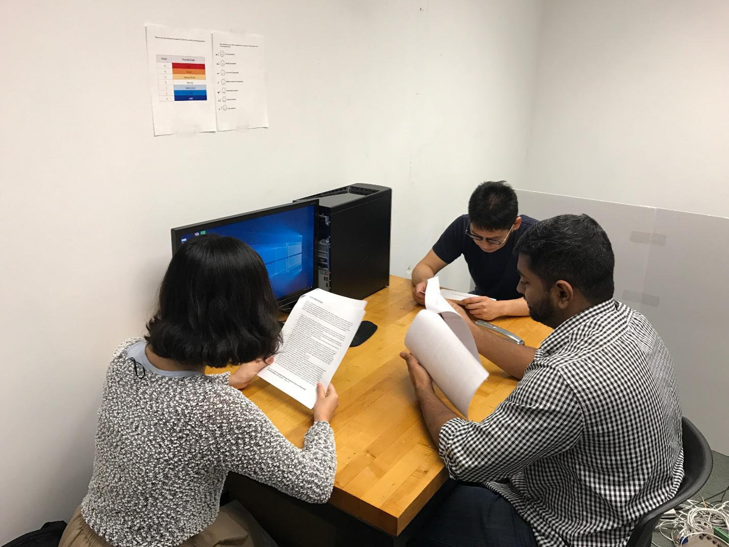

Figure 3.13 Position of multiple occupants

## 3.5. Multiple occupancy condition evaluation method – Overall Thermal Discomfort index

In order to indicate all occupants’ thermal comfort condition in the room, simply using the average of total thermal discomfort value was not applicable. For example, in a 3-people group condition, if two people felt comfortable, one could still feel very uncomfortable. The total thermal discomfort value is 3 and the average is 1. Obviously, it is not acceptable to sacrifice one person when there are only 3 people in the room. However, another condition is acceptable, wherein all the 3 people feel slightly uncomfortable. The total thermal discomfort value is 3 and the average is 1, which is the same as in the last case.

Therefore, it is necessary to develop an index to consider each occupant’s thermal comfort conditions to avoid an extreme condition. Overall Thermal Discomfort (OTD) index was developed to evaluate multiple occupancy condition thermal comfort. Rather than using 0, 1, 2, 3 scales in different thermal comfort conditions, an OTD index using 0, 1, N+1, (N+1)2 in different thermal comfort condition was used. N is the number of occupants.

Table.3.5 Overall Thermal Discomfort (OTD) Evaluation

|  |  |
| --- | --- |
| Thermal comfort condition | Evaluation score |
| Comfortable | 0 |
| Slightly uncomfortable | 1 |
| Uncomfortable | N+1 |
| Very uncomfortable | (N+1)2 |

N – Number of occupants

The OTD index equals the total evaluation score of occupants of the current environmental condition.

OTD = ∑ Evaluation score of occupants

OTDmax = (N-A)\*1 + A \* (N+1)

A – Number of occupants allowed to be uncomfortable

TD – Overall thermal discomfort index

OTDmax – max allowed overall thermal discomfort index

Under the OTD index evaluation method, an overall thermal discomfort condition is easier to define and set acceptable boundary conditions. The acceptable boundary OTDmax can be decided depending on specific requirements. In order to illustrate the application of OTD, two case studies were listed:

Example 1:

When there are 4 people (N=4) in one HVAC zone, and the requirement is PPD = 10%, which means no one should be *uncomfortable* in this condition:

OTDmax = (N-A)\*1 + A \* (N+1) = = 4\*1 + 0 \* (4+1) = 4

When the OTD value is larger than 4, the environmental condition is not acceptable. The corresponding condition of OTD=4 is where everyone feel *slightly uncomfortable*. (1;1;1;1) If anyone feels *uncomfortable*, even though others feel comfortable, then, TD = 5 is larger than OTDmax, which is unacceptable (5;0;0;0).

Example 2:

When there are 10 people (N=10) in one HVAC zone, and the requirement is PPD =10%, this means only one person is allowed to be *uncomfortable* in this condition.

OTDmax = (N-A)\*1 + A \* (N+1) = (9\*1) + 1 \* (10+1) = 20

When the OTD value is larger than 20, the environmental condition is not acceptable. The corresponding condition of OTD = 20 is where only one person feels *uncomfortable (evaluation score = 11)* and the rest of 9 people feel *slightly* *uncomfortable* (evaluation score is 1). If there are 2 people who feel *uncomfortable*, even though others feel comfortable, then, TD = 22 is larger than OTDmax, which is unacceptable.

OTD index can avoid the extreme condition where thermal comfort occurs and it is easier to make the decision boundary.

## 3.6. Data preprocess

### 3.6.1. Data cleaning

Data cleaning consists of corrupt data detecting and correcting. The incomplete data or missing feature values of attributes would influence the results of the machine learning model performance. Therefore, it is necessary to perform data cleaning in the first step. There are three main categories of data cleaning, including filling in missing values of attributes and identifying outliers and noisy data (Lakshminarayan and Samad, 1999).

#### 3.6.1.1 Filling in missing values

Lakshminarayan proposed several methods to fill in the missing values of attributes (Lakshminarayan and Samad, 1999). In this research, missing data was filled in by regression method. Based on complete case data from the same feature previous to, and after 5 minute records, a linear regression model was generated and used to predict the missing values.

#### 3.6.1.2 Defining the outliers and noisy data

Binning method was used in defining the outliers and noisy data. Based on the experiment setting as well as human common physical parameter range, bins were developed to filter the outliers and noisy data:

Environmental temperature: 18ºC to 32ºC

Relative humidity: 40% to 45%

Heart rate: 60 to 110

### 3.6.2 Data transformation

In order to transform raw dataset into training and testing data that can be used in the development of the machine learning algorithm, all data was transformed into numerical data and using the same scale. The data transformation process can be categorized into two types, data normalization and data numeralization.

#### 3.6.2.1. Data normalization

Normalization is one of the techniques used to convert attributes to the same scales. It is a very important and necessary step of data preprocessing in the artificial neural network. Because the ANN used the sigmoid function as the primary function of activation, therefore the same scale of attributes is important to activate the function. In this research, all scale of attributes was normalized to 0 and +1. The normalization process was done using the Rapidminer software by Normalize operator (Fig.3.14). The parameter details were set in the Rapidminer operator setting panel (Fig.3.15).

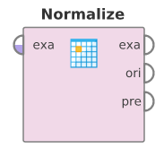

Figure.3.14 Normalize operator

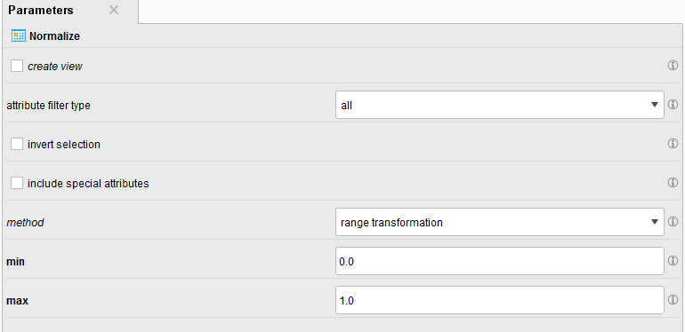

Figure 3.15 Normalize parameter setting

#### 3.6.2.2. Data numeralization

For neural networks, all attributes are supposed to be in numerical form. The numeralization process was used to transfer nominal parameters into numerical parameters such as thermal comfort (Comfortable, Slightly Uncomfortable, Uncomfortable, and Very Uncomfortable). The important thing is that when data is numeralized, it is necessary to pay attention to the relationship among the attributes. The type of each categorical attribute had a large influence to the method of numeralization. In this research, the numeralization process was done in Rapidminer by Nominal to Numerical operator (Fig.3.16). The parameter was set in the Rapidminer operator setting panel. (Fig.3.17)

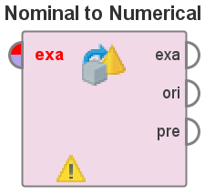

Figure 3.16 Nominal to Numerical operator

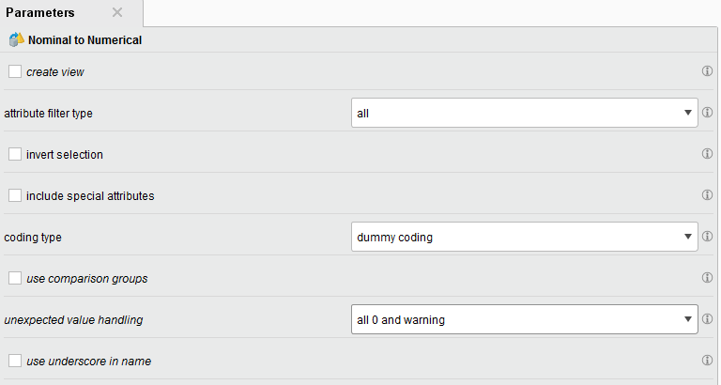

Figure 3.17 Nominal to Numerical parameter setting

### 3.6.3. Data reduction

Removing some irrelevant attributes can improve the performance of the machine learning algorithm. Some irrelevant or less relevant attributes may cause the machine learning algorithm to be influenced and result in poor prediction performance. Therefore, data reduction is important in data preprocessing.

In this research, the stepwise regression analysis was used to identify useful variables that have significant contribution to the thermal comfort. Stepwise Regression is used to analyze the correlation among predictors, and removes the least significant variables as well as adds the most significant variables during each step.

## 3.7. Machine learning algorithm development

Artificial neural network (ANN) is one of the most popular machine learning algorithms that has been widely used in both research and industry. Based on the literature review in Chapter 2, artificial neural network was selected for this research. The structure of the ANN model is critical and has a great influence on the model’s performance. For example, the number of layers and the number of nodes in each layer is important to discuss. The basic structure of the ANN model was determined based on experience rules and some test performance. All the results are discussed in Chapter 5 of this thesis.

### 3.7.1. SOC neural network model development

In order to develop the ANN model, the training data set is important and must be collected and organized based on the experiment. As for the single occupancy experiment, the dataset collected was divided into two parts: input set and output set. Rapidminer software was used to be the platform of the ANN model development.

Input set:

* Environmental air temperature
* Environmental relative humidity

Output set:

* Occupants’ thermal comfort

Add the input data and output data into the input layer and output layer of the ANN model respectively. Fig.3.18 shows the logic of the data relocation, and the ANN model development in Rapidminer by Neural Net operator. The parameters of the Neural Net operator details were set in the Neural Net parameter panel (Fig.3.19).

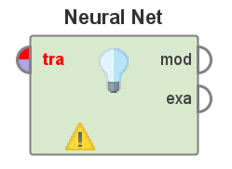

Figure 3.18 Neural Net operator

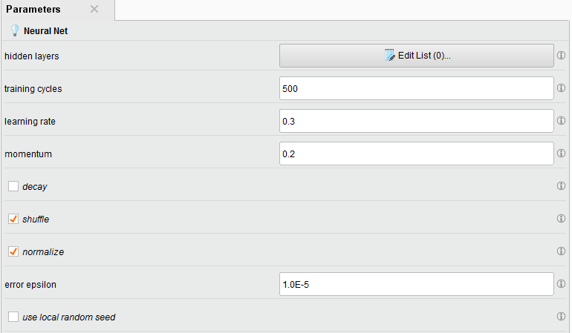

Figure 3.19 Neural Net parameter setting

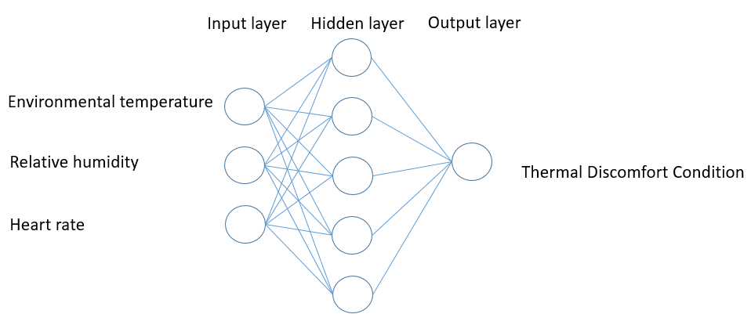

Figure 3.20 SOC neural network model structure

### 3.7.2. MOC neural network model development

A multiple-occupancy condition (MOC) neural network model was developed on the similar strategy. The MOC neural network model was developed in Rapidminer (Fig.3.21). However, the input and output attributes are different. Input data are attributes that were used to predict the output attribute.

Input set:

• Environmental air temperature

• Environmental relative humidity

Output set:

• Occupants’ thermal comfort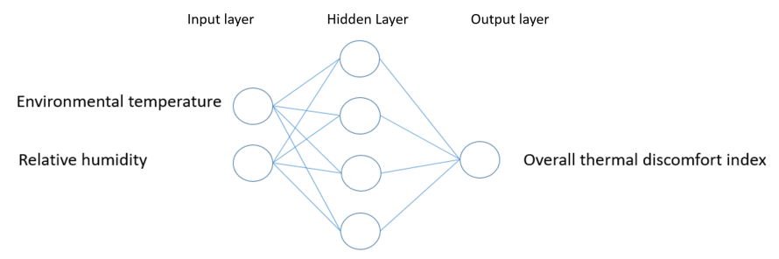

Figure 3.21 MOC neural network structure

## 3.8. Performance validation

The 10-fold cross validation method was used in this research to generate the performance of the artificial neural network model. Cross validation has two sub-processes, including a training sub-process and a testing sub-process. The model was trained by training sub-process data and the performance was generated based on the application of testing the sub-process. The cross validation was done in Rapidminer software by X-Validation operator (Fig.3.22). The parameters of cross validation operator details were set in the cross validation parameter panel (Fig.3.23).

Figure 3.22 Cross Validation operator

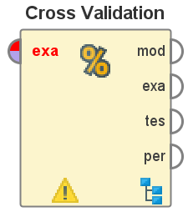

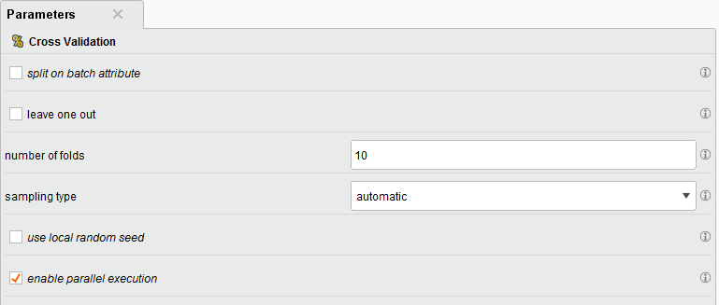

Figure 3.23 Cross Validation parameter setting

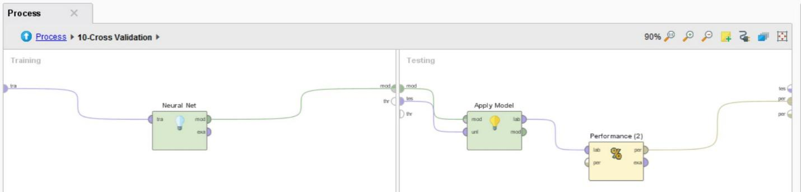

Figure 3.24 Cross Validation setting in Rapidminer

## 3.9. Summary

This chapter described the design of the experiment, experiment equipment, experimental procedure, ANN model development, and control algorithm development. The logic and process of the proposed algorithm development is shown in Fig.3.25.

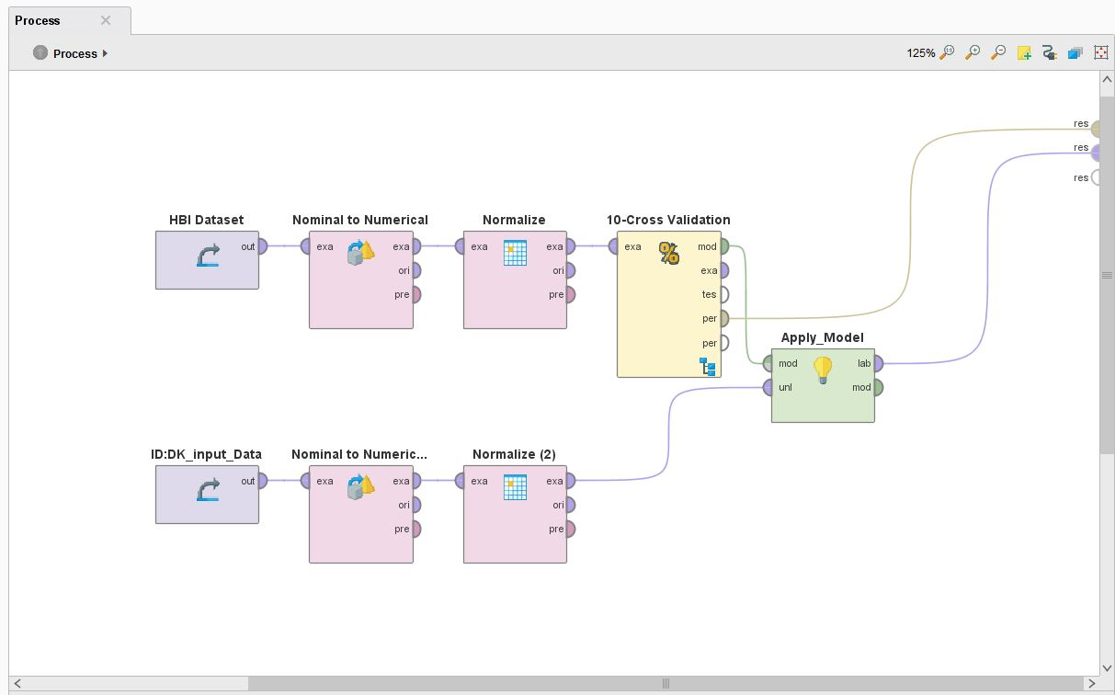

Figure 3.25 Overall process of Neural Network in Rapidminer

Two occupancy condition were considered in the experiment including single occupancy condition and multiple occupancy condition. There were 21 subjects attending the single occupancy condition experiment, and 9 subjects (3 three-people groups) attending the multiple occupancy condition experiment. Five subjects attended single occupancy condition validation experiment, and three three-people groups attended multiple occupancy condition validation experiment. Both SOC and MOC experiment lasted 60 minutes and every 5 minutes a thermal comfort survey was taken. The environment temperature increasing from 18 ℃ to 32 ℃ during the experiment. SOC experiment and MOC experiment data were used to train SOC-ANN and MOC-ANN model respectively, and SOC validation experiment and MOC validation experiment were used to test the accuracy performance of ANN model. Industry standard (PMV model) were introduced as a comparison with ANN model for performance analysis. The performance consist of energy-saving and thermal comfort.

# **Chapter 4 Human thermal comfort experiment data and results**

## 4.1. Database analysis:

Twenty subjects attended the human thermal comfort experiment. All the experiment data was transported into a human thermal comfort database. Table 4.1 displays the total number of experiment records, recording intervals, survey intervals, and length of experiment period.

Table 4.1 Database overview

|  |  |
| --- | --- |
| *Total records* | *7815* |
| *Recording interval* | 10 seconds |
| *Survey interval* | 5 minutes |
| *Experiment time* | 70 minutes |

### 4.1.1. Database information

Before the experiment, the subjects’ individual information was collected including Identity, Gender, Body Mass Index (BMI), and Race. During the experiment, the subject’s real time heart rate, environmental temperature and environmental relative humidity were detected by heart rate sensor, environmental temperature sensor, and relative humidity sensors. All the real-time data with corresponding time were transported into the database by the LabVIEW platform. The database information is shown in Table 4.2.

Table 4.2. Database information

|  |  |  |  |  |  |
| --- | --- | --- | --- | --- | --- |
| *Attributes* | *Type* | *Missing* | *Statistics* | | |
| *ID* | Polynomial | 0 | 20 individuals (20 ID) | | |
| *Heart Rate* | Integer | 0 | Min: 65 | Max:109 | Average: 85.8 |
| *Gender* | Polynomial | 0 | Male: 12 | Female: 9 |  |
| *BMI* | Real | 0 | Min: 17.4 | Max: 25.1 | Average: 19.8 |
| *Race* | Polynomial | 0 | Black: 3 | White:4 | Asian:14 |
| *Environmental Temperature* | Real | 0 | Min: 18.0 ℃ | Max:32.0 ℃ |  |
| *Relative Humidity* | Real | 0 | Min: 40.0% | Max: 45.0% | Average: 42.3% |
| *Thermal Discomfort* | Polynomial | 0 | Comfortable/Slightly Uncomfortable/Uncomfortable/Very Uncomfortable | | |

### 4.1.2. Stepwise Regression analysis

In order to find the significant factors affecting human thermal comfort, stepwise regression was used to remove variables based on the t-statistics of estimated coefficients. The regression analysis was done in Minitab. The results of the stepwise regression analysis of Minitab is displayed in Fig. 4.1.

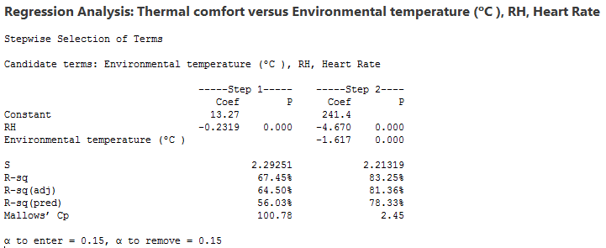

Figure 4.1 Stepwise regression result in Minitab

## 4.2. Overall thermal comfort analysis

From the database of 7815 records, overall thermal comfort conditions with corresponding environmental temperature can be generated (Fig.4.2). With the relative humidity controlled from 40% to 45%, and the environmental temperature ranging from 18℃ to 32℃, the thermal comfort condition ranges from 0 (comfortable) to 3, (very uncomfortable).

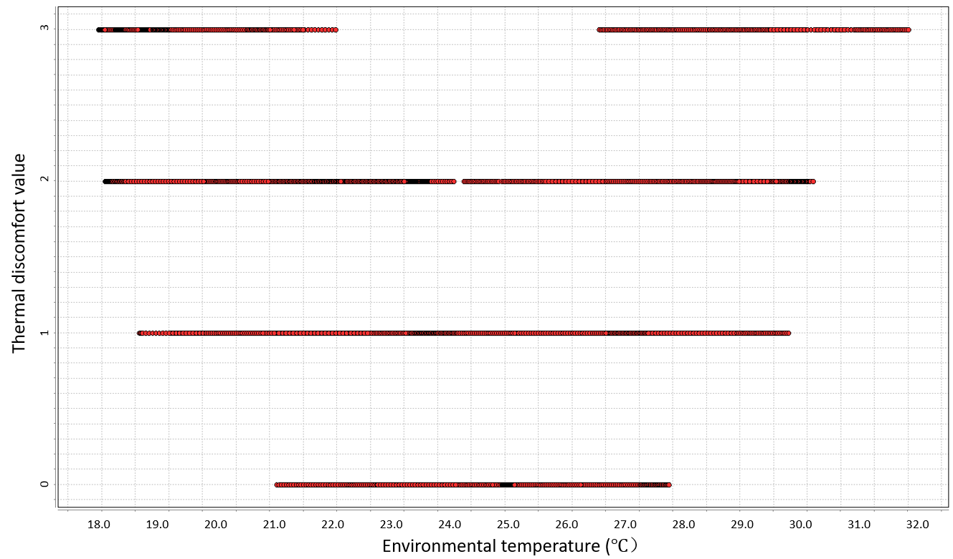

Figure 4.2 Overall Thermal discomfort versus Environmental temperature

There were many data points that overlapped because different occupants have different thermal preferences. Some subjects prefer higher temperatures while others prefer lower temperatures.

## 4.3. Individual experiment data

Totally, twenty one subjects participated in the thermal comfort experiment, and each subject had different thermal preferences. Therefore, each subject’s thermal comfort experiment data was used to build their individual thermal comfort preference profile. All subjects’ thermal preference data were collected by using thermal discomfort value. Below are three subjects’ thermal preference displayed as examples. The evaluation of thermal discomfort value was illustrated in Table 3.1 in Chapter 3.2. The blue point indicated occupant’s thermal discomfort condition under certain environment temperature.

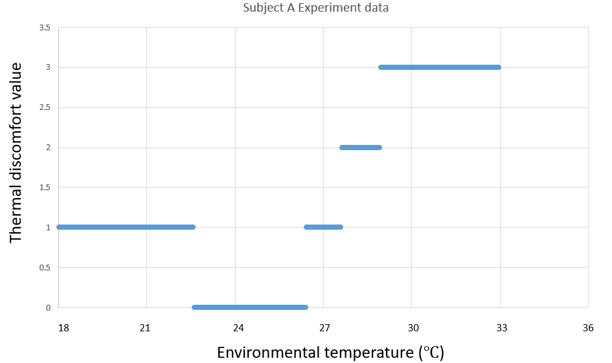

Figure 4.3 Subject A’s thermal comfort experiment data

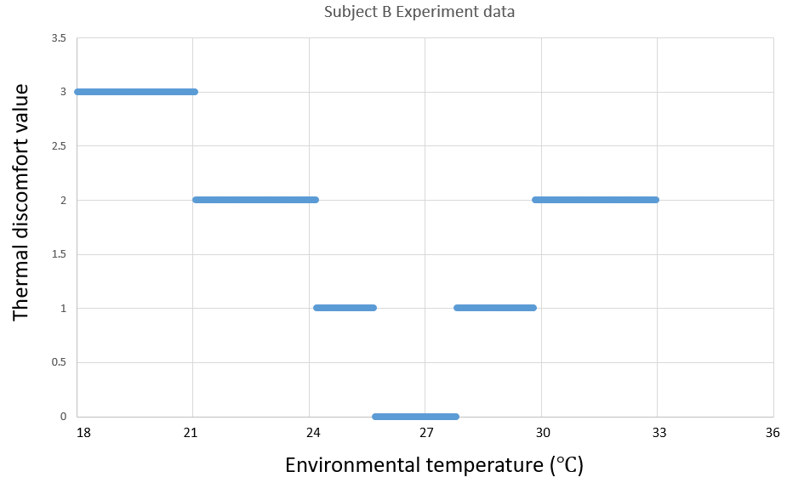

Figure 4.4 Subject B’s thermal comfort experiment data

## 4.4. Validation experiment

Figure 4.5 Subject C’s thermal comfort experiment data

### 4.4.1. Individual occupancy conditions validation experiment data

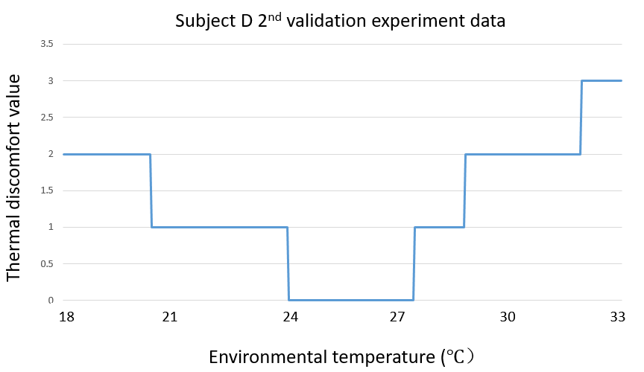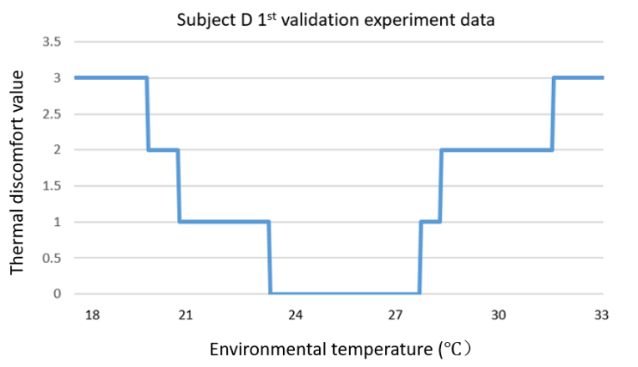A validation experiment was carried out, in order to validate the machine learning model’s prediction performance. The SOC validation experiment had the same process as the SOC experiment. Five selected subjects repeated the thermal comfort experiment for 4 times. The following are the results of the validation experiment, which displays their thermal comfort preference in each experiment.

Figure 4.7 Subject D’s 2nd validation experiment data

Figure 4.6 Subject D’s 1st validation experiment data

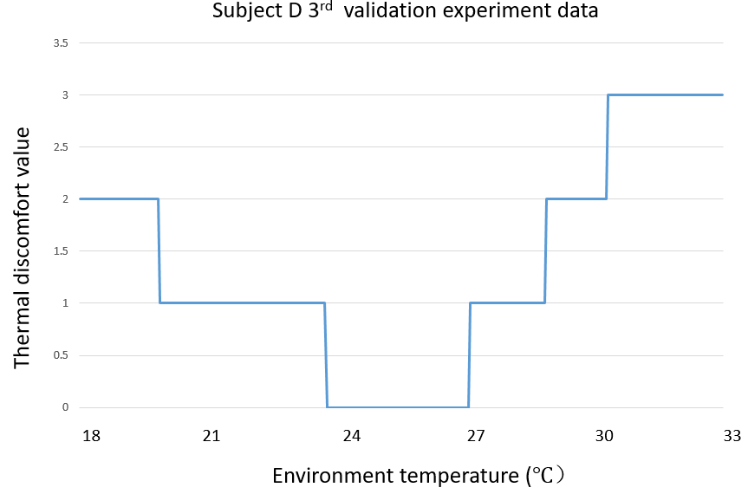

Figure 4.8 Subject D’s 3rd validation experiment data

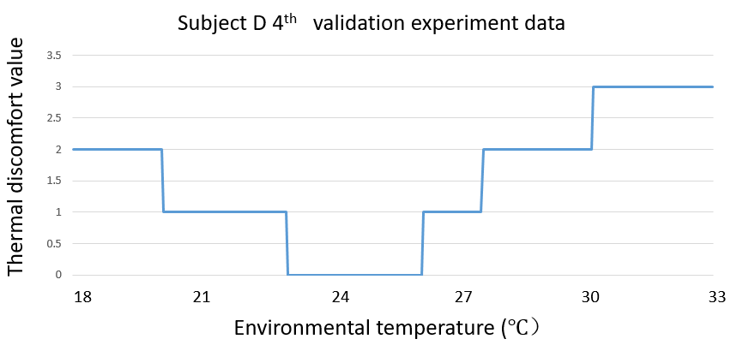

Figure 4.9 Subject D’s 4th validation experiment data

Comparing the four validation experiment results, each time, the subjects indicated a slightly different thermal preference (Fig.4.10). Even though the environmental condition was strictly controlled by staff and the temperature changing processes were almost the same in each validation experiment, there were some possible reasons that might have influenced the subjects’ thermal comfort. Those possible reasons are discussed in Chapter 5.

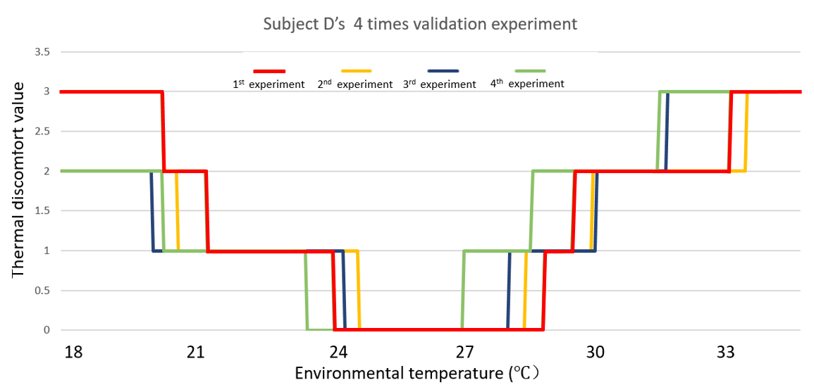

Figure 4.10 Subject D’s 4 times validation experiments’ data comparison

### 4.4.2. Multiple occupancy condition validation experiment data

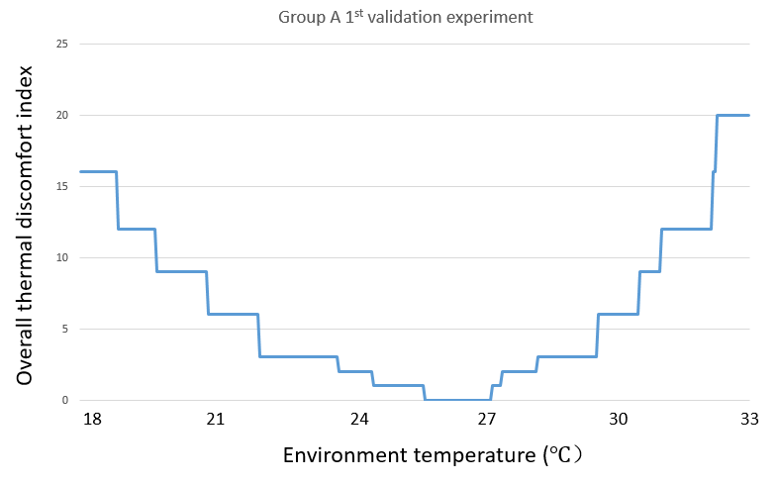In the multiple occupancy condition, 3 three-people groups participated in the thermal comfort experiment. The experiment process was similar to the single occupancy condition (SOC) experiment. The evaluation method of multiple occupancy conditions was different from the single occupancy. An Overall Thermal Discomfort (OTD) index (described in Chapter 3) was developed to evaluate the overall thermal comfort condition of multiple occupants. Group A’s validation experiment results are displayed in the following figures, which reflect the relationship between OTD index and environmental temperature.

Figure 4.11 Group A's 1st validation experiment

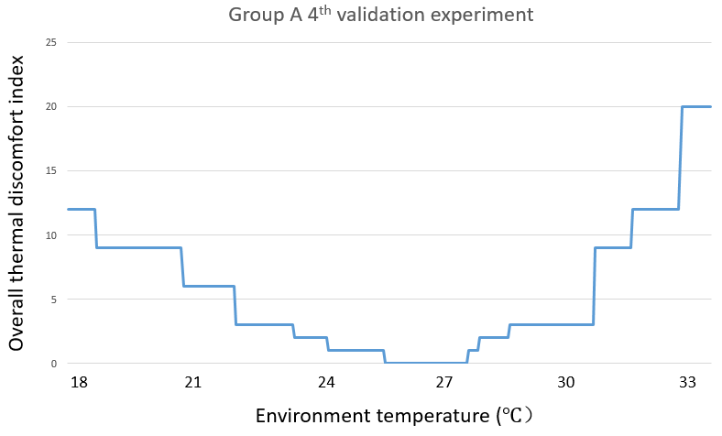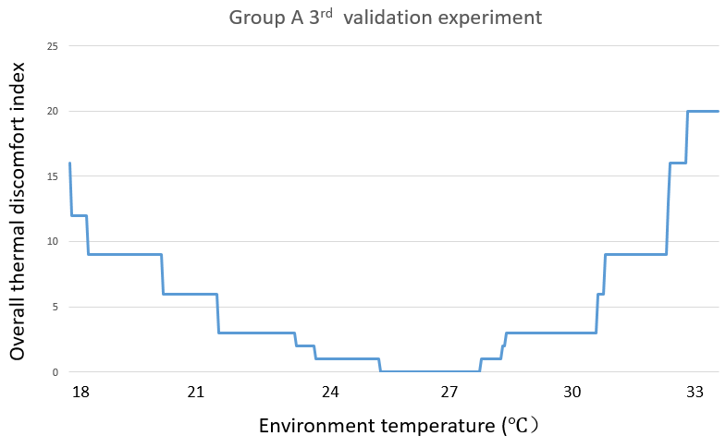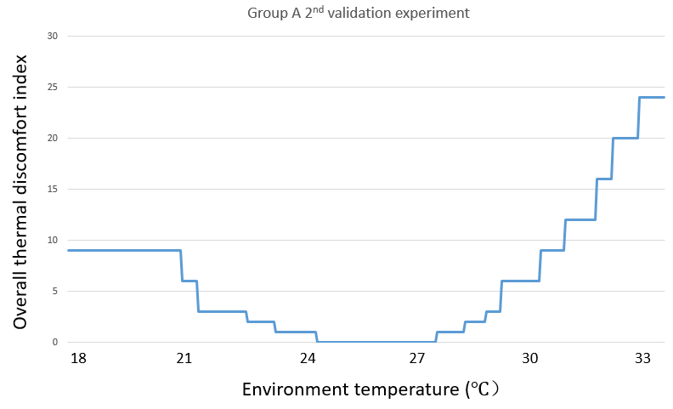

Figure 4.14 Group A's 4thvalidation experiment

Figure 4.13 Group A's 3rd validation experiment

Figure 4.12 Group A's 2nd validation experiment

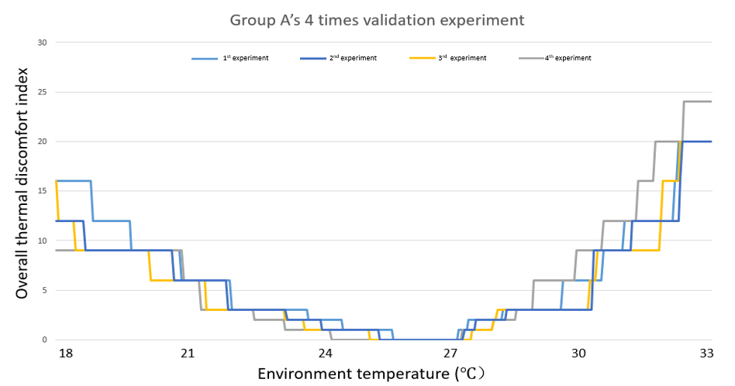Comparing the validation experiment data for all four times (Fig.4.15), the overall thermal preference slightly changed in each experiment. Some of the possible reasons will be discussed in Chapter 5.

Figure 4.15 Group A’s 4 times validation experiment data comparison

## 4.5. Industry recommended temperature range under environment chamber condition

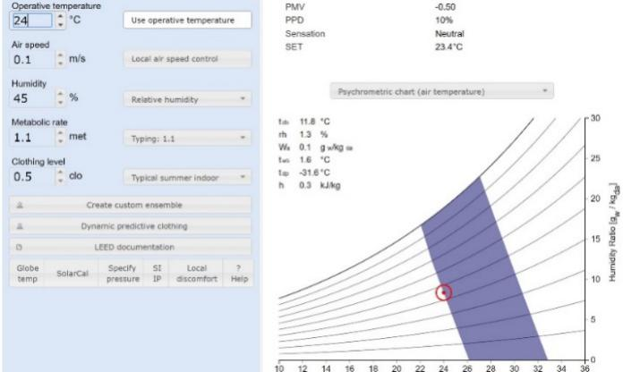CBE Thermal Comfort Tool (Fig.4.16), developed by University of California at Berkley, was used to calculated the environmental temperature under the experiment setting. The relative humidity was set to 45%, Metabolic rate was set to 1.1, Clothing level was set to 0.5clo, and air speed was set to 0.1m/s. The changing operative temperature, to find the boundary of thermal comfort requirement with 10% PPD, complied with ASHRAE Standard 55-2013. The temperature range was from 24℃ to 27 ℃.

Figure 4.16 CBE Thermal Comfort Tool

# **Chapter 5 Data Analysis**

## 5.1. Single occupancy condition Artificial Neural Network model

This model is based on the stepwise regression analysis of thermal comfort versus environment temperature, relative humidity (RH), and heart rate of occupants. The stepwise regression indicates that the R-sq. is 83.25% when considering environment temperature and relative humidity as factors of human thermal comfort. The heart rate factor has been ignored because of its little influence to human thermal comfort. Therefore, significant factors affecting the human thermal comfort are environment temperature and relative humidity. In this research, the artificial neural network model was changed based on the stepwise regression results (Fig.5.1).

Input:

* Environment temperature
* Relative humidity

Output:

* Thermal discomfort condition

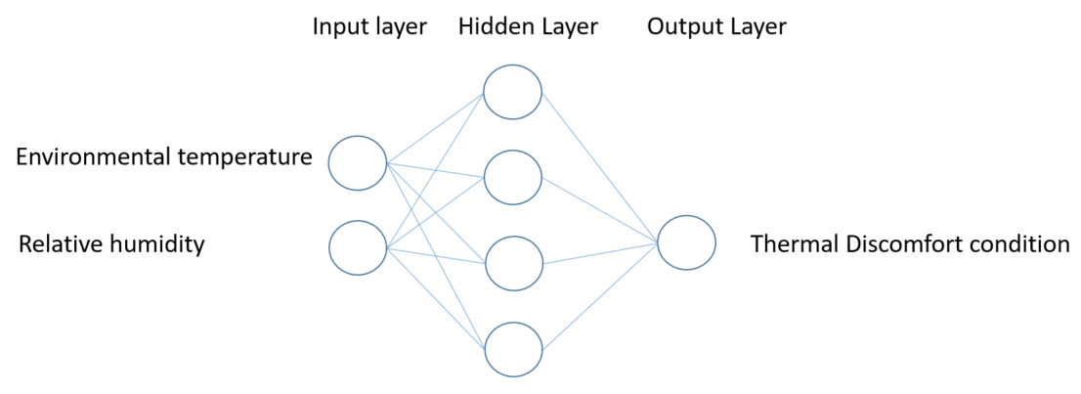In order to assure the architecture of the Artificial Neural Network, 10-fold cross validation was used to test the accuracy of different architecture ANN models. In this research, input layers have only two attributes, and the output layer has only one. Usually, one hidden layer was used for a simple task under supervised learning (Hansen et al, 1990). In this research, only one hidden layer was set in the ANN model, and different architecture models were tested using 10-cross validation. From the results of the 10-cross validation, the ANN model structure was determined with 4 nodes in the hidden layer.

Figure 5.1 Single occupancy condition ANN model architecture

Table5.1 Accuracy comparison among different ANNs’ architecture

|  |  |  |  |
| --- | --- | --- | --- |
| *Number of Nodes in Hidden layer* | *Correctly Classified Instances* | *Incorrectly Classified Instances* | *Accuracy* |
| *2* | 5741 | 2074 | 73.47% +/-3.29% |
| *3* | 6168 | 1647 | 78.93% +/- 6.20% |
| *4* | 6603 | 1212 | 84.50% +/- 1.80% |
| *5* | 6470 | 1345 | 82.79% +/- 1.69% |
| *6* | 6380 | 1435 | 81.65% +/- 1.19% |

### 5.1.1. SOC ANN model prediction

A Single Occupancy Condition (SOC) Artificial Neural Network (ANN) model was developed by each occupant’s thermal comfort experiment data. Totally, there were 21 ANN models developed for the single occupancy condition. Using these ANN models, the occupant’s thermal preferences were predicted by input prediction attributes, including environmental temperature and relative humidity. Five subjects’ thermal comfort preference predictions are displayed in the following figures, as examples. In these predictions, environment temperature increases from 18℃ to 32℃, which is the same range as the experiment. The relative humidity was set to 45%.

Fig.5.2 displays subject E’s thermal comfort preference prediction. This prediction reflects subject E’s thermal comfort condition under several different environmental temperature settings. The four different thermal comfort conditions and their corresponding temperature ranges are displayed in Table 5.2. The transparent red box is the ASHRAE-55 recommended temperature range under environment chamber condition, with 10% PPD.

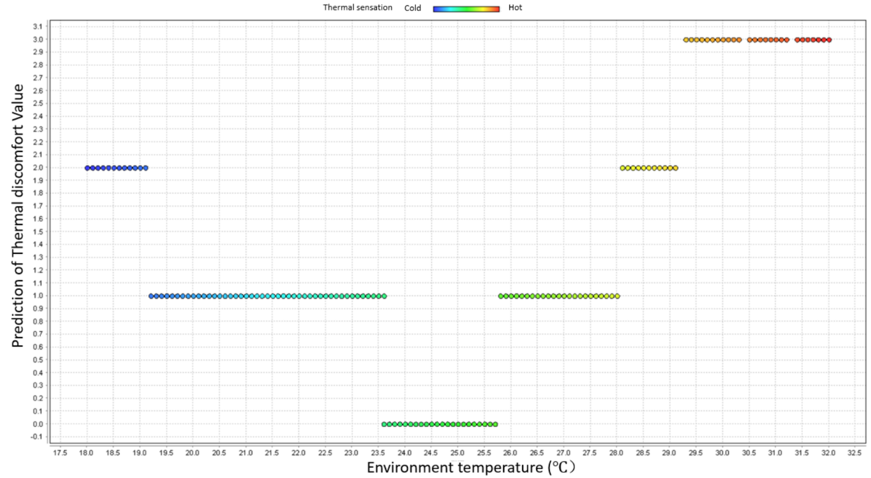Subject E’s thermal comfort preference prediction temperature range is significantly different with the PMV model’s recommended temperature range. In the PMV recommended range, some areas’ prediction is a slightly uncomfortable condition.

ASHRAE recommended temperature

Figure 5.2 Subject E’s thermal comfort preference prediction

Table.5.2 Subject E’s temperature range of different thermal comfort conditions

|  |  |  |  |  |
| --- | --- | --- | --- | --- |
| *Thermal discomfort* | *Comfortable* | *Slightly Uncomfortable* | *Uncomfortable* | *Very Uncomfortable* |
| *Temperature range (℃)* | 23.6 ~ 25.7 | 19.2 ~ 23.6；  25.7 ~ 28.1 | 18.0 ~ 19.1；  28.1 ~ 29.1 | 29.1 ~ 32.0 |

Fig.5.3 displays subject A’s thermal comfort preference, and Table 5.3 shows subject A’s different thermal comfort condition temperature range. Unlike subject E, subject A preferred cooler environmental temperatures.

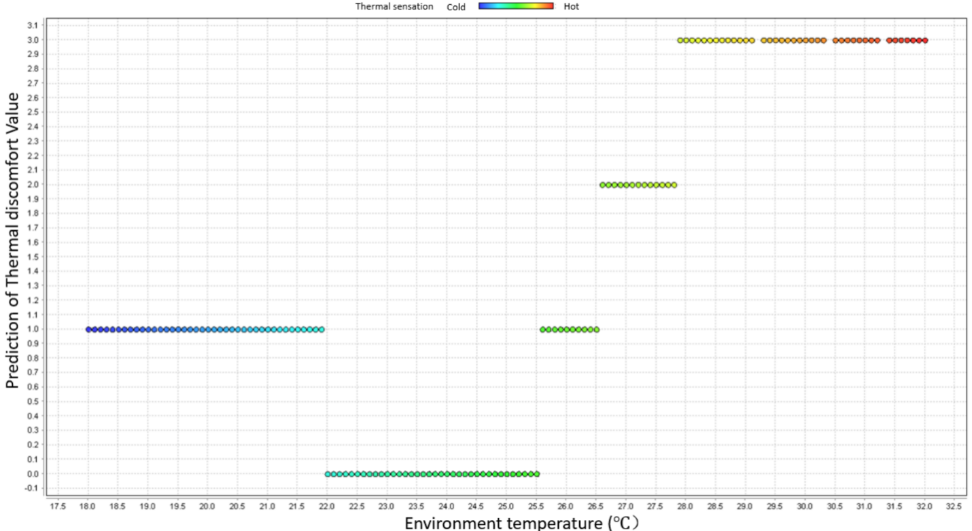Similar with subject E’s prediction, subject A’s thermal comfort preference prediction also is significantly different from the PMV model’s recommended temperature range.

Figure 5.3 Subject A’s thermal comfort preference prediction

Table.5.3 Subject A’s temperature range of different thermal comfort conditions

|  |  |  |  |  |
| --- | --- | --- | --- | --- |
| *Thermal discomfort* | *Comfortable* | *Slightly Uncomfortable* | *Uncomfortable* | *Very Uncomfortable* |
| *Temperature range (℃)* | 22.0 ~ 25.5 | 18.0 ~ 22.0；  25.5 ~ 26.5 | 26.5 ~ 27.8； | 27.8 ~ 32.0 |

Subject B’s thermal comfort preference and corresponding temperature range are displayed in Fig.5.4 and Table 5.4. From those three subjects’ prediction example, there are significant thermal preferences among occupants. The ANN model was based on individual experiment data and made the prediction for each individual.

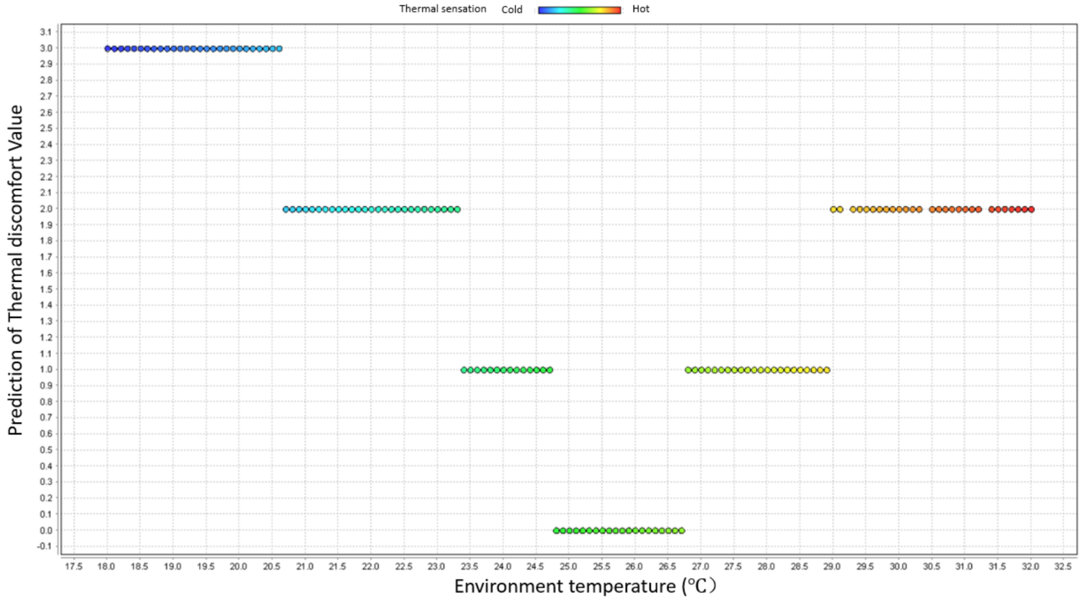Table.5.4 Subject B’s temperature range of different thermal comfort condition

Figure 5.4 Subject B’s thermal comfort preference prediction

|  |  |  |  |  |
| --- | --- | --- | --- | --- |
| *Thermal discomfort* | *Comfortable* | *Slightly Uncomfortable* | *Uncomfortable* | *Very Uncomfortable* |
| *Temperature range (℃)* | 24.7 ~ 26.7 | 23.4 ~ 24.7；  26.7 ~ 29.0 | 20.7 ~ 23.4；  29.0 ~ 32.0 | 18.0 ~ 20.7 |

### 5.1.2. SOC validation experiment results

In the SOC validation experiment, 5 subjects were selected to participate in order to validate the ANN prediction. Fig.5.5 shows Subject A’s validation experiment results.

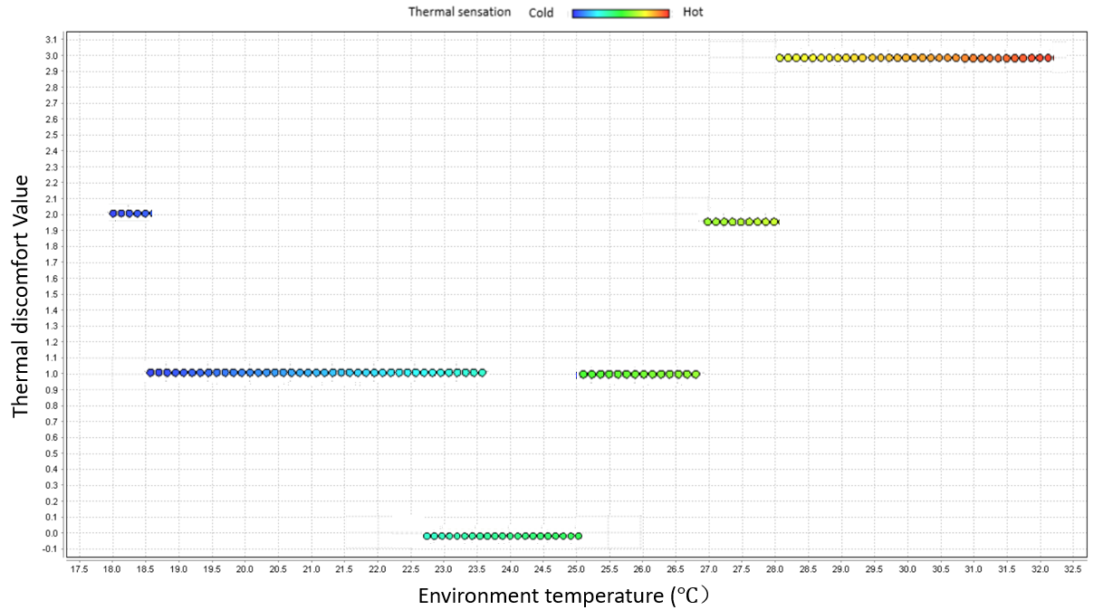

Figure 5.5 Subject A’s validation experiment results

Table 5.5 shows subject A’s temperature range of different thermal discomfort conditions.

Table.5.5 Subject A’s validation experiment temperature range results

|  |  |  |  |  |
| --- | --- | --- | --- | --- |
| *Thermal discomfort* | *Comfortable* | *Slightly Uncomfortable* | *Uncomfortable* | *Very Uncomfortable* |
| *Temperature range (℃)* | 22.7 ~ 25.0 | 18.5 ~ 22.7；  25.0 ~ 26.9 | 18.0 ~ 18.5；  26.9 ~ 28.0 | 28.0 ~ 32.0 |

Comparing the validation experiment results and SOC ANN model prediction, there were some differences seen between the two results. Fig.5.6 displayed both validation experiment results and ANN model prediction. The green color dots indicate the overlap data, which means these ANN predictions are correct. The blue dots show the validation experiment results that are different from the ANN predictions. The red dots are the results of the ANN predictions from Fig.5.6. A small difference occurred in almost every thermal discomfort condition.

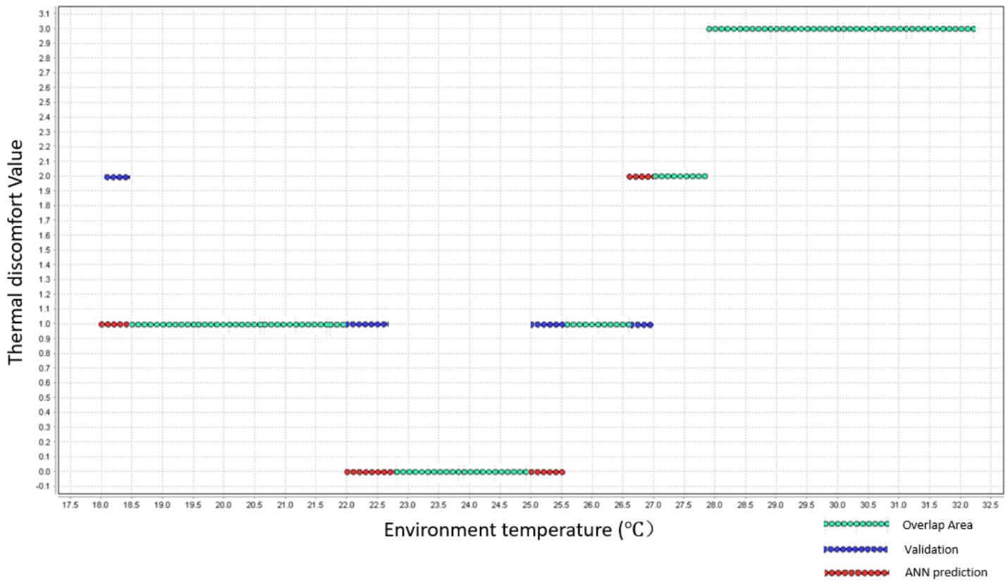Both the ANN prediction, and the validation experiment temperature range under different thermal comfort conditions, are displayed in Table 5.6. The maximum difference range boundary lying between the two results is 0.7℃, which occurred in comfortable and slightly uncomfortable condition predictions.

Figure 5.6 Validation experiment results and ANN model prediction

Table.5.6 Temperature range between validation experiment results and ANN model prediction

|  |  |  |  |  |
| --- | --- | --- | --- | --- |
| *Thermal discomfort* | *Comfortable* | *Slightly Uncomfortable* | *Uncomfortable* | *Very Uncomfortable* |
| *ANN prediction Temperature range (℃)* | 22.0 ~ 25.5 | 18.0 ~ 22.0；  25.5 ~ 26.5 | 26.5 ~ 27.8； | 27.8 ~ 32.0 |
| *Validation experiment Temperature range (℃)* | 22.7 ~ 25.0 | 18.5 ~ 22.7；  25.0 ~ 26.9 | 18.0 ~ 18.5；  26.9 ~ 28.0 | 28.0 ~ 32.0 |
| *Range boundary maximum difference (℃)* | 0.7 | 0.7 | 0.5 | 0.2 |

Ten-fold cross validation was used to calculate the accuracy of the ANN model by inputting both ANN model prediction data and validation experiment data. The accuracy of the ANN model prediction is 75.49% +/- 3.74%. Fig.5.7 shows the 10-fold cross validation results in Rapidminer software.

Table.5.7 ANN model 10-cross validation results

|  |  |  |  |  |  |
| --- | --- | --- | --- | --- | --- |
|  | *True Very Uncomfortable* | *True Uncomfortable* | *True Slightly Uncomfortable* | *True Comfortable* | *Class precision* |
| *Pred. Very Uncomfortable* | 87 | 23 | 0 | 0 | 79.09% |
| *Pred. Uncomfortable* | 63 | 172 | 27 | 2 | 65.15% |
| *Pred. Slightly Uncomfortable* | 0 | 8 | 109 | 6 | 88.62% |
| *Pred. Comfortable* | 0 | 4 | 41 | 168 | 78.87% |
| *Class recall* | 58.00% | 83.09% | 61.58% | 95.45% |  |

### 5.1.3. SOC ANN model improvement

From the validation experiment results, the ANN model prediction performance is not good enough. Based on the validation experiment results, two methods of ANN model improvement were proposed.

#### 5.1.3.1. Increasing training set

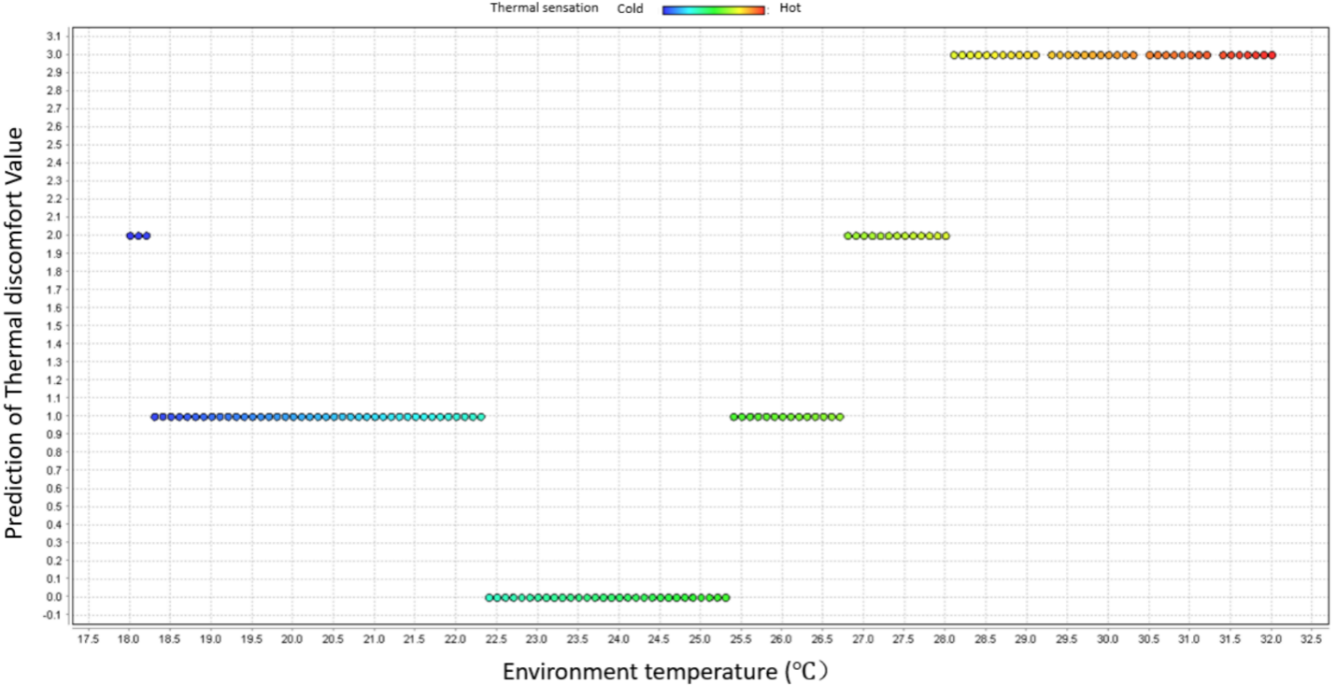One of the methods to increase the accuracy of an artificial neural network model is to increase the amount of training data. Therefore, a new training database was developed by integrating the SOC experiment data and the validation experiment data. Based on the new database information, a proposed new artificial neural network model was developed. A new prediction was generated by using a new ANN model (Fig.5.7).

Figure 5.7 Proposed new ANN model prediction

ASHRAE recommended temperature

The temperature range under different thermal discomfort conditions is displayed in Table 5.8.

Table.5.8 Temperature range of proposed new ANN model prediction

|  |  |  |  |  |
| --- | --- | --- | --- | --- |
| *Thermal discomfort* | *Comfortable* | *Slightly Uncomfortable* | *Uncomfortable* | *Very Uncomfortable* |
| *Temperature range (℃)* | 22.3 ~ 25.3 | 18.2 ~ 22.3；  25.2 ~ 26.7 | 18.0 ~ 18.2；  26.7 ~ 28.0 | 28.0 ~ 32.0 |

In order to test the prediction performance of the improved ANN model, a second round of validation experiments was conducted. Subject A was asked to attend the second round of the validation experiment. The second round of validation experiment is the same process as the first validation experiment. Comparing the improved ANN model prediction and the second round of validation experiment results, the performance was generated and is displayed in Fig.5.8.

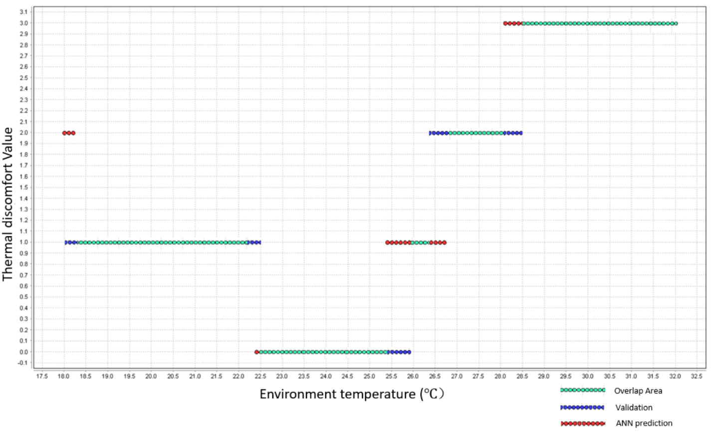From the comparison results, the proposed new ANN model has a slightly better performance than the previous ANN model. Both ANN predictions and validation experiment temperature range under different thermal comfort conditions are displayed in Table 5.9. The maximum difference range boundary lying between the two results is 0.6 ℃ and only occurred in comfortable condition prediction.

Figure 5.8 Comparison between ANN model prediction and validation experiment

Table.5.9 Temperature range of ANN model and validation experiment

|  |  |  |  |  |
| --- | --- | --- | --- | --- |
| *Thermal discomfort* | *Comfortable* | *Slightly Uncomfortable* | *Uncomfortable* | *Very Uncomfortable* |
| *New ANN prediction Temperature range (℃)* | 22.3 ~ 25.3 | 18.2 ~ 22.3；  25.2 ~ 26.7 | 18.0 ~ 18.2;  26.7 ~ 28.0； | 28.0 ~ 32.0 |
| *Validation experiment Temperature range (℃)* | 22.6 ~ 25.9 | 18.0 ~ 22.5；  25.0 ~ 26.3 | 26.3 ~ 28.5 | 28.5 ~ 32.0 |
| *Range boundary maximum difference (℃)* | 0.6 | 0.4 | 0.5 | 0.3 |

Ten-cross validation was also used to calculate the accuracy of the ANN model by inputting both proposed new ANN model prediction data and validation experiment data. The accuracy of the ANN model prediction is 78.23% +/- 4.77%. Fig.5.10 shows the 10-cross validation results in Rapidminer software.

Table.5.10. New ANN model’s 10-cross validation results

|  |  |  |  |  |  |
| --- | --- | --- | --- | --- | --- |
|  | *True Very Uncomfortable* | *True Uncomfortable* | *True Slightly Uncomfortable* | *True Comfortable* | *Class precision* |
| *Pred. Very Uncomfortable* | 150 | 28 | 0 | 0 | 84.27% |
| *Pred. Uncomfortable* | 59 | 219 | 35 | 0 | 69.97% |
| *Pred. Slightly Uncomfortable* | 5 | 38 | 232 | 23 | 77.85% |
| *Pred. Comfortable* | 0 | 0 | 44 | 232 | 84.05% |
| *Class recall* | 70.09% | 76.84% | 74.60% | 90.98% |  |

Accuracy: 78.23% +/- 4.77%.

Following this strategy, two more validation experiments were done for Subject A. The results of all the different training dataset size prediction accuracy are displayed in Table 5.11.

Table 5.11 ANN prediction accuracy of different training data size

|  |  |
| --- | --- |
| Training data size | ANN model prediction accuracy |
| 1st experiment (SOC experiment) | 75.46% +/- 3.74% |
| 2nd experiment (SOC experiment + 1st validation) | 78.23% +/- 4.77% |
| 3rd experiment (SOC experiment + 1st & 2nd validation | 79.58% +/- 3.48% |
| 4th experiment (SOC experiment + 1st, 2nd & 3rd validation, | 80.12% +/- 3.57% |

Fig.5.9 shows the tendency of accuracy changing by increasing the training dataset. After 4 experiments, there was no significant increase in accuracy by adding training dataset. Generally, the best accuracy of Subject A’s neural network model is 80.12% +/- 3.57%.

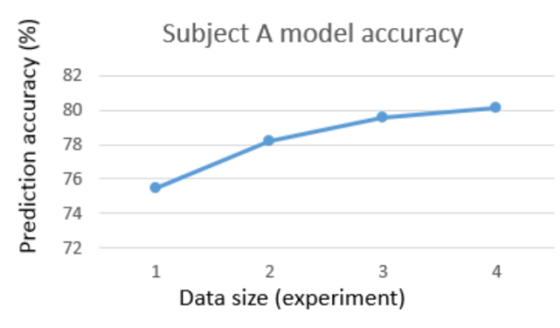All five subjects of the ANN model’s performance, trained by the 4 experiments’ data are displayed in Table 5.12. The accuracy range of ANN model prediction is 74.43% to 84.03%.

Figure 5.9 Tendency of ANN accuracy

Table.5.12 ANN accuracy of different training size

|  |  |  |  |  |  |
| --- | --- | --- | --- | --- | --- |
| *ANN Training data size* | *Subject A* | *Subject B* | *Subject C* | *Subject D* | *Subject E* |
| *1* | 75.46% +/- 3.74% | 66.65% +/- 5.65% | 73.13% +/- 1.95% | 69.65% +/- 4.33% | 71.09% +/- 5.03% |
| *2* | 78.23% +/- 4.77% | 70.32% +/- 6.62% | 77.23% +/- 3.29% | 73.25% +/- 4.01% | 76.32% +/- 4.86% |
| *3* | 79.58% +/- 3.48 | 73.01% +/- 4.95% | 82.9% +/- 1.98% | 75.96% +/- 3.30% | 78.02% +/- 3.96% |
| *4* | 80.12% +/- 3.57% | 74.43% +/- 2.93% | 84.03% +/- 2.01% | 77.02% +/- 3.01% | 78.39% +/- 3.50% |

#### 5.1.3.2. Simplifying the prediction output

Another method of improving the ANN model is simply the prediction output. There are 4 values of output that are Comfortable, Slightly Uncomfortable, Uncomfortable and Very Uncomfortable. One possible solution is combining the uncomfortable outputs. Considering 10% Predicted Percentage of Dissatisfied (PPD) is allowed as per the ASHRAE 55 standard, Comfortable and Slightly Uncomfortable are combined into Acceptable; Uncomfortable and Very Uncomfortable are combined into Unacceptable (Table 5.13). The reduction of prediction output options would not influence the building system design and control. The designer and facility manager only need to identify which temperature range is reasonable to maintain. There is no need to identify which temperature is uncomfortable or more uncomfortable to occupants, since an uncomfortable condition and its corresponding temperature are not allowed.

Table.5.13 New ANN model output options

|  |  |  |
| --- | --- | --- |
| *Thermal discomfort condition* | *Acceptability* | *Evaluation score* |
| *Comfortable* | Acceptable | 0 |
| *Slightly Uncomfortable* |
| *Uncomfortable* | Unacceptable | 1 |
| *Very Uncomfortable* |

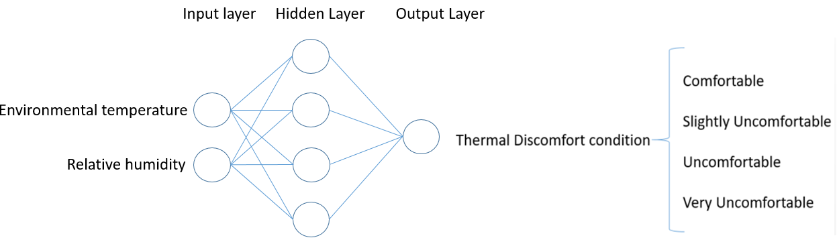The architecture of the ANN model was also changed, based on new classification of output options (Fig.5.10 and Fig.5.11).

Figure 5.11 New SOC-ANN architecture

Figure 5.10 Previous SOC-ANN architecture

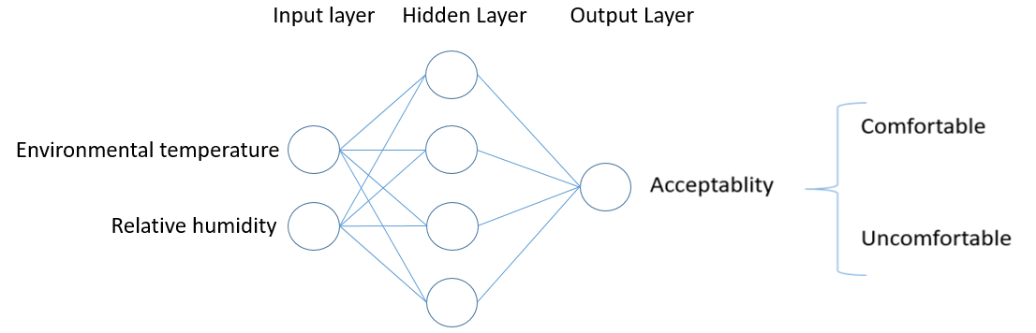The same strategy with previous SOC ANN model, experiment data, and validation experiment data were used to training the model as well as testing the performance of the ANN model prediction accuracy. Fig.5.12 shows the thermal comfort acceptability prediction.

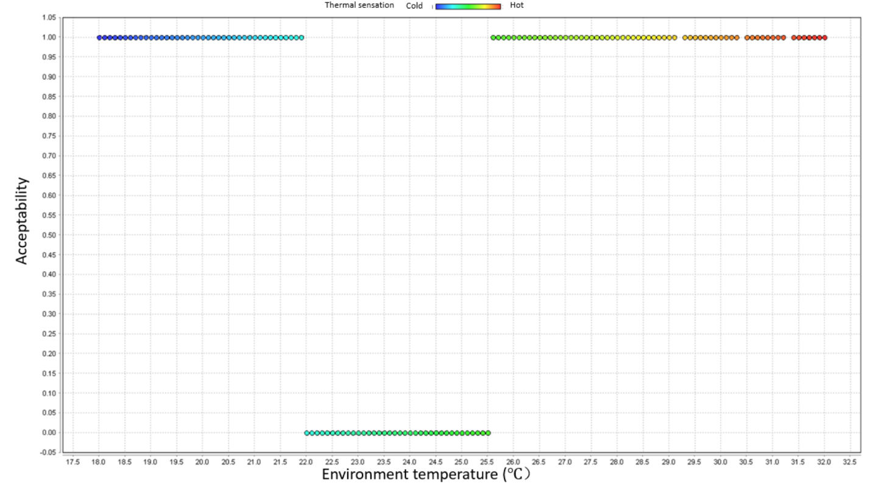

Figure 5.12 Prediction of new ANN model

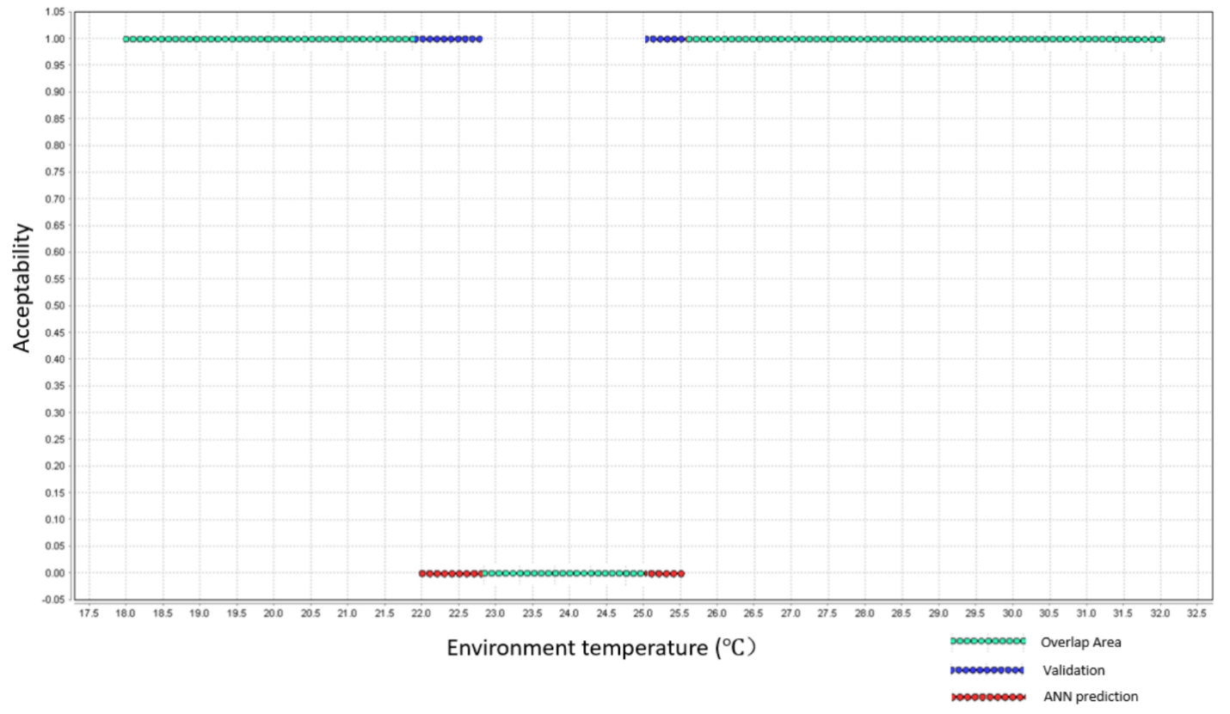Similarly, validation experiment data was compared with the ANN model prediction. Fig.5.13 shows the comparison results. The green colored dots indicate the overlap data, which means

Figure 5.13 Comparison between validation data and new ANN model prediction

these ANN predictions are correct. The blue dots show the validation experiment results that are different with the ANN prediction. The red dots are the results of the ANN prediction.

The temperature range of acceptable or unacceptable condition is shown in Table 5.14. The largest difference of acceptable condition range boundary is 0.7℃, and the largest difference of unacceptable condition range boundary is 0.7℃. Considering the minimum thermal sensation of human beings is 0.5℃ (Hoyt et al, 2015). the ANN prediction results are acceptable.

Table.5.14 Temperature range of ANN model and validation experiment

|  |  |  |
| --- | --- | --- |
| *Thermal discomfort* | *Acceptable* | *Unacceptable* |
| *ANN prediction Temperature range (℃)* | 22.0 ~ 25.5 | 18.0 ~ 22.0;  26.5 ~ 32.0 |
| *Validation experiment Temperature range (℃)* | 22.7 ~ 25.0 | 18.0 ~ 22.7；  26.9 ~ 32.0 |
| *Range boundary maximum difference (℃)* | 0.7 | 0.7 |

Ten-cross validation was used to check the accuracy of the prediction, and the results of the calculations from Rapidminer are displayed in Table.5.15. The accuracy is 83.85% +/- 3.60%. The new ANN model accuracy (83.85%) increased by 8.39% from the previous ANN model. The improvement by reducing the prediction output method is significant.

Table.5.15 10-cross validation result of new ANN model

|  |  |  |  |  |  |
| --- | --- | --- | --- | --- | --- |
|  | *True Very Uncomfortable* | *True Uncomfortable* | *True Slightly Uncomfortable* | *True Comfortable* | *Class precision* |
| *Pred. Very Uncomfortable* | 162 | 16 | 0 | 0 | 91.01% |
| *Pred. Uncomfortable* | 40 | 244 | 29 | 0 | 77.96% |
| *Pred. Slightly Uncomfortable* | 12 | 25 | 246 | 14 | 88.17% |
| *Pred. Comfortable* | 0 | 0 | 46 | 241 | 87.00% |
| *Class recall* | 75.70% | 85.61% | 79.10% | 94.51% |  |

Accuracy: 83.85%+/- 3.60%.

Table 5.16 shows all the results of the new ANN model prediction accuracy by using the SOC experiment data and the validation experiment data. After inputting experiment data 4 times as training data, subject A’s ANN model accuracy increased from 83.85% to 86.15%. The SOC ANN model accuracy ranges from 82.84% to 86.41%. The ANN model accuracy varies from the individual’s specific condition. The accuracy is good enough, considering human beings’ thermal sensation mistakes.

Table.5.16 New ANN model accuracy of different training data size

|  |  |  |  |  |  |
| --- | --- | --- | --- | --- | --- |
| *ANN Training data size* | *Subject A* | *Subject B* | *Subject C* | *Subject D* | *Subject E* |
| *1* | 83.85% +/- 3.60% | 79.37% +/- 4.49% | 81.85% +/- 2.68% | 83.31% +/- 3.43% | 84.32% +/- 2.35% |
| *2* | 85.32% +/- 4.31% | 81.63% +/- 3.46% | 83.14% +/- 2.29% | 84.66% +/- 2.02% | 85.13% +/- 3.00% |
| *3* | 86.10% +/- 3.03% | 82.15% +/- 3.48% | 83.19% +/- 2.04% | 85.00% +/- 1.30% | 86.30% +/- 1.69% |
| *4* | 86.15% +/- 3.17% | 82.84% +/- 2.36% | 84.03% +/- 1.14% | 85.12% +/- 1.01% | 86.41% +/- 1.50% |

### 5.1.4. Single occupancy condition summary

In the Single Occupancy Condition (SOC) ANN model development, two improvement methods were used to increase the ANN model’s prediction accuracy. Subject A’s ANN model’s prediction accuracy was improved from 75.49% to 86.15%, a total increase of 10.66%. As for all 5 subjects’ ANN model accuracy, the final ANN model prediction accuracy is above 80% (minimum is 82.84%). As per the results of the validation experiments, the performance of the ANN model was proven (with over 80% accuracy). The reduction of the ANN output options’ improvement method can be used for this research purpose. The goal of this research is to find the optimal design temperature range and assist the designer or manager to operate the building system more reasonably. There is no need to determine which temperature range is uncomfortable or more uncomfortable. Combining the uncomfortable output options made the ANN model work simpler, which contributes to the increasing of prediction accuracy.

## 5.2. Multiple occupancy condition Artificial Neural Network model

In the multiple occupancy condition, OTD index rather than thermal discomfort value, was used to evaluate the overall thermal discomfort condition of the zone. Therefore, the ANN model of MOC Artificial Neural Network model’s architecture is different with SOM Artificial Neural Network model. The MOC artificial neural network architecture is displayed in Fig.5.14.

Input:

* Environment temperature
* Relative humidity

Output:

* Overall Thermal Discomfort (OTD) index

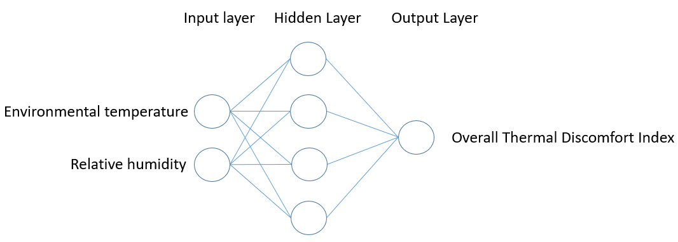

Figure 5.14 MOC-ANN model architecture

Similar with SOC neural network model, 10-cross validation was used to test the different architecture models’ accuracy. Table 5.17 shows that the results of 10-cross validation, and the 4 nodes in the hidden layer is the optimal setting. The best performance among different ANN architecture is 50.41% accuracy and occurs in the architecture with 4 nodes in the hidden layer. Therefore, in MOC ANN model development, a 4-node hidden layer was set as the architecture of MOC ANN model.

Table.5.17 MOC-ANN model accuracy of different architecture

|  |  |  |  |
| --- | --- | --- | --- |
| *Number of Node in Hidden layer* | *Correctly Classified Instances* | *Incorrectly Classified Instances* | *Accuracy* |
| *2* | 2513 | 5302 | 32.16% +/- 9.92% |
| *3* | 3613 | 4202 | 46.24% +/- 6.55% |
| *4* | 3939 | 3876 | 50.41% +/- 4.92% |
| *5* | 3888 | 3927 | 49.75% +/- 7.77% |
| *6* | 3752 | 4063 | 48.01% +/- 8.29% |

### 5.2.1. MOC ANN model performance

Multiple Occupancy Condition (MOC) Artificial Neural Network (ANN) model was developed based on the architecture with 4-node hidden layer. The MOC ANN model was trained with each group’s individual thermal comfort data. For example, Group A consisted of Subject A, Subject B and Subject C. Further, group A’s MOC ANN model was trained by group A’s data which included subject A, subject B, and subject C’s individual thermal comfort experiment data. Using the MOC ANN model, the group’s overall thermal discomfort condition was predicted by inputting environment temperature and relative humidity. Similarly, with the SOC ANN model’s development process, the environment temperature increased from 18℃ to 32℃, and relative humidity was set to 45%. Fig.5.15 shows group A’s MOC ANN model prediction. The color represents the occupants’ thermal sensation under different environmental conditions. Blue is cold thermal sensation while Red is hot sensation. Group B and Group C’s MOC ANN 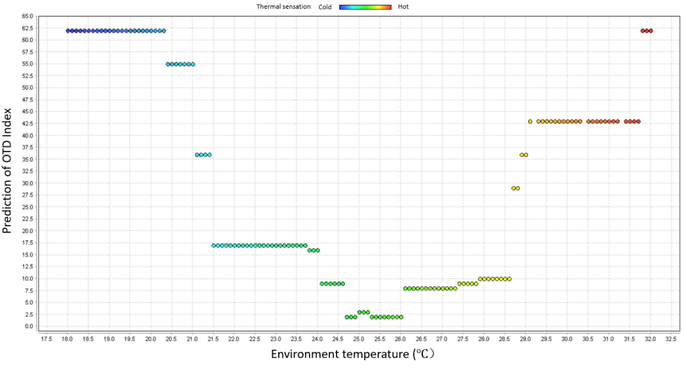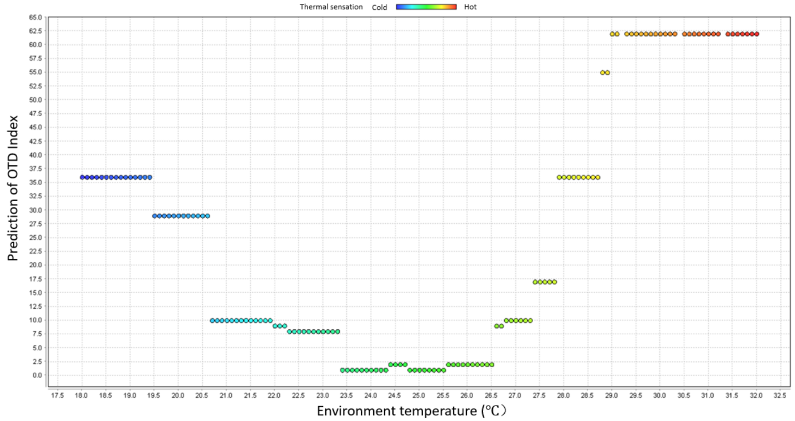prediction are displayed in Fig.5.16 and Fig.5.17.

Figure 5.16 Group B MOC-ANN model prediction

Figure 5.15 Group A MOC-ANN model prediction

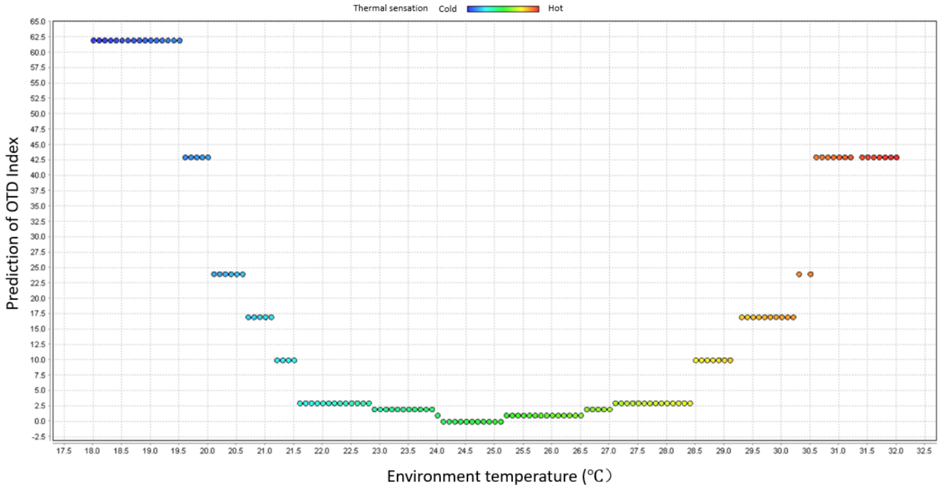From the MOC-ANN prediction of the three groups, it is obvious that different groups have different thermal preferences. Because of the inconsistency of the different subjects, the overall thermal comfort preference of each group is varied.

Figure 5.17 Group C MOC-ANN model prediction

### 5.2.2. MOC validation experiment results

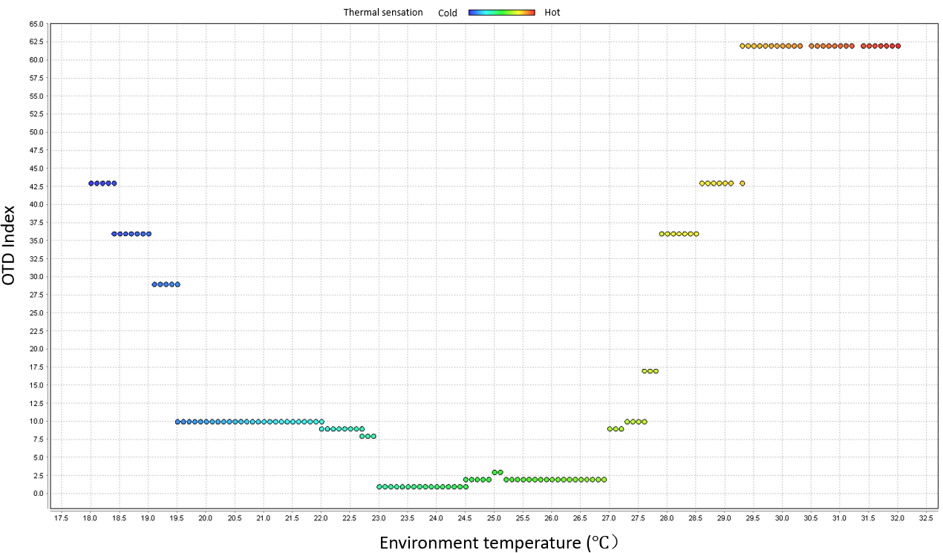In the multiple occupancy condition validation experiments, each group was asked to attend the thermal comfort experiment. All three people in the group were asked to participate in the thermal comfort experiment together, and the experiment process is similar with the SOC validation experiment. The results of group A’s validation experiment results are displayed in Fig.5.18.

Figure 5.18 Group A Validation Experiment result

Fig.5.19 compares the difference between the MOC-ANN model prediction and the validation experiment results. As each individual’s thermal preference varies slightly in each experiment, the overall thermal preference prediction didn’t have a good performance. The green dots represent the overlap area between the MOC-ANN prediction and the validation experiments. The blue dots indicate the validation experiment data and red is the prediction data.

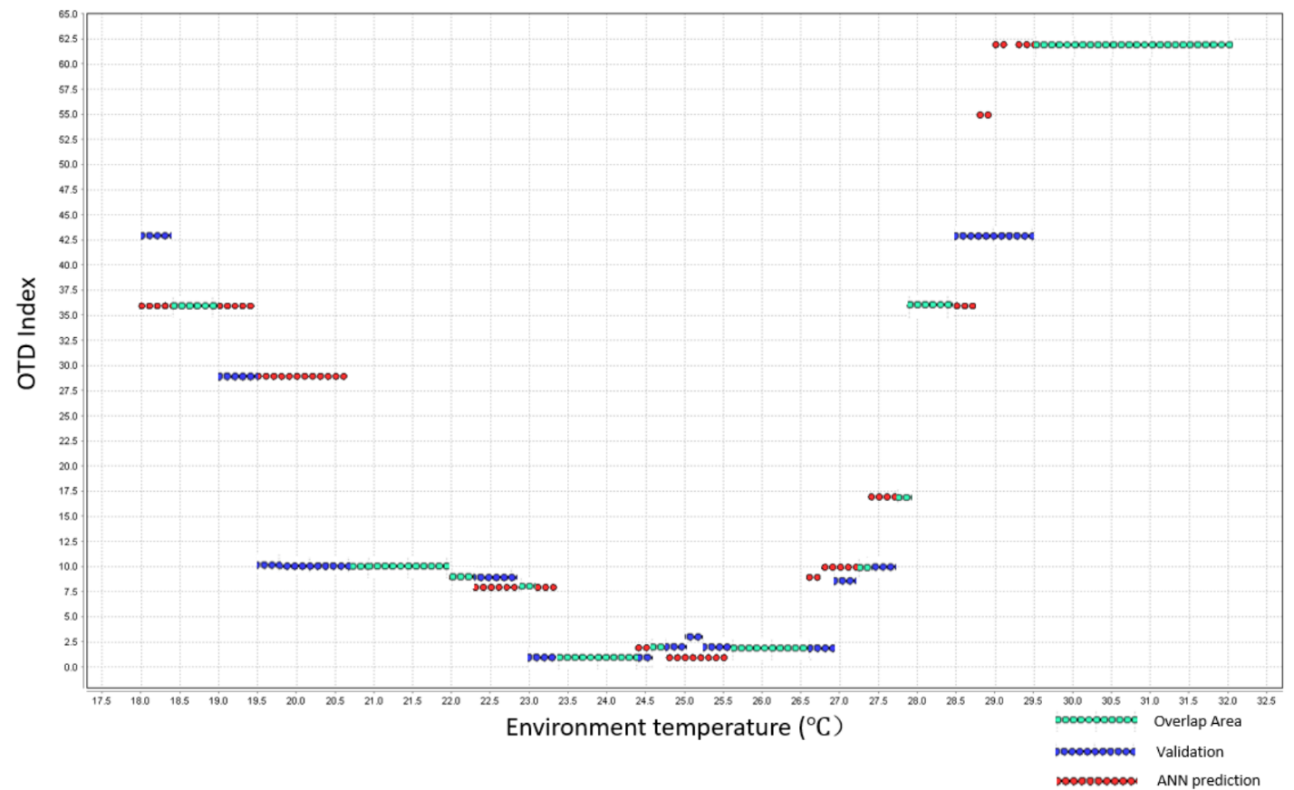Similarly, with the SOC-ANN model development strategy, more validation experiment data were input the MOC-ANN model. In order to test different training set size, and the ANN model’s prediction accuracy, 10-fold cross validation was used to calculate the accuracy. The results of 10-cross validation are displayed in Table 5.18.

Figure 5.19 Comparison between prediction and validation experiment result

Table.5.18 MOC-ANN model accuracy of different training data size

|  |  |  |  |
| --- | --- | --- | --- |
| *Training set size (experiment)* | *Correctly Classified Instances* | *Incorrectly Classified Instances* | *Accuracy* |
| *1* | 242 | 238 | 50.41% +/- 4.92% |
| *2* | 571 | 389 | 59.53% +/- 5.80% |
| *3* | 965 | 475 | 67.00% +/- 4.41% |
| *4* | 1366 | 554 | 71.15% +/- 5.15% |
| *5* | 1757 | 643 | 73.22% +/- 4.85% |

The tendency curve of different training set size and its corresponding prediction accuracy are displayed in Fig.5.20.

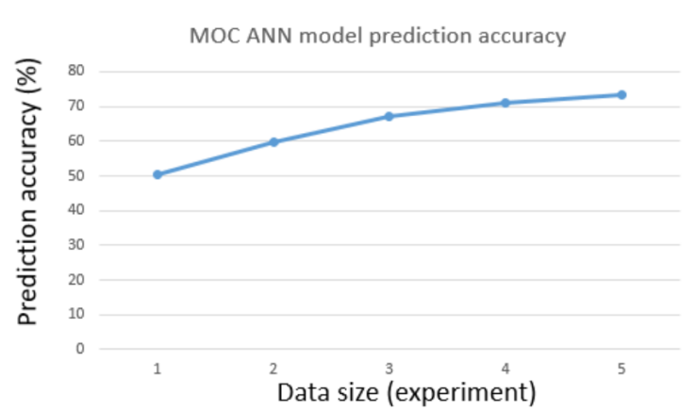The total results of the MOC ANN model prediction accuracy are displayed in Table 5.19. The best performance is Group A’s MOC-ANN model with an accuracy of 73.22%. Generally, the performance of the MOC-ANN model is not good enough since the accuracy is around 59% to 73%. Further improvement of MOC-ANN model is, therefore, necessary.

Figure 5.20 MOC-ANN model accuracy with different training data size

Table.5.19 Results of MOC ANN model prediction accuracy

|  |  |  |  |
| --- | --- | --- | --- |
| *ANN model Training data size* | *Group A* | *Group B* | *Group C* |
| *1* | 50.41% +/- 4.92% | 47.27% +/- 5.45% | 56.23% +/- 4.58% |
| *2* | 59.53% +/- 5.80% | 49.13% +/- 6.62% | 61.63% +/- 4.29% |
| *3* | 67.00% +/- 4.41% | 56.53% +/- 4.38% | 63.32% +/- 4.63% |
| *4* | 71.15% +/- 5.15% | 58.12% +/- 4.54% | 64.10% +/- 3.86% |
| *5* | 73.22% +/- 4.85% | 59.33% +/- 3.13% | 64.99% +/- 3.50% |

### 5.2.3. MOC ANN model improvement

After adding 5 times experiment data, the accuracy of the MOC ANN model is still not good enough. Therefore, simplification of prediction output was used to improve the prediction accuracy. Similar to the SOC ANN model improvement method, the output of the ANN model was divided into acceptable condition and unacceptable condition. OTDmax was used to define the boundary OTD index value into acceptable condition and unacceptable condition. In Chapter 3, the OTD evaluation scores’ calculation was described in detail.

Table.5.20 New ANN output options

|  |  |
| --- | --- |
| Overall thermal comfort acceptability | OTD Index value decision boundary |
| Acceptable | 0 ≤ OTD ≤ OTD max |
| Unacceptable | OTD > OTD max |

OTD = ∑ Evaluation score of occupants

OTD max = (N-A)\*1 + A \* (N+1)

A – Number of occupants allowed to be uncomfortable

TD – Overall thermal discomfort index

OTD max – Max allowed overall thermal discomfort index

In the MOC experiment setting, N = the number of occupants = 3. No one is allowed to be uncomfortable, hence A = 0. Therefore, OTD max = (N-A)\*1 + A \* (N+1) = (4-0)\*1 + 0\* (4+1) = 4. Therefore, acceptable condition is 0 ≤ OTD ≤ 4; Unacceptable condition is OTD > 4.

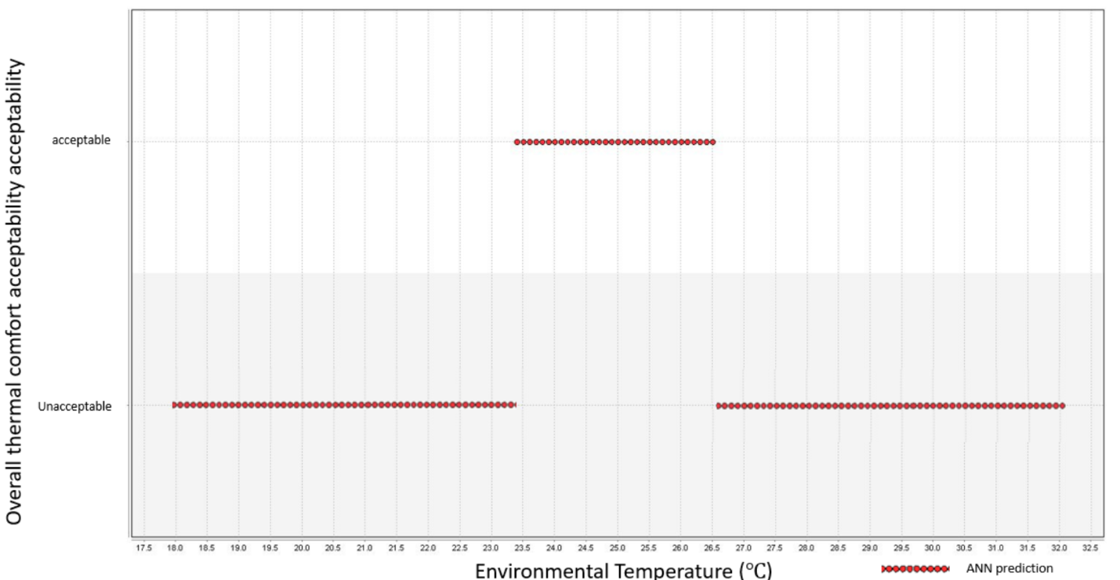After reducing the output option of the MOC-ANN model, the new prediction of group A’s overall thermal discomfort acceptability was generated by the new MOC-ANN model (Fig.5.21).

Figure 5.21 New ANN Model prediction

Validation experiment data was used to test the performance of the new MOC-ANN model. Fig.5.22 shows the comparison between validation experiment results and the MOC-ANN model prediction. The same was done with the previous MOC-ANN prediction image; the green, red and blue colors represent the overlap area, validation data, and ANN prediction data, 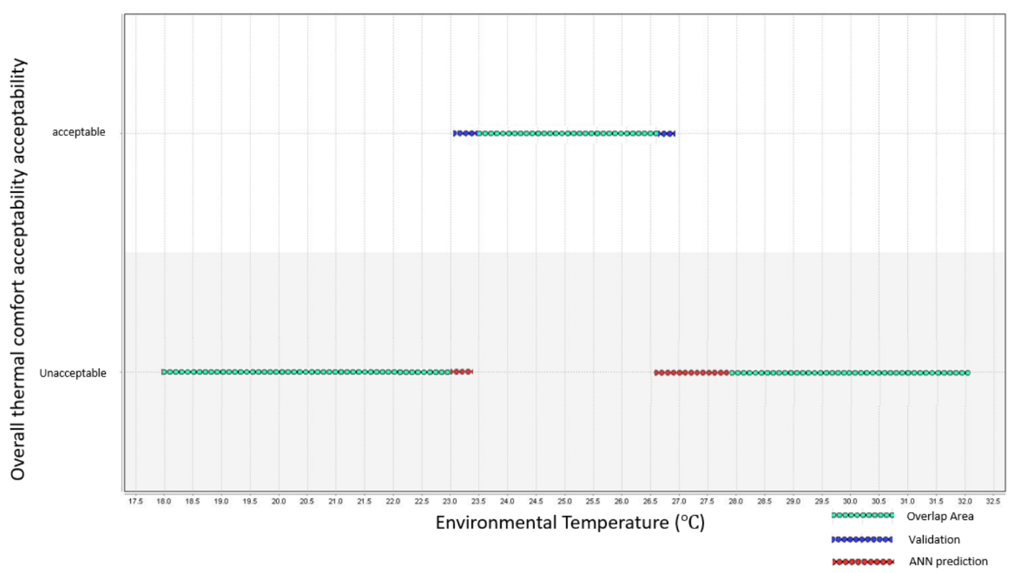respectively.

Figure 5.22 Comparison of validation experiment data and new MOC-ANN model prediction

Like done with the previous MOC-ANN model, 10-cross validation was used to test the accuracy of different training data size models and their accuracy. The results are displayed in Table 5.21.

Table.5.21 Results of 10-cross validation

|  |  |  |  |
| --- | --- | --- | --- |
| *ANN model Training data size* | *Group A* | *Group B* | *Group C* |
| *1* | 83.56% +/- 2.92% | 82.96% +/- 3.55% | 84.63% +/- 2.50% |
| *2* | 84.93% +/- 1.80% | 82.84% +/- 2.23% | 85.96% +/- 1.94% |
| *3* | 85.13% +/- 1.68% | 83.65% +/- 2.38% | 85.82% +/- 1.60% |
| *4* | 85.30% +/- 1.51% | 84.68% +/- 1.69% | 86.65% +/- 1.36% |
| *5* | 85.36% +/- 1.35% | 84.77% +/- 1.11% | 87.06% +/- 1.05% |

### 5.2.4. Multiple occupancy condition summary

The multiple occupancy condition ANN model development is more difficult than the SOC-ANN model, because each individual’s thermal preference varies, and their thermal sensation varies in different environmental conditions. The unstable factors of each subject were accumulated in multiple occupancy condition ANN predictions, which makes the accuracy lower than the SOC-ANN model. However, by reducing and combining the output options, which is the same strategy in SOC-ANN model development, MOC-ANN model’s performance was significantly improved. The group A’s MOC-ANN prediction accuracy was improved from 50.41% to 85.30%, with both adding the training dataset and reducing the output options methods. Generally, the performance of the MOC-ANN models of group A (accuracy 85.36%), group B (accuracy 84.77%) and group C (accuracy 87.06%) were excellent after adding 5 times experiment data and reducing the output options.

## 5.3 Performance comparison between the data-driven approach and industry standard

The performance of the data-driven approach for human-based environmental controls was compared with the PMV model, which determines most building system industry standards such as ASHRAE 55.

### 5.3.1. Single occupancy condition

In the single occupancy condition, ASHRAE 55-2013 recommends that the environment temperature setting is from 24℃ to 27℃, no matter what the occupant’s individual condition is. Conversely, the SOC-ANN model generates the recommended environment temperature based on the individual’s historic thermal preference data. Subject A was taken as an example to display the difference between the ASHRAE Standard’s recommended temperature and the SOC-ANN prediction design temperature (Fig.5.23). The red highlighted area is the ASHRAE 55 recommended temperature range, and the blue highlighted area is the prediction temperature range of the SOC-ANN model.

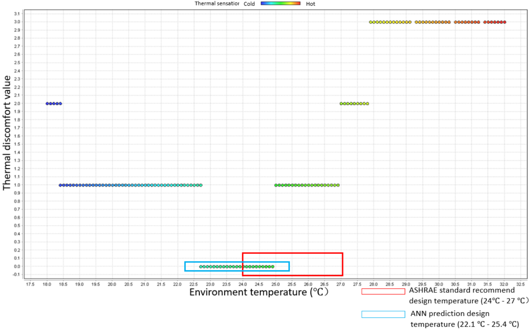

Figure 5.23 Comparison of ASHRAE Standard (PMV based) and ANN prediction

From Fig.5.23, it is obvious that the red area is a mismatch for a large part of the occupant’s thermal preference temperature, while the blue area covers the occupant’s thermal preference temperature. The same comparison was done for the five subjects (A, B, C, D, and E). The results of the comfort range are displayed in Table 5.22.

Table.5.22 Temperature range of PMV model and ANN model

|  |  |  |  |
| --- | --- | --- | --- |
| *Subject* | *Validation experiment comfort range (℃)* | *PMV calculated thermal comfort temperature range (℃)* | *ANN prediction temperature range (℃)* |
| *Subject A* | 22.7 ~ 25.0 | 24 - 27 | 22.1 ~ 25.4 |
| *Subject B* | 24.7 ~ 26.7 | 24.3 ~ 26.9 |
| *Subject C* | 23.0 ~ 27.5 | 23.3 ~ 27.6 |
| *Subject D* | 21.5 ~ 26.3 | 21.0 ~ 26.7 |
| *Subject E* | 25.6 ~ 27.9 | 25.4 ~ 27.6 |

The SOC-ANN model has different prediction temperature ranges for different subjects while ASHRAE standards recommend a constant range (24℃ to 27℃) for all subjects. The performance of these two types of recommended temperature ranges were compared from both, the thermal comfort aspect and the energy saving aspect.

For the thermal comfort aspect, the validation experiment data was used as the correct thermal comfort preference data. Comparing the temperature range with correct temperature range, the subject’s thermal comfort condition can be decided by considering each temperature and its corresponding correct thermal preference data. For example, subject A’s actual comfort range is from 22.7℃ to 25℃. When the environmental temperature is within this range, the subject’s thermal comfort condition can be considered as comfortable. The thermal comfort probability was calculated by using the following formula:

Thermal comfort probability = range of overlap temperature / recommended temperature range

For Subject A:

PMV Thermal comfort probability = (25.0 – 24.0) / (27.0 – 24.0) = 33.33%

ANN Thermal comfort probability = (25.0 - 22.7) / (25.4 - 22.1) = 70.0%

As for the energy saving aspect, a lower set-point temperature in winter and a higher set-point temperature in summer have a significant energy saving effect. A 1℃ difference has a potential energy saving range from 10% to 15% (Hoyt et al, 2015). Following this strategy, a lower boundary temperature was set as the winter design temperature while a higher boundary temperature was set as the summer design temperature. The potential energy saving was calculated by temperature difference, times 15%.

Summer energy saving = High boundary temperature difference \* 15%

High boundary temperature difference = High boundary temperature of ANN - High boundary temperature of PMV. Positive value means the ANN model is more energy saving, while negative value means the PMV model is more energy saving.

Winter energy saving = Low boundary temperature difference \* 15%

Low boundary temperature difference = Low boundary temperature of ANN – Low boundary temperature of PMV. Positive value means the ANN model is more energy saving while negative value means the PMV model is more energy saving.

The results of the 5 subjects’ energy saving and thermal comfort performance is displayed in Table 5.23.

Table.5.23. 5 Subject-wise results of PMV model and ANN model

|  |  |  |  |  |  |  |
| --- | --- | --- | --- | --- | --- | --- |
| *Subject* | *PMV Thermal comfort probability* | *ANN Thermal comfort probability* | *High boundary difference (ANN-PMV) (℃)* | *Summer Potential energy saving* | *Low boundary difference (PMV-ANN) (℃)* | *Winter Potential energy saving* |
| *Subject A* | 33.3% | 70.0% | -1.6 | - 24% | 1.9 | 28.5% |
| *Subject B* | 66.6% | 77.8% | -0.1 | -1.5% | -0.3 | -4.5% |
| *Subject C* | 100% | 98.7% | 0.6 | 9% | 0.7 | 10.5% |
| *Subject D* | 76.7% | 86% | -0.3 | -4.5% | 3 | 45% |
| *Subject E* | 46.7% | 91.0% | 0.6 | 9% | -1.4 | -21% |
| *Average* | 64.7% | 84.7% | -0.16 | -2.4% | 0.78 | 11.7% |
| *Max Delta* | 44.3% | | -1.6 | -24% | 3 | 45% |

As per the results seen in Table 5.19, two conclusions can be made. The PMV model thermal comfort probability is less precise when compared with the ANN thermal comfort probability. The PMV model thermal comfort probability varies from 33.3% to 100% based on different subjects while the ANN model thermal comfort probability varies from 70% to 98.7%. The ANN model prediction successfully maintains an acceptable thermal comfort level for different subjects’ conditions. The average thermal comfort probability of the PMV model is 64.7% while that of the ANN model is 84.7%. Therefore, the ANN Model demonstrates better performance than the PMV model in thermal comfort aspect in this research setting.

In terms of the energy-saving aspect, the PMV model demonstrates better performance in summer while the ANN model performs better in winter. However, the PMV model sacrifices the occupant’s thermal comfort for a better energy performance. Taking subject A as an example, even though in summer, the PMV model has a 24% higher energy saving performance, the thermal comfort probability is only 33.3%. Similar condition occurred in subject E. The principle of the thermal environmental control is to save energy while maintaining an acceptable or comfortable thermal condition. The ANN model demonstrated good energy performance in subject A’s winter season and subject D’s winter season while maintaining a thermal comfort probability of 70% and 91% respectively.

Considering the principle of thermal environment control, the ANN model demonstrates better performance than the PMV model in single occupancy condition.

### 5.3.2. Multiple occupancy condition

Apropos the single occupancy condition, both energy saving and thermal comfort aspects were compared in multiple occupancy condition. The PMV model has the same recommended temperature range in multiple occupancy condition; that is, from 24℃ to 27℃. The ANN model generated the recommend temperature range based on all occupants’ thermal comfort preference in one HVAC zone. Group B was taken as an example, and the validation experiment data of group B was used as the actual thermal comfort preference data. Fig.5.24 displays the comparison of the PMV model and the ANN model recommended temperature ranges and their corresponding OTD indices.

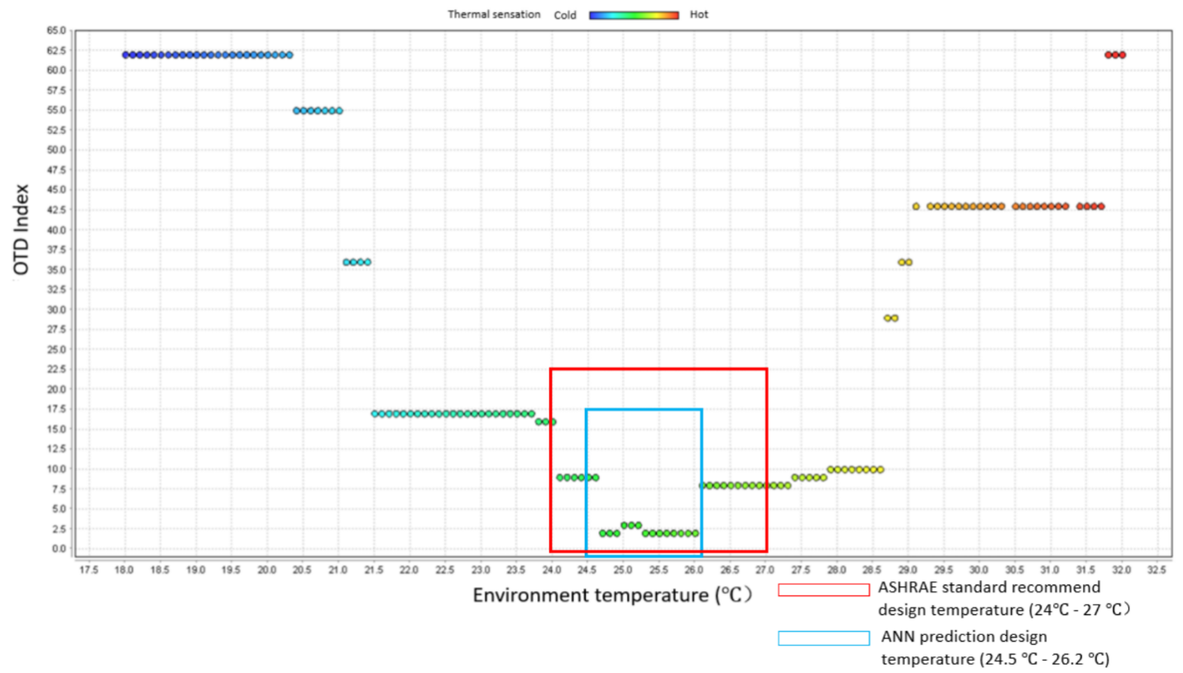The ASHRAE 55 Standard (PMV model) recommends a significantly wider temperature range than the ANN model on group B’s condition. The temperature range of validation experiment data (considered as actual condition), the PMV model and the ANN model are displayed in Table 5.24.

Figure 5.24 Comparison of ASHRAE Standard (PMV based) and ANN in multiple occupancy condition

Table.5.24 Temperature range of PMV model, ANN model, and validation experiment

|  |  |  |  |
| --- | --- | --- | --- |
| *Group* | *Validation experiment acceptable range (℃)* | *PMV calculated thermal acceptable temperature range (℃)* | *ANN prediction acceptable range (℃)* |
| *Subject A* | 23.4 ~ 26.6 | 24 - 27 | 23.7 ~ 27.0 |
| *Subject B* | 24.7 ~ 26.1 | 24.5 ~ 26.2 |
| *Subject C* | 21.6 ~ 26.7 | 21.2 ~ 26.3 |
| *OTD index* | 2 ~ 3 | 2 ~ 16 | 2 ~ 9 |

PMV model still maintains the constant recommended temperature range for group B’s multiple occupancy condition while the ANN model recommends a temperature range based on multiple occupants’ condition. Similar with single occupancy condition, the energy saving and the thermal comfort performance were calculated and are displayed in Table.5.25.

Table.5.25. 3 Group results of PMV model and ANN model

|  |  |  |  |  |  |  |
| --- | --- | --- | --- | --- | --- | --- |
| *Group* | *PMV Thermal comfort probability* | *ANN Thermal comfort probability* | *High boundary difference (ANN-PMV) (℃)* | *Summer Potential energy saving* | *Low boundary difference (PMV-ANN) (℃)* | *Winter Potential energy saving* |
| *Group A* | 86.7% | 87.9% | 0 | 0% | 0.3 | 4.5% |
| *Group B* | 46.7% | 88.2% | -0.8 | -12.0% | -0.5 | -7.5% |
| *Group C* | 90.0% | 92.2% | -0.7 | -10.5% | 2.8 | 42% |
| *Average* | 74.5% | 89.4% | -0.5 | -7.5% | 0.86 | 13.0% |
| *Max delta* | 41.5% | | -0.8 | -12.0% | 2.8 | 42% |

In the multiple occupancy condition, the PMV model still has a wider range of variability of thermal comfort probability (46.7% to 90.0%) than the ANN model (87.9% to 92.2%). The worst thermal comfort condition of the PMV model occurred in group B, wherein the environment temperature is 24℃, and its corresponding OTD index 15, which means all the 3 subjects feel uncomfortable (uncomfortable evaluation score in group B is 5). The worst thermal comfort condition of the ANN model prediction is an OTD equal to 3, which means all the 3 subjects feel slightly uncomfortable. Slightly uncomfortable condition is acceptable considering 10% PPD. The average thermal comfort probability of the PMV model is 74.5%, which is lower than the ANN model (89.4%). Therefore, the ANN model demonstrates better performance than the PMV model in multiple occupancy conditions, with regard to the thermal comfort aspect.

For the energy saving aspect, both the ANN and the PMV model demonstrate similar performance in group A’s condition. In group B’s condition, the PMV model shows a better energy performance. However, the thermal comfort condition in the PMV model is unacceptable. In group C’s condition, the ANN model demonstrates significantly better energy saving performance as compared to the PMV model, while the thermal comfort performance is similar. Therefore, the ANN model also shows a better performance of energy saving than the PMV model in a multiple occupancy condition.

## 5.4. Explore larger group size data-driven approach performance

In a multiple occupancy condition research, only three-people group size was researched. In the real world, one HVAC zone sometimes contains more occupants than three people. Therefore, a larger size multiple occupancy condition was discussed. Two types of group size were discussed, including six-people group and ten-people group.

Due to the experiment’s condition limitation, a multiple occupancy validation experiment cannot be carried out in this research. Instead, a combination of individual thermal preference data were used to explore the performance of MOC-ANN model.

In the single occupancy condition, there were 5 subjects attending the SOC experiment and the SOC validation experiment. In the multiple occupancy condition, there were 3 three-people groups, 9 subjects in total, attending the MOC validation experiments. Totally, there were 14 subjects experiment results for both, the thermal comfort experiment and the validation experiment. Their individual thermal comfort experiment results as training data (Fig.5.25), and the individual validation experiments were taken as actual reaction for the multiple occupancy condition (Fig.5.26). The assumption was that the occupants thermal comfort feedback would be the same between multiple occupancy condition and single occupancy condition. Even though there are many factors that could influence the occupants’ thermal comfort in different occupancy conditions, the experiment process of two occupancy condition is similar with strict environment control in the climate chamber.

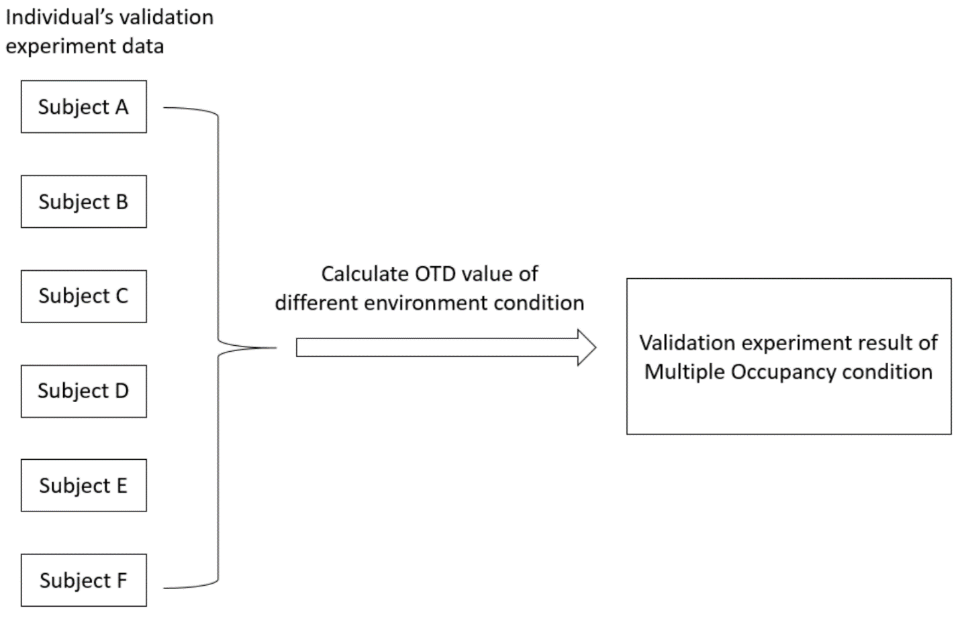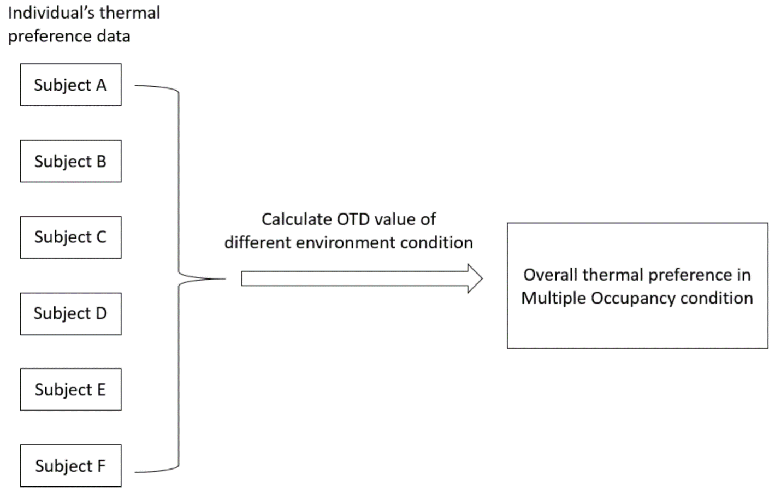

Figure 5.26 Integrating individual validation data into group validation data

Figure 5.25 Integrating individual thermal preference data into group thermal preference data

### 5.4.1. Six-people occupancy condition

Each group consisted of 6 subjects, and their information were randomly selected from among 14 subjects’ information. Totally, there were 5 six-people groups considered for multiple occupancy condition performance investigation. Group (6) A was taken as an example to display the comparison result of the PMV model and the MOC-ANN model. The performance is shown in Fig.5.27, and the red area is the ASHRAE (PMV) model recommends the temperature range while the blue area is the MOC-ANN model which recommends the temperature range. The ANN model’s prediction temperature range (24.8℃ - 26.7℃) is narrower than the PMV model’s recommended temperature range (24℃ - 27℃).

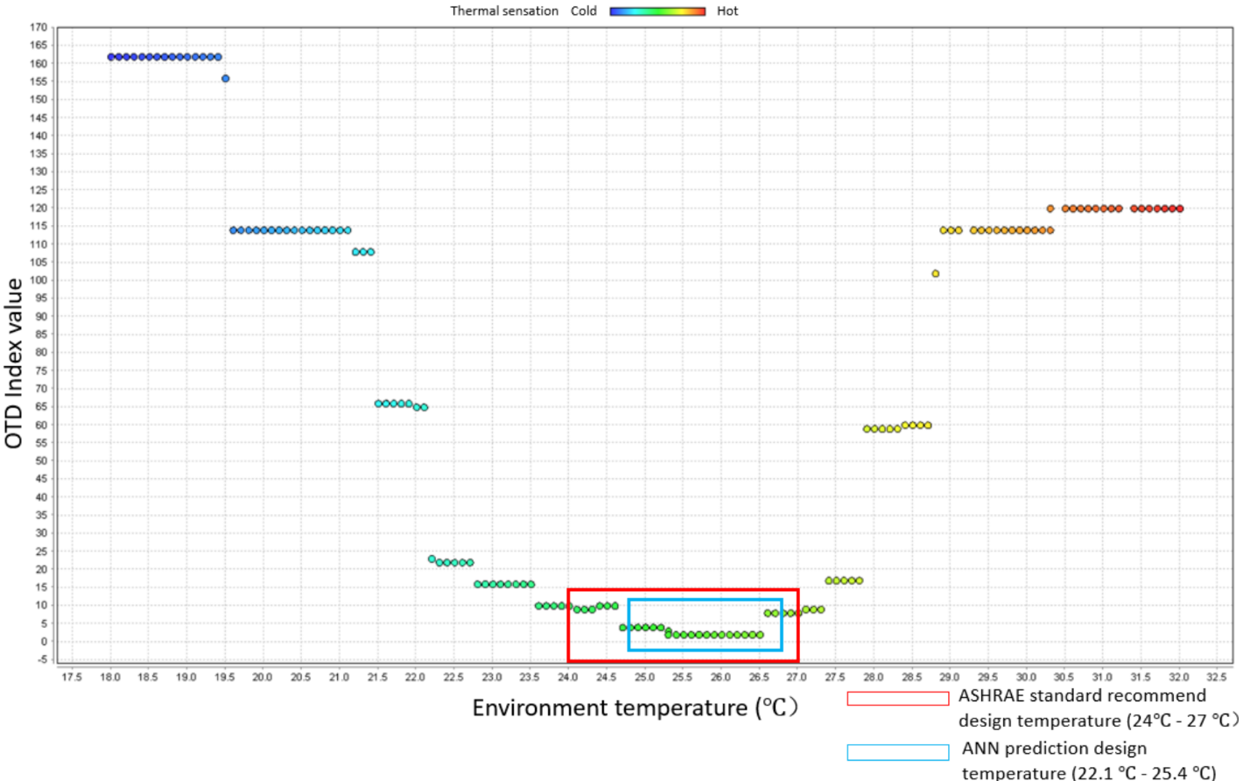In a six-people group setting, the acceptable condition of overall thermal comfort can be calculated by OTDmax calculation. The PPD = 10%, which means the worst condition is where all the 6 subjects feel *slightly* uncomfortable while no one feels uncomfortable. Therefore, OTDmax = 6, and the acceptable condition is OTD ≤ 6. The results of the acceptability condition temperature range of all 5 groups are displayed in Table 5.26.

Figure 5.27 Temperature range of PMV model and ANN model

Table.5.26 Temperature range of PMV model, ANN model and validation experiment data, \*6people size

|  |  |  |  |
| --- | --- | --- | --- |
| *Group* | *Validation experiment acceptable range (℃)* | *PMV calculated thermal acceptable temperature range (℃)* | *ANN prediction acceptable range (℃)* |
| *Group (\*6) A* | 24.4 ~ 26.6 | 24 - 27 | 24.8 ~ 26.8 |
| *Group (\*6) B* | 24.1 ~ 24.9 | 24.3 ~ 25.1 |
| *Group (\*6) C* | 23.2 ~ 25.2 | 22.9 ~ 24.7 |
| *Group (\*6) D* | 22.7 ~ 25.1 | 22.4 ~ 25.3 |
| *Group (\*6) E* | 24.6 ~ 25.7 | 24.4 ~ 25.5 |

The performance of ANN and PMV model has displayed in Table.5.27.

Table.5.27 5 Six-people groups’ results of PMV model and ANN model performance, \*6people size

|  |  |  |  |  |  |  |
| --- | --- | --- | --- | --- | --- | --- |
| *Group* | *PMV Thermal comfort probability* | *ANN Thermal comfort probability* | *High boundary difference (ANN-PMV) (℃)* | *Summer Potential energy saving* | *Low boundary difference (PMV-ANN) (℃)* | *Winter Potential energy saving* |
| *Group (\*6) A* | 73.3% | 90.0% | -0.2 | -3.0% | -0.8 | -12.0% |
| *Group (\*6) B* | 26.7% | 75.0% | -1.9 | -28.5% | -0.3 | -4.5% |
| *Group (\*6) C* | 40.0% | 83.3% | -2.3 | -34.5% | 1.1 | 16.5% |
| *Group (\*6) D* | 36.7% | 73.7% | -1.7 | -25.5% | 1.6 | 24% |
| *Group (\*6) E* | 56.7% | 81.8% | -1.5 | -22.5% | -0.4 | -6% |
| *Average* | 46.68% | 80.76% | -1.52 | -22.8% | 0.24 | 3.6% |
| *Max Delta* | 48.3% | | -2.3 | -34.5% | 1.6 | 24% |

In the 6-people occupancy condition, the PMV model’s performance on thermal comfort is poor. As per the 5 groups’ data calculation, the average thermal comfort probability is 46.68% under the PMV model recommended temperature range. The SOC-ANN model still demonstrates a good performance on the thermal comfort aspect since the average thermal comfort probability is 80.76%. The possible reason is that the ANN model’s recommended temperature range is based on the occupants’ thermal preference rather than a simple constant range. In terms of energy saving, the PMV model saves more (average is 22.8%) than the ANN model in the summer season design. However, the thermal comfort condition is unacceptable under this setting. It is not acceptable to sacrifice an occupant’s thermal comfort in pursuit of energy saving. In the winter season, the ANN model saves slightly more energy (average is 3.6%) than the PMV model. Considering both, thermal comfort and energy saving aspects, the ANN model demonstrates better performance.

### 5.4.2. Ten-people occupancy condition

Employing a strategy similar to the six-people occupancy condition, 5 ten-people groups were made, based on the subjects’ individual data. In the ten-people occupancy condition, the acceptable level of the MOC-ANN model is OTD ≤ 10, which means the worst acceptable condition is when all subjects feel *slightly uncomfortable.* However, in the Group (10) A setting, the lowest OTD value is 14. The MOC-ANN model prediction of group (10) A is shown in Fig.5.28.

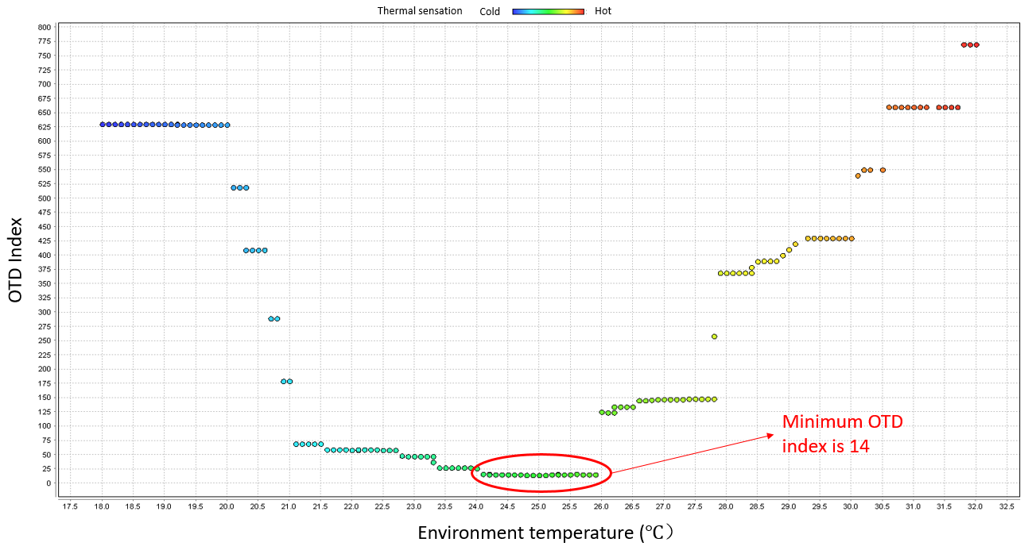

Figure 5.28 Overall thermal discomfort condition of group (10) A

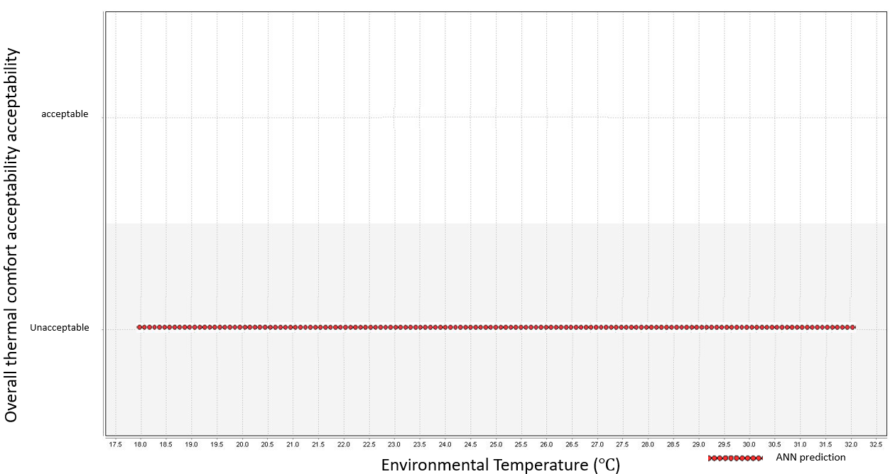In the ANN model prediction, there is no acceptable condition in this experiment, which shows the same results with the validation data as displayed in Fig.5.29. Therefore, it is difficult to maintain a PPD = 10% thermal comfort level in Group (10) A’s condition.

Figure 5.29 MOC-ANN model prediction of acceptability of different environment temperature

For the ten-people occupancy condition research, the following two thermal comfort condition were considered:

* Thermal Comfort Level: PPD = 10%; all occupants should be comfortable or slightly uncomfortable.
* Energy Saving Level: Where 10% of the occupants are allowed to be uncomfortable; the rest should be comfortable or slightly uncomfortable.

The OTDmax of Energy Saving Level is 20 (1\*11+9\*1). Therefore, the acceptable condition is OTD ≤ 20. Fig.5.30 displays the MOC-ANN model’s prediction of the energy saving level.

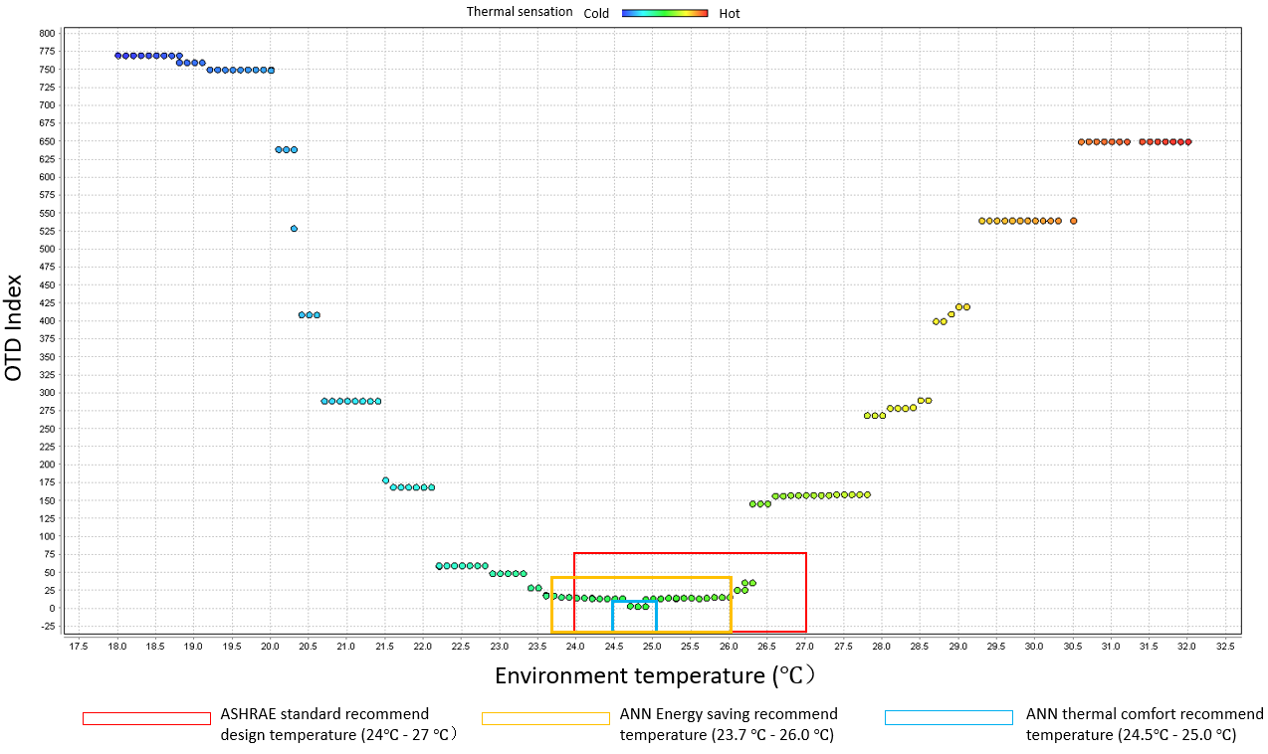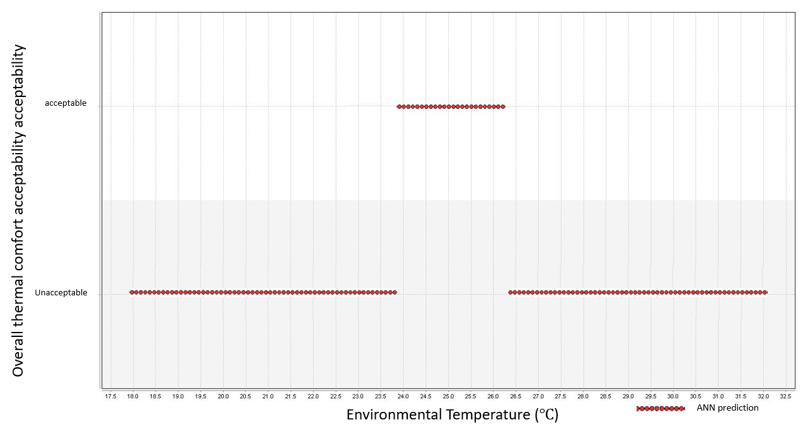The recommended temperature range of the MOC-ANN model is from 23.7℃ to 26.3℃. Since there is no available thermal comfort level prediction in Group (10) A condition, Group (10) B was used as an example to compare the thermal comfort level, energy saving, and the PMV recommended temperature range (Fig.5.31).

Figure 5.31 Recommended temperature range of the MOC-ANN model and the PMV model

Figure 5.30 MOC-ANN model prediction of energy saving level

In the MOC-ANN prediction, the Energy Saving Level recommended temperature range is significantly wider than the Thermal Comfort Level recommended temperature range due to the lower thermal comfort requirement of the Energy Saving Level. Therefore, the performance comparison between the PMV model and the MOC-ANN model was divided into two thermal comfort requirements, including thermal comfort level and energy saving level.

#### 5.4.2.1. Performance on Thermal Comfort Level condition

Table.5.28 Temperature range of Thermal Comfort Level condition, \*10 people size

|  |  |  |  |
| --- | --- | --- | --- |
| *Group* | *Validation experiment acceptable range (℃)* | *PMV calculated thermal acceptable temperature range (℃)* | *ANN prediction acceptable range (℃)* |
| *Group (\*10) A* | N/A | 24 - 27 | N/A |
| *Group (\*10) B* | 24.7 ~ 24.9 | 24.5 ~ 25.0 |
| *Group (\*10) C* | 25.2 ~ 25.9 | 25.4 ~ 26.1 |
| *Group (\*10) D* | N/A | N/A |
| *Group (\*10) E* | 24.3 ~ 25.1 | 24.0 ~ 24.9 |

Table 5.28 displays the recommend temperature range of PMV and ANN model. Table 5.29 displays the performance of the MOC-ANN model and the PMV model under the Thermal Comfort Level’s thermal requirement.

Table.5.29. 5 Ten-people group results of PMV model and ANN model performance in Thermal Comfort Level

|  |  |  |  |  |  |  |
| --- | --- | --- | --- | --- | --- | --- |
| *Group* | *PMV Thermal comfort probability* | *ANN Thermal comfort probability* | *High boundary difference (ANN-PMV) (℃)* | *Summer Potential energy saving* | *Low boundary difference (PMV-ANN) (℃)* | *Winter Potential energy saving* |
| *Group (\*10) A* | N/A | N/A | N/A | N/A | N/A | N/A |
| *Group (\*10) B* | 6.7% | 40.0% | -2.0 | -30% | -0.5 | -7.5% |
| *Group (\*10) C* | 23.3% | 71.4% | -0.9 | -13.5% | -1.4 | -21% |
| *Group (\*10) D* | N/A | N/A | N/A | N/A | N/A | N/A |
| *Group (\*10) E* | 26.7% | 66.7% | -2.1 | -31.5% | 0 | 0% |
| *Average* | 18.9% | 59.4% | -1.68 | -25.0% | -0.63 | -9.5% |
| *Max delta* | 48.1% | | -2.1 | -31.5% | -1.4 | -21% |

From the results of the 5 ten-people groups’ analysis, the PMV model demonstrated a poor performance on the thermal comfort aspect with an average thermal comfort probability of 18.9%. Even though the ANN model showed worse performance than before, the average thermal comfort probability was 59.4%, which is a comparatively acceptable condition. Moreover, there are some groups that do not have an acceptable environmental condition, while the PMV model still recommended a temperature range from 24℃ to 27℃. Therefore, the SOC-ANN model demonstrates better performance under the Thermal Comfort Level condition of the ten-people occupancy condition.

#### 5.4.2.2. Performance on Thermal Comfort Level condition

In the Energy Saving Level condition, a similar analysis was carried out for 5 ten-people groups. Table 5.30 displays the temperature range of the ANN and the PMV model.

Table.5.30 Temperature range of Energy Saving Level condition, \*10-people size

|  |  |  |  |
| --- | --- | --- | --- |
| *Group* | *Validation experiment acceptable range (℃)* | *PMV calculated thermal acceptable temperature range (℃)* | *ANN prediction acceptable range (℃)* |
| *Group (\*10) A* | 24.1 ~ 25.9 | 24 - 27 | 23.7 ~ 26.4 |
| *Group (\*10) B* | 23.5 ~ 26.2 | 23.9 ~ 26.7 |
| *Group (\*10) C* | 23.3 ~ 27.9 | 23.0 ~ 28.2 |
| *Group (\*10) D* | 21.5 ~ 26.6 | 21.7 ~ 27.0 |
| *Group (\*10) E* | 24.5 ~ 28.3 | 23.7 ~ 28.6 |

In the Energy Saving model, all groups have acceptable temperature ranges according to the validation experiment data, and the ANN model also made the corresponding prediction temperature range. The temperature range in the Energy Saving Level is significantly wider than in the Thermal Comfort Level. A performance analysis was done; the results are displayed in Table 5.31. The average thermal comfort probability of the PMV model is 79.2% while the ANN model is seen to be slightly better with 83.02%. As for the energy saving aspect, the ANN model is slightly more energy saving (average is 5.7%) than the PMV model in the summer, with an average of 12% more energy saving in winter.

Table.5.31 Five \*10-people size group results of PMV model and ANN model performance in Energy Saving Level,

|  |  |  |  |  |  |  |
| --- | --- | --- | --- | --- | --- | --- |
| *Group* | *PMV Thermal comfort probability* | *ANN Thermal comfort probability* | *High boundary difference (ANN-PMV) (℃)* | *Summer Potential energy saving* | *Low boundary difference (PMV-ANN) (℃)* | *Winter Potential energy saving* |
| *Group (\*10) A* | 60.0% | 78.3% | -0.6 | -9% | 0.3 | 4.5% |
| *Group (\*10) B* | 66.0% | 82.1% | -0.3 | -4.5% | 0.1 | 1.5% |
| *Group (\*10) C* | 100% | 88.5% | 1.2 | 18% | 1.0 | 15% |
| *Group (\*10) D* | 86.7% | 88.7% | 0 | 0% | 2.3 | 34.5% |
| *Group (\*10) E* | 83.3% | 77.5% | 1.6 | 24% | 0.3 | 4.5% |
| *Average* | 79.2% | 83.02% | 0.38 | 5.7% | 0.8 | 12% |
| *Max delta* | 18.3% | | 1.6 | 24% | 2.3 | 34.5% |

Generally, the MOC-ANN model demonstrated better performance on both the Energy Saving Level and the Thermal Comfort Level in a ten-people occupancy condition. Especially in Thermal Comfort Level, the PMV model cannot be applied to maintain the acceptable thermal comfort condition.

# **Chapter 6 Conclusion**

Twenty-one subjects participated in the human thermal comfort experiment, and their thermal preferences were collected by surveying their thermal comfort feedback under different environmental conditions. The environment condition was strictly controlled with only the environment temperature increasing from 18℃ to 32℃, and the relative humidity varying between 40% and 45%. An Artificial Neural Network was used to determine the recommended temperatures for occupants based on their thermal preference data. Validation experiments were done to test the performance of ANN model prediction. Both energy saving and thermal comfort aspects were considered to make the performance comparison between the ANN model and the PMV model.

## 6.1. Data-driven approach performance in different occupancy conditions

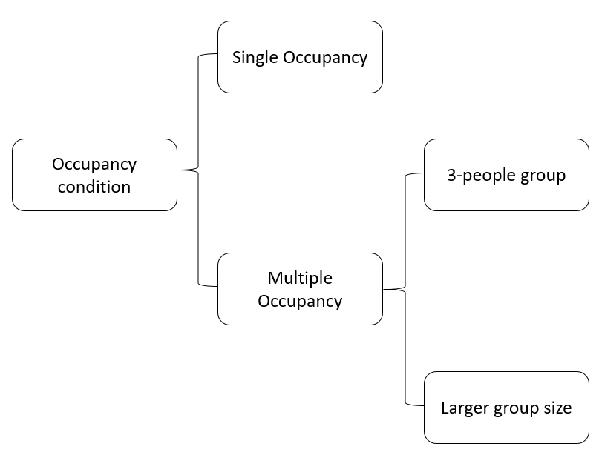In this research, several occupancy conditions were considered (Fig.6.1). Thermal comfort experiment data was used to train the ANN model and validation experiment data was used to test the model performance.

Figure 6.1 Occupancy condition category in this research

* Single occupancy condition

An individual’s thermal preference data was used to develop the SOC-ANN model, and a validation experiment was done for the same subject to test the SOC-ANN model performance. Two improvement methods were used to improve the SOC-ANN model, including adding more training data and simplifying the output options. The average accuracy of the SOC-ANN model is 84.91% in the single occupancy condition. Energy performance of the SOC-ANN model averages 9.3% more energy saving than the PMV model, and can be up to 45% more efficient. The thermal comfort performance of the SOC-ANN model is 20% better than the PMV model, on average, and can perform up to 44.3% better.

* Multiple occupancy condition (three-people)

Three three-people groups were made for multiple occupancy condition research. An OTD index was developed to evaluate the overall thermal comfort condition of the zone. Validation experiments were done to test the MOC-ANN model performance in multiple occupancy condition. Adding training data and simplifying output options were used to improve the MOC-ANN model. Based on 3 three-people groups’ data, the average accuracy of the MOC-ANN model is 85.73% in multiple occupancy condition. On an average, the MOC-ANN model demonstrates 5.5% more energy efficiency as compared to the PMV model, and can save up to 42% more energy. The MOC-ANN model is, at an average, 14.9% better than PMV model in thermal comfort performance, and can show, up to 41.5% better performance than PMV model.

* Multiple occupancy condition (larger group size)

The larger group size, including six-people group and ten-people group were discussed, based on the assumption that individual experiment data is applicable in multiple occupancy condition, when integrating an individual’s data to simulate a group condition. In a six-people occupancy condition, the MOC-ANN model showed significantly better performance (average 34.08% better) than the PMV model, and the MOC-ANN up to 48.3% better performance in thermal comfort, while demonstrating up to 24% better performance in energy saving. Since the PMV model can hardly maintain thermal comfort requirement for occupants, sacrificing human thermal comfort for more energy saving is not acceptable in this research.

In the ten-people occupancy condition, two different thermal comfort levels were also considered, including the Energy Saving Level and the Thermal Comfort Level. In the Thermal Comfort Level requirement, the MOC-ANN model showed a significantly better performance (average 40.5% better) than the PMV model, and the MOC-ANN can demonstrate up to 48.1% better performance. Since the PMV thermal comfort performance was too poor to maintain the occupants’ thermal comfort requirement, the energy performance is not meaningful. In Energy Saving Level, the thermal comfort performance of the MOC-ANN model is slightly better (on an average, 3.82% better) than the PMV model. The MOC-ANN performance can be up to 18.3% better than the PMV model. As for the energy saving aspect, MOC-ANN performance is better (at an average, 6.3% better) than the PMV model, and the MOC-ANN can perform up to 24% better in summer condition, as well as 34.5% better in winter condition.

## 6.2. Limitation of the work

This research has several limitations that need mention.

* Number of subjects

There were 21 subjects in total, attending the experiment. In order to increase the data-driven approach in terms of accuracy and reliability, more subjects must be considered.

* Larger group size multiple occupancy condition experiment

In the larger group size such as six-people and ten-people, multiple occupancy condition experiments were not conducted, due to the limitation of the size of the climate chamber. Even though the experiment process and environment conditions are almost the same for the SOC and the MOC experiment, the occupants might feel different sensations due to varying occupancy conditions. A multiple occupancy condition experiment needs to be carried out to ensure that the occupants are in exactly the same conditions.

* More validation experiment for historic data

In this research, 4-time validation experiments were done to be used as training data to improve the ANN model. According to the improvement effect of adding training data size, it is necessary to conduct more historic experiments and update the ANN model, which might help increase the accuracy of the ANN model.

## 6.3. Future work

This research has been done based on human thermal comfort experiments carried out in a climate chamber. However, there are other factors that may influence occupants’ thermal comfort. Therefore, SOC and MOC experiments should be conducted in a real office setting. The attributes should include real time weather conditions, surrounding air speed, cloth insulation, MRT, etc. Moreover, there are some other machine learning algorithms that could be used in this research, such as the decision tree, support vector machine, deep learning, etc. For example, the Support Vector Machine (SVM) has been widely used in thermal comfort research recently. Dai and Changzhi have used the SVM to investigate the relationship between overall thermal comfort condition and local skin sensation (Dai et al, 2017). SVM can effectively avoid overfitting by a regularization parameter, and it is defined by a convex optimization problem. Convex optimization problem makes the model more efficient and requires less training data (Cortes et al, 1995). Future work should focus on comparing the different machine learnings’ performance on human thermal comfort prediction, and find the optimal machine learning algorithm.

## 6.4. Scope of the work

One of important preconditions of using the data-driven approach for thermal environment control is collecting occupants’ information. Both the SOC-ANN model and the MOC-ANN model require an occupant’s individual thermal preference information to train the model before using it to control the environment condition. In this research, the occupants’ individual thermal preferences were collected by human thermal comfort experiment; however, it is difficult to execute such an experiment for each occupant in the real world.

Another precondition is that the occupancy identification should be detected by using the data-driven control system, because the system will change the environmental condition based on the current occupant’s information. Therefore, the SOC-ANN and MOC-ANN models must know who is in the room at any given moment.

With the rapid development of portable smart devices such as the smart phone, smart watch, smart glasses, etc., there are some potential solutions to solve the above problem by combining these smart devices. Let’s take the smart watch (or smart band) as an example. A smart watch can be paired with a smart phone in order to facilitate the transmission of data. An app can be developed to collect the occupant’s thermal comfort feedback and its corresponding time, which is not difficult, using the current technology. At the same time, the environment condition

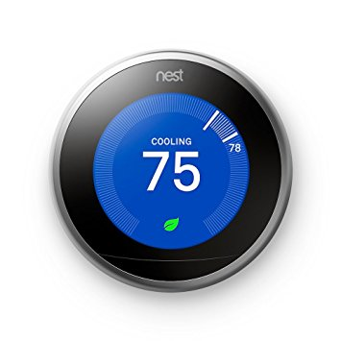 (including temperature and humidity) can be read by a digital thermal stat such as NEST. Thereafter, the occupant’s thermal preference can be developed by

Figure6.2 Apple watch

Figure 6.3 NEST Thermal stat

combining the information obtained from the smart watch and the smart thermal stat. As for the occupancy identification, the GPS function of a smart watch can be used to identify the occupants in the room. The workflow of the combined smart device is displayed in Fig 6.4.

In this research, the scope was limited in the data-driven algorithm development. As for combining the smart device, some potential solutions have been proposed and can be done in future work.

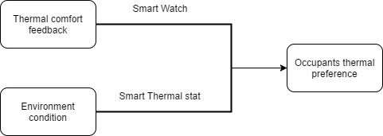

Figure 6.4 Workflow of combining smart device

## 6.5. Conclusion

Under this research condition setting, the data-driven approach demonstrated better performance in terms of both, energy saving as well as thermal comfort, in both single occupancy condition and multiple occupancy condition. Especially in the thermal comfort area, both the SOC-ANN and MOC-ANN models showed better performance for maintaining the occupants’ thermal comfort within an acceptable level than the PMV model. From the energy saving aspect, even though the PMV model showed good performance in certain conditions, it sacrificed the occupants’ thermal comfort. Both SOC-ANN and MOC-ANN models can exhibit good energy saving performance while maintaining an acceptable thermal comfort condition.

# **REFERENCES**

Alcal'a, R., 1M. Ben'ttez, 1 Casillas, O. Cordo'n, and R Pe'rez. 2003. “Fuzzy control of HV AC systems optimized by genetic algorithms.” *Applied Intelligence*, 18, 155-177.

ANSI/ASHRAE Standard 55-2013, *Thermal Environmental Conditions for Human Occupancy*.

Argiriou, A., Bellas-Velidis, I., Kummert, M., and Andre, P. 2004. “A neural network controller for hydronic heating systems of solar buildings.” *Neural Networks*, 17, 427–40.

Arthur Mac J.W., Gerald, E.W. 1998. “Optimal comfort control for variable-speed heat pumps.” *ASHRAE Transactions*, 94, 1283–97.

Asakawa, K., Takagi, H. 1994. “Neural networks in Japan.” *Communications of the ACM*, 37 (3):106–12. 42.

ASHRAE, 2004. “ASHRAE standard 55-2004, Thermal Environmental Conditions for Human Occupancy.” *American Society of Heating, Refrigerating and Air- Conditioning Engineers, Inc*.

ASHRAE, 2004. “ASHRAE standard 55-2004, Thermal Environmental Conditions for Human Occupancy.” *American Society of Heating, Refrigerating and Air- Conditioning Engineers, Inc*.

Atilla Y., 1995. “Building Energy Management: A Case Study in METU Library, Master Thesis,” *Mechanical Engineering,* METU, 1.

Barlow, S., and Fiala, D. 2007. “Occupant comfort in UK offices–how adaptive comfort theories might influence future low energy office refurbishment strategies.” *Energy Build.,* 39 (7): 837–846.

Brambley. 2005. Advanced Sensors and Controls for Building Applications: Market Assessment and Potential R&D Pathways.

Buratti, C., and Ricciardi, P. 2009. “Adaptive analysis of thermal comfort in university classrooms: correlation between experimental data and mathematical models.” *Build. Environ.*, 44 (4): 674–687.

Calvino F., Gennusca, M.L., Rizzo, G., Scaccianoce, G. 2004. “The control of indoor thermal comfort conditions: introducing a fuzzy adaptive controller.” *Energy and Buildings*, 36, 97–102.

Choi, Joon-Ho, Azizan, Aziz, and Vivian, Loftness. 2010. “Investigation on the impacts of different genders and ages on satisfaction with thermal environments in office buildings." *Building and Environment* 45 (6), 1529-1535.

Choi, Joon-Ho, Vivian, Loftness, and Dong-Won, Lee. 2012. "Investigation of the possibility of the use of heart rate as a human factor for thermal sensation models." *Building and Environment* 50, 165-175.

Corgnati, S. P., Filippi, M., and Viazzo, S. 2007. “Perception of the thermal environment in high school and university classrooms: Subjective preferences and thermal comfort.” *Build. Environ*., 42 (2): 951–959.

Cortes, Corinna, and Vladimir, Vapnik. 1995. "Support-vector networks." *Machine learning,* 20(3), 273-297.

Dai, Changzhi, Hui, Zhang, Edward, Arens, and Zhiwei Lian. 2017. "Machine learning approaches to predict thermal demands using skin temperatures: Steady-state conditions." *Building and Environment,* 114, 1-10.

Dounis A.I. and Manolakis D.E. 2001. “Design of a fuzzy system for living space thermal comfort regulation.” *Applied Energy*, 69, 119–44.

Dounis, A.I., Santamouris, M.J., and Lefas, C.C. 1992. “Implementation of A.I. techniques in thermal comfort control for passive solar buildings.” *Energy Conversion and Management*, 33 (3): 175–82.

Erickson, V.L. and Cerpa, A.E. 2012. “Thermovote: Participatory Sensing for Efficient Building.” *HVAC Conditioning*, 9–16.

Fanger, P. O. 1972. “Thermal comfort analysis and applications in environmental engineering.” 1st edition, New York: McGraw Hill.

Federspiel, C.C., Asada, H. 1994. “User-adaptable comfort control for HVAC systems.” *Journal of Dynamic Systems Measurement and Control*, 116 (3): 474–86.

Feldmeier, M. and Paradiso, J.A. 2010. *Personalized HVAC Control System*, 1–8.

Fountain, M., Brager, G., Arens, E., Bauman, F., and Benton, C. 1994. “Comfort control for short-term occupancy.” *Energy Build*, 21, 1-13.

Hansen, Lars Kai, and Peter Salamon. "Neural network ensembles." *IEEE transactions on pattern analysis and machine intelligence* 12, no. 10 (1990): 993-1001.

Havenith, G. 1999. “Heat balance when wearing protective clothing.” *The Annals of Occupational Hygiene*. 43 (5): 289–96.

Hernández, A. 1994. “NTP 343: New criteria for future indoor ventilation standards (in Spanish. Nuevos criterios para futuros estándares de ventilación de interiores*).” Instituto Nacional de Seguridad e Higiene en el Trabajo, Ministerio de Trabajo y Asuntos Sociales Espa˜na.*

Hoyt, Tyler, Edward, Arens, and Hui Zhang. 2015. "Extending air temperature setpoints: Simulated energy savings and design considerations for new and retrofit buildings." *Building and Environment,* 88, 89-96.

Huang, S. and Nelson, R.M. 1994. “Rule development and adjustment strategies of fuzzy logic controller for an HVAC system. Part 1: Analysis and part two-experiment.” *ASHRAE Transactions*, 1, 841–56.

Hwang, R., Cheng, M., Lin, T., and Ho, M. 2009. “Thermal perceptions, general adaptation methods and occupant’s idea about the trade-off between thermal comfort and energy saving in hot-humid regions.” *Build. Environ*., 44 (6): 1128–1134.

Jang, J.S.R., Sun, C.T., and Mizutani, E. 1996. “Neuro-fuzzy and soft computing.” Prentice Hall.

Jazizadeh, F. and Becerik-Gerber, B. 2012. *Toward Adaptive Comfort Management in Office Buildings Using Participatory Sensing for End User Driven Control*, 1–8.

Jazizadeh, F., Ghahramani, A., Becerik-Gerber, B., Kichkaylo, T., and Orosz, M. 2014. “User-leddecentralized thermal comfort driven HVAC operations for improved efficiency in office buildings.” *Energy and Buildings,* 70, 398–410.

Kanarachos, A., Geramanis, K. 1998. “Multivariable control of single zone hydronic heating systems with neural networks.” *Energy Conversion Management*, 13 (13): 1317–36.

Karjalainen, Sami. 2007. “Biological sex differences in thermal comfort and use of thermostats in everyday thermal environments.” *Building and Environment*. 42 (4): 1594.

Khodakarami, Jamal and Nasrollahi, Nazanin. 2012. "Thermal comfort in hospitals – A literature review". *Renewable and Sustainable Energy Reviews.* 16 (6): 4071. doi:10.1016/j.rser.2012.03.054

Kolokotsa, D. 2001. “Design and implementation of an integrated intelligent building indoor environment management system using fuzzy logic, advanced decision support techniques, local operating network capabilities and smart card technology.” PhD. Technical University of Crete.

Kolokotsa, D., Tsiavos, D., Stavrakakis, G.S., Kalaitzakis, K., and Antonidakis, E. 2000. “Advanced fuzzy logic controllers design and evaluation for buildings’ occupants thermal – visual comfort and indoor air quality satisfaction.” *Energy and Buildings,* 33, 531–543.

Kurian, C.P., Kuriachan, S., Bhat, J., and Aithal, R.S. 2005. “An adaptive neuro-fuzzy model for the prediction and control of light in integrated lighting schemes.” *Lighting Research and Technology*, 37 (4): 343–52.

Lakshminarayan K., Harp S., and Samad, T. 1999. “Imputation of Missing Data in Industrial Databases.” *Applied Intelligence,* 11, 259–275.

Lan, Li, Lian, Zhiwei, Liu, Weiwei, Liu, and Yuanmou. 2007. “Investigation of biological sex difference in thermal comfort for Chinese people.” *European Journal of Applied Physiology*, 102 (4): 471–80.

Lenzuni, P., Freda, D., and Del Gaudio, M. 2009. "Classification of Thermal Environments for Comfort Assessment". *Annals of Occupational Hygiene*. 53 (4): 325–32.

Li, H.X., Zhang, L., Cai, K.Y., and Chen, G. 2005. “An improved robust fuzzy ID controller with optimal fuzzy reasoning.” *IEEE Trans. SYs., Man, and Cybern*. 35, 6.

Liang, and Du, R. 2007. "Design of intelligent comfort control system with human learning and minimum power control strategies." *Energy Conversion and Management*, 49, 517-528.

Liang, J. and Du, R. 2005. “Thermal comfort control based on neural network for HVAC application.” In: *Control applications, CCA 2005, proceedings of 2005, IEEE conference*. *2005*, 819–24.

Ling, K.V., Dexter, A.L., Geng, G., and Haves, P. 1991. “Self-tuning control with fuzzy rulebased supervision for HVAC applications.” In: *IFAC intelligent tuning and adaptive control*, 205–9.

Lopez L, Sanchez, Doctor F, Hagras H, Callaghan V. 2004. “An evolutionary algorithm for the off-line data driven generation of fuzzy controllers for intelligent buildings.” In: *Systems, man and cybernetics*, 2004 IEEE International Conference, 1, 42–7.

Luis Pe´rez-Lombard a, \*, Jose´ Ortiz b, and Christine Pout b. 2008. *A review on buildings energy consumption information*.

McCulloch, W. and Pitts, W. 1943. “A logical calculus of ideas immanent in nervous activity, Bull.” *Math. Biophys*. 5, 115–133.

Mohan, B.M. and Patel, A.V. 2002. “Analytical structures and analysis of the simplest fuzzy PD controllers.” *IEEE Trans. Syst. Man, CybernB*, 32 (April): 2, 239-248.

Moon, J.W. and Kim, J.J. 2010. “ANN-based thermal control methods for residential buildings.” *Build. Environ*. 45, 1612–1625.

Moon, Jin Woo, and Jong-Jin Kim. "ANN-based thermal control models for residential buildings." *Building and Environment* 45, no. 7 (2010): 1612-1625.

Morel, N., Bauer, M., and El-Khoury, Krauss, J. 2000. “Neurobat, a predictive and adaptive heating control system using artificial neural networks.” *International Journal of Solar Energy*, 21, 161–201.

Murakami, Y., Terano, M., Mizutani, K., Harada, M., and Kuno, S. 2007. “Field experiments on energy consumption and thermal comfort in the office environment controlled by occupants’ requirements from PC terminal.” *Building and Environment,* 42, 4022–4027.

Nicol, F. and Humphreys, M. 2002. “Adaptive thermal comfort and sustainable thermal standards for buildings.” *Energy and Buildings,* 34, 563–572.

Nicol, J.F. and Humphreys, M.A. 2002. “Adaptive thermal comfort and sustainable thermal standards for buildings.” *Energy and Buildings,* 34, 563–572.

Nicol, J.F., and Humphreys, M.A. 2009. “New standards for comfort and energy use in buildings.” *Build. Res. Inf*., 37 (1): 68–73.

References Ari, S., Wilcoxen, P., Khalifa, H. E., Dannenhoffer, J. F., and Isik, C. 2008. “A practical approach to individual thermal comfort and energy optimization problem.” *Proc., NAFIPS 2008–Annual Meeting North Am. Fuzzy Info. Process. Soc*., IEEE, Piscataway, NJ, 388–393.

Shepherd, A.B. and Batty, W.J. 2003. “Fuzzy control strategies to provide cost and energy efficient high quality indoor environments in buildings with high occupant densities.” *Building Service Engineering Research and Technology*, 24 (1): 35–45.

Singh, J., Singh, N., and Sharma, J.K. 2006. “Fuzzy modelling and control of HVAC systems—a review.” *Journal of Scientific and Industrial Research*, 65 (6): 470–6.

Tobi, T., Hanafusa, T. 1991. “A practical application of fuzzy control for an air-conditioning system.” *International Journal of Approximate Reasoning*, 5, 331–48.

Toftum, J. 2005. “Thermal Comfort Indices.” *Handbook of Human Factors and Ergonomics Methods*. Boca Raton, FL, USA: 63. CRC Press.

Vahid Vakiloroaya, Bijan Samali, Ahmad Fakhar, and Kambiz Pishghadam. 2014. “A review of different strategies for HVAC energy saving.” *Energy Convers. Manag*., 77, 738–754.

Van Hoof, J. 2008. “Forty years of Fanger’s model of thermal comfort: Comfort for all?” *Indoor Air*, 18 (3): 182–201.

Wagner, A., Gossauer, E., Moosmann, C., Gropp, T., and Leonhart, R. 2007. “Thermal comfort and workplace occupant satisfaction-results of field studies in German low energy office buildings.” *Energy Build*., 39 (7): 758–769.

Wu, S. 2013. "A review on coarse warranty data and analysis", *Reliability Engineering and System*, 114: 1–11, doi:10.1016/j.ress.2012.12.021

Wyon, D. P., Andersen, I., and Lundqvist, G. R. 2009. "Spontaneous magnitude estimation of thermal discomfort during changes in the ambient temperature\*". *Journal of Hygiene.* 70 (2): 203–21.

Yamada, F., Yonezawa K., Sugarawa, S., and Nishimura, N. 1999. “Development of airconditioning control algorithm for building energy-saving.” In: *IEEE international conference on control applications*.

Yang, In-Ho, Myoung-Souk Yeo, and Kwang-Woo Kim. "Application of artificial neural network to predict the optimal start time for heating system in building." *Energy Conversion and Management* 44, no. 17 (2003): 2791-2809.

Yu, Jinghua, Yang, Changzhi, Tian, Liwei, and Liao, Dan. 2009. "Evaluation on energy and thermal performance for residential envelopes in hot summer and cold winter zone of China". *Applied Energy*. 86 (10): 1970.